DRAFT Plants and the
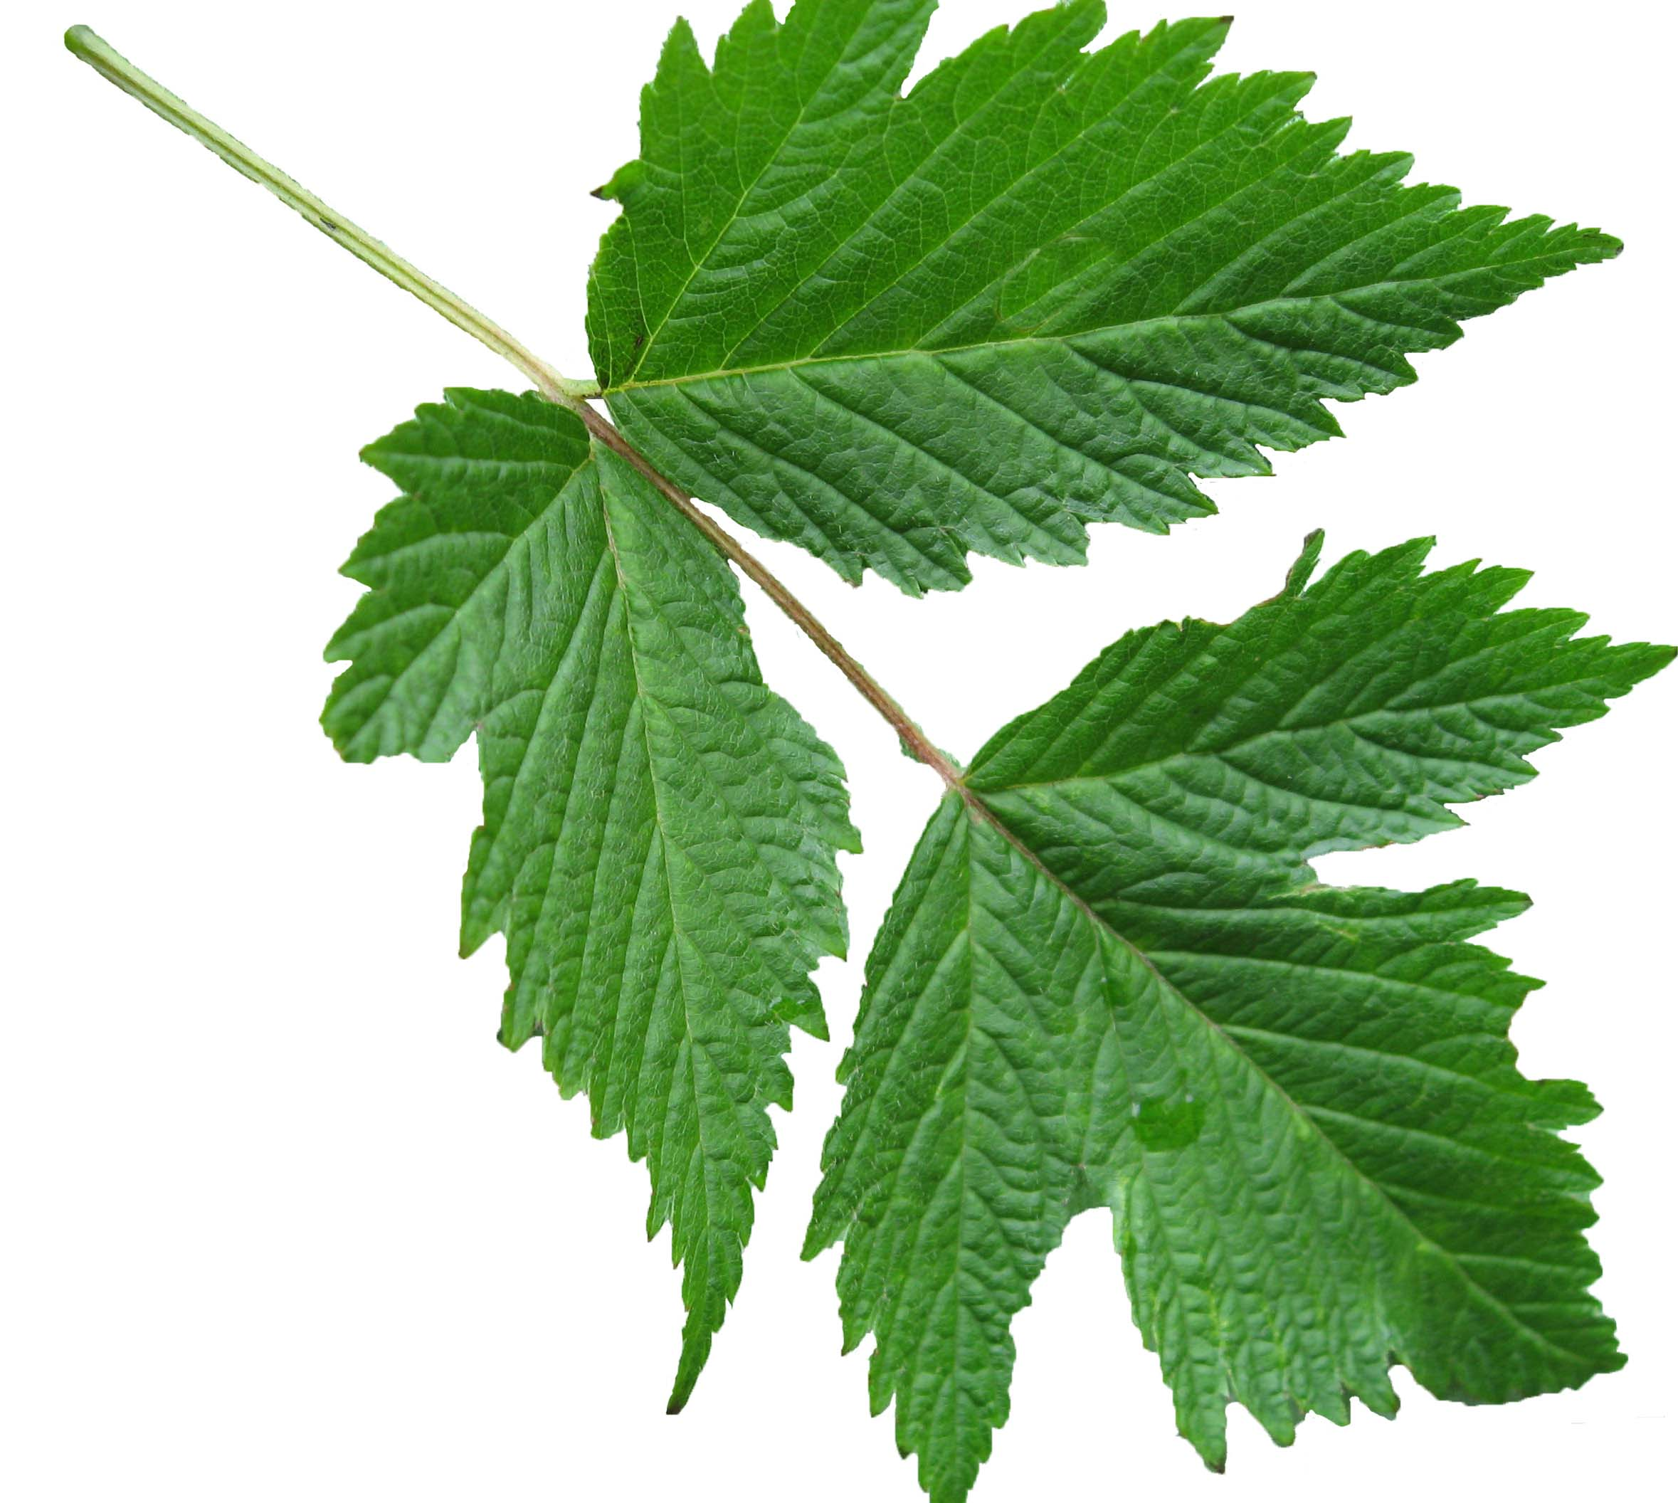
Carbon Cycle

How seeds grow to trees
and plants transform Carbon

The Environmental Literacy Project
Carbon: Transformations in Matter and Energy
(Carbon TIME)
2011-2012

Table of Contents

Table of Contents 2
Notes to Teachers 4
Specifications for Plants Unit 5
Investigations 5
Accounts Activity Sequences 6
Photosynthesis in Plants 6
Biosynthesis in Plants 7
Cellular Respiration in Plants 8
Lesson and Activity Overview 9
Additional Unit Information 14
Targeted Grades: 14
Key Concepts: 14
Vocabulary: 14
Materials: 14
Lab Materials: 14
Re-Usable Student Handouts/Resources: 14
Consumable Student Worksheets: 15
Video Links: 15
Acknowledgments: 15
Core Lesson 1: Unit Pre-Assessment and Plant Growth Investigation 16
Activity 1: Unit Pre-Assessment 19
Activity 2: My Ideas About Plant Growth Formative Assessment 19
Activity 3: Plant Growth Investigation 20
Activity 4: Accounting For Results with Claims, Evidence, and Reasoning 21
Optional Activity: Water and Plant Biomass Demonstration 22
Core Lesson 2: A Big Job For Little Seeds 29
Activity 1: Packed With Chemical Energy 30
Activity 2: Zooming Into A Plant 31
Core Lesson 3: A Dirty Job 33
Activity 1: A Dirty Job/ Famous Studies of Plants 35
Activity 2: What Does It Give To Plants? 35
Core Lesson 4: Something In The Air 41
Activity 1: Initial Explanations and Predictions 42
Activity 2: Something In The Air: CO₂ Measurement 43
Activity 3: Accounting For Results with Claims, Evidence, and Reasoning 48
Core Lesson 5: Photosynthesis, What’s It All About? 64
Activity 1: What Is Photosynthesis? 65
Activity 2: Modeling Photosynthesis 67
Core Lesson 6: Biosynthesis 72
Activity 1: Biosynthesis PowerPoint and Worksheet 72
Optional Activity: How is food used in plants? 80
Optional Activity: Telling a Starch Story 87
Optional Respiration Lesson: Cellular Respiration In Plants 90
Activity 1: Plants In The Dark: Our Evidence & Ideas 92
Activity 2: The Air Around A Seed 93
Activity 3: What Is Cellular Respiration In Plants? 96
Optional Activity: Modeling Cellular Respiration In Plants 97
Core 7: Plant Application Activities 107
Activity 1: Examples of Photosynthesis, Biosynthesis, and Cellular Respiration 107
Optional Activity 2: What’s the Carbon Trend? Explaining the Keeling Curve 107
Optional Activity 3: How Many Trees Do I Need? 108
APPENDICES 123
Optional: Air Adds Mass Demonstrations 123

Notes to Teachers

NOTE ABOUT LESSONS: We have not finished revising the Plants Unit Teacher’s Guide, so although the lesson plans in this guide are detailed and useful, there are places where they do not reflect the current state of our teaching materials.
The unit map, student worksheets, and student handouts are all updated, so when you see a conflict between this Teacher’s Guide and other materials, follow the other materials.

NOTE ABOUT POWERPOINTS: The Plant VTTs PowerPoint is packaged in a few different ways. There is one version that includes all three components of the Plant Unit (i.e., Photosynthesis, Biosynthesis, and Cellular Respiration). There are also individual PowerPoints for these three sections. You should choose the format that works best for you and your students.

Specifications for Plants Unit
Note that black text indicates Level 3 goals for both Level 2 and Level 3 students. Red italics indicate Level 4 goals for Level 3 students only.

Investigations
Title | Inv 1: Plant growth* | Inv 2: Plant gas exchange in light and dark | Inv 3: Gas exchange in sprouting seeds*
Research Question | Where does the mass of a plant come from? | How do plants “breathe” (exchange gases with their environments) in the light and in the dark? | What happens to the mass of a seed when it sprouts in light and dark conditions?
Conditions | Seeds sprouting in light and growing. | Plants in light.  Plants in dark. | Seeds sprouting in dark.  Seeds sprouting in light and growing.
Measurements | Dry mass of seeds, plants and soil. | Changes in CO₂ concentration measured using BTB and soda lime (and/or optional use of CO₂ probe). | For both conditions (light and dark), dry mass of seeds, plants and soil.  Changes in CO₂ concentration measured using BTB and soda lime (and/or optional use of CO₂ probe).
Evidence (results) | When plants grow they gain more mass than the soil loses. | Plants emit CO₂ in dark  Plants absorb CO₂ in light | When seeds/plants grow in dark, they lose dry mass. When seeds/plants grow in light, they gain dry mass.
Backup Evidence | Von Helmont and Woodward experiments  Videos, pictures, data from RETs | Priestley, Senebier experiments  Videos, pictures, data from RETs | Videos, pictures, data from RETs
Claims (mass/gases account) | Plants in the light are growing by incorporating carbon from CO₂ into their bodies.  Plants in the dark obtain energy for functioning by oxidizing organic matter.
Reasoning | Because the atmosphere loses CO₂ when a plant grows, and because the plant gains more mass than the soil loses, conservation of mass suggests that much of the mass of the plant must come from the atmosphere.
*Note that investigations 1 and 2 rely on the same set of data collected through growing and harvesting seeds/plants. Investigation 1 relies only on data involving light condition.

Accounts Activity Sequences

Photosynthesis in Plants
Scale | Structures | Matter Movements | Matter Transformations | Energy | Notes
Large | Forests and other large scale plant systems | Carbon flows from atmosphere into plants | Inorganic carbon is transformed into organic carbon by plants | Plants transform light energy into chemical energy | Not included in this unit
Macro | Plants, roots, stems, Leaves, (all biomass) | CO₂ flows into leaves from air.  H₂O flows into plant to leaves (and into air).  O₂ flows from plant into air.  Sugar flows from leaves to rest of plant. | CO₂, H₂O transformed into O₂, glucose | Light is transformed into chemical energy and heat | Only a small amount of H₂O taken in by plant is used in photosynthesis. Most H₂O is transpired.
Micro | Leaf cells, stomata, chloroplasts | CO₂ into leaf cells and chloroplasts  H₂O into leaf cells and chloroplasts  O₂ out of leaf cells and chloroplasts  Glucose out of leaf cells and chloroplasts | CO₂, H₂O transformed into O₂, glucose | Light is transformed into chemical energy and heat
Atomic-molecular | CO₂, H₂O, O₂, glucose, including chemical structures | Atoms of CO₂, H₂O rearranged into O₂, glucose |  | Sunlight provides energy for formation of organic molecule (with C-C and C-H bonds) and heat

Photosynthesis Accounts Activity Sequence
Step in Sequence | Activity
Establishing the problem | Results of plant growth and gas exchange investigations: How is carbon dioxide connected to plant growth?
Modeling | PowerPoint discussion based on photosynthesis slides  Reading (Core Lesson 6): Photosynthesis: What’s It All About?
Coaching | Modeling photosynthesis with molecular models
Fading | Explaining photosynthesis
Maintenance | Carbon cycling unit, Human energy systems unit

Biosynthesis in Plants
Scale | Structures | Matter Movements | Matter Transformations | Energy | Notes
Large | Forests and other large scale plant systems | Carbon moves within plants | Glucose is transformed into plant biomass | All plant biomass stores chemical energy | Not included in this unit
Macro | Roots, stems, leaves, storage organs (e.g., seeds, potatoes), | H₂O and minerals move through plant and into leaves (and H₂O moves into air)  Sugar moves from leaves to rest of plant | Glucose and minerals (nitrogen, phosphorous) are transformed into other organic monomers (amino acids, fatty acids), then to large organic molecules in plant biomass (starch, cellulose, fats, proteins) | Chemical energy in glucose is transformed into chemical energy in biomass and heat
Micro | Cell walls (made of cellulose), cytoplasm | H₂O, minerals and glucose move into leaves  Cell growth  Cell division
Atomic-molecular | Large organic molecules: starch, cellulose, fats, proteins | Large organic molecules are made with C, H, O from glucose and with mineral atoms from soil (N, P)  Amino acids made with C, H, O from glucose, N from soil minerals  Fatty acids made with C, H, O from glucose  Polymers made from monomers by dehydration synthesis |  | Chemical energy (C-C and C-H bonds) is still present in large organic molecules  Dehydration synthesis requires energy from cellular respiration

Plant Biosynthesis Accounts Activity Sequence
Step in Sequence | Activity
Establishing the problem | Discussion question: How does a tree trunk grow, making the tree bigger?
Modeling | PowerPoint discussion based on biosynthesis slides  Reading (Core Lesson 7): It’s All About Carbon
Coaching | Building Molecules to Simulate Biosynthesis
Fading | My Ideas about Biosynthesis after Building Molecular Models and Viewing the PowerPoint
Maintenance | Animal growth in animals unit, decomposer growth in decomposers unit

Cellular Respiration in Plants
Scale | Structures | Matter Movements | Matter Transformations | Energy | Notes
Large | Forests and other large scale plant systems | Carbon flows out of plants | Plants oxidize organic materials for cell functioning | Chemical energy is transformed into kinetic energy and heat energy | Not included in this unit
Macro | Roots, stems, leaves, storage organs (e.g., seeds, potatoes) | O₂ enters roots, stems, leaves through diffusion.  Sugar moves from leaves to rest of plant.  CO₂ leaves roots, stems, leaves through diffusion. | Organic materials (e.g., glucose, starch) and O₂ are transformed into H₂O and CO₂. | Chemical energy is transformed into work (e.g., movement of materials around plant, movement of plant) and heat
Micro | Cell membrane, mitochondria | Sugar, O₂ enter cells and mitochondria through diffusion.  H2O, CO₂ leave cells and mitochondria through diffusion.
Atomic-molecular | CO₂, H₂O, O₂, glucose, including chemical structures | Atoms of O₂, glucose rearranged into CO₂, H₂O |  | Oxidation (going from C-C and C-H bonds to C-O and H-O bonds) provides energy for cellular work, growth, and heat | Chemical structures and bonds for both L3 and L4?

Plant Cellular Respiration Accounts Activity Sequence (Optional lessons)
Step in Sequence | Activity
Establishing the problem | What happens to the air around sprouting seeds?
Modeling | Plant cellular respiration PowerPoints  Reading: Cellular respiration in plants  Reading: Modeling cellular respiration
Coaching | Molecular modeling activity  How do plants use glucose? Worksheet
Fading | Explaining your results
Maintenance | Animals, decomposers, ecological carbon cycling units

Lesson and Activity Overview
Lesson | Activity | Lesson Description | Core Investigations | Other Investigations  & Modifications | Tools For Reasoning | Formative Assessment | Media and other VTTs | Required Materials
Core 1 | 1  (20 min) | Unit Pre-assessment |  |  |  |  |  | Pre-Assessment
 | 2  (30 min) | My Ideas About Plant Growth: Students share their ideas to question: What things add mass or do not add mass to a growing plant? The class considers 3 possible explanations by Alex, Blake and Carmen, and then "votes" on which they think is best. Class then uses process tool to describe initial ideas about plant growth and what plants do with the materials they need. |  |  |  | Embedded Formative Assessment |  | Computer to Project  Public space to record ideas  Worksheet My Ideas About Plant Growth
 | 3  (60 min) | Investigation 1, Plant Growth: Students set up Plant Growth investigation by planting radish seeds in vermiculite, placing some seeds in dark and some in light, and harvesting seeds over the course of 2 weeks. The investigation is designed so that students collect data on mass change of plant material and soil material in both light and dark at Day 7 and Day 14 leading to discussions of where mass comes from and goes during photosynthesis and respiration. | Mass Change in Plants (light and dark).  Mass Change in Soil | Modification: Eliminate dark condition if not covering respiration.  Modification: Complete as whole class to reduce supplies required. |  |  |  | Vermiculite, Radish Seeds  Aluminum utility cups  Handi-wipe "wicks"  Digital Scale, Paper bags  Lamp, Dehydrator/Oven  Handout Plant Growth Investigation-Procedures  Worksheet Investigating Plant Growth, Parts 1 & 2
 | 4  (40 min) | Investigation 1, Accounting for Results with Claims, Evidence, and Reasoning: Students reconsider their From Seed to Plant evidence and make claims about where plants get their mass. They discuss whether the evidence supports their claims and look closely at what their data on soil mass change tells them about whether this is a major source of mass for plants. Students revisit process diagrams about plant growth in light of their new evidence. |  |  | Process Tool | Embedded Formative Assessment | Plant VTTs PPT | Computer to project  From Seed To Plant results  Worksheet Investigating Plant Growth, Part 3
 | Opt  (20 min) | Optional Investigation, Water and Plant Biomass Demonstration: Teacher uses a sponge and clump of vermiculite to discuss how water contributes to plant biomass. Both materials are soaked in water and then students predict the mass change that will happen once the sponge and vermiculite are dried (after 1 week). Students learn about water as an inorganic material contributing mostly to short-term mass changes. |  |  |  |  |  | Sponge  Vermiculite  Digital Scale  Sunny window/Dehydrator
Core 2 | 1  (20 to 35 min) | Packed with Chemical Energy: Teacher poses the question: What are plants actually made of? Teacher shows students the nutrition label for peas, corn, and lima beans, all of which are primarily carbohydrates. Students examine nutrition labels and note that carbohydrates are the primary material in a seed--sugar, starch, fiber--with some protein and fat. |  |  |  |  |  | Worksheet A Big Job For Little Seeds
 | Opt  (50 min) | Optional from Animal Unit: Materials in Food: (Consider doing this activity if you are doing plants before animals.) Students examine common foods and materials that we take inside our bodies and look for patterns across nutrition labels. They read and discuss a handout on materials in food, then they complete a worksheet using nutrition labels to analyze different foods. Students sort the materials into "organic matter with chemical energy" or "inorganic matter, no chemical energy". Students discuss the atoms and bonds that help them make this distinction. |  |  |  |  |  | Materials from Animals unit:  Handout Nutrition Label Packets  Worksheet Exploring Food Labels  Reading What Makes Up Our Food  Handout: Comparing food molecules (optional)
 | 2  (20 min) | Zooming Into Plants PowerPoint: Teacher reminds students that they found most plants are made of different carbohydrates--sugars, starch, fiber. The teacher uses a PowerPoint to zoom into a plant to show plant cells and plant molecules, focusing on locating plant systems on different scales. The teacher also zooms into a seed. Using the PowerPoint and molecular model of glucose to show students that carbohydrates (and proteins/fats) are carbon-based and have C-C and C-H bonds. |  | Modification: Stain seeds and plant parts for starch and other substances | Power of Ten |  | Zooming Into A Plant PPT | Computer to project  Molecular models (optional)
Core 3 | 1  (30 min) | Handout, Worksheets, and Discussion, A Dirty Job: Students first review their own seed investigation results. Then students complete a short activity looking at secondary data sets from van Helmont and others, looking for key findings about inputs to plant growth, and comparing against what they found in their own investigations. |  |  |  | Embedded Formative Assessment |  | Handout Famous Studies of Plants  Worksheet A Dirty Job
 | 2  (15 min) | Handout and Worksheet, What Does It Give To Plants: Students examine the molecules (atoms) that make up the things that plants need. Students must decide what type of atoms the material supplies to plants. |  |  |  |  |  | Handout: Nutrients For Plants  Worksheet: What Does It Give To Plants
Core 4 | 1  (25 min) | Investigation 2, Something in the Air, Initial Explanation and Predictions: Students express their ideas about what happens to the air around plants as they gain mass. Students use the Process Tool as a way to make predictions about what will happen to the air around plants in a closed container. |  |  |  |  |  | Computer to project  Worksheet There’s Something in the Air, Part 1
 | 2  (30 min) | Investigation 2, There's Something In The Air, Observations: Students make observations of an investigation that targets CO₂ gas being taken in by plants in light and given off by plants in the dark. Students link these observations of CO₂ gas to mass changes in plants. Investigations include the use of BTB indicator and soda lime but could be replaced with the use of CO₂ probe (or video of probe) if available. | CO₂ measurement around plants in light and dark. | Modification: Eliminate dark condition if not covering respiration.  Modification: Use CO₂ probe or video of probes whenever possible. |  |  |  | Worksheet There’s Something In The Air, Part 2  Extra radish plants  BTB indicator, Soda Lime  Airtight containers & Petri dishes, Digital scale  Options:  Elodea and BTB  CO2 probe or video of probe
 | 3  (30 min) | Investigation 2, There’s Something in the Air, Accounting for Results with CER: Students make claims about where plants get mass and what plants are doing with CO₂ using evidence from the previous investigation. Students revisit process diagrams in light of their new evidence. |  |  |  | Embedded Formative Assessment |  | Worksheet There’s Something In The Air, Part 3
Core 5 | 1  (30 min) | PowerPoint, Reading, and Worksheet, What Is Photosynthesis? Students complete a reading and/or PowerPoint slides where teacher presents a scientific model for plants grown in the light. Students compare this model against their evidence. |  |  | Process Tool  Powers of Ten |  | Plant VTTs PPT | Computer to project  Reading What Is Photosynthesis?  Worksheet: Photosynthesis: What's It All About?, Parts 1, 2 and 3
 | 2  (25 min) | Molecular Models, Worksheet, and Handout, Modeling Photosynthesis: In small groups students model the process of photosynthesis, conserving atoms. Activity concludes with talking about where carbon atoms come from. Teacher ends the lesson by posing the questions about how matter and energy change during photosynthesis. |  |  |  |  |  | Handout Modeling Photosynthesis Instructions  Molecular Model Kits
Core 6 | 1  (50 min) | PowerPoint and Worksheet: Biosynthesis: Students may wonder more about how plants make different materials. The teacher shows different molecules found in plants--sugars, starches, fibers. Using molecular models or the Plant VTTs PPT, the teacher demonstrates how plants build larger molecules. |  |  |  |  | Plant VTTs PPT | Computer to project  Worksheet Biosynthesis, Parts 1, 2, and 3
 | Opt  (30 min) | Optional Potato Poster activity: Students use a poster of a potato plant to trace the origins and movements of essential materials for biosynthesis (sugar, water, soil minerals) through a potato plant and describe how cells in different parts of the plant use biosynthesis to grow and divide. |  |  |  |  |  | Worksheet How is Food Used in Plants?  Worksheet Telling a Starch Story
 | Opt  (30 min) | Optional Paperclip Biosynthesis Activity: Students use paper clips from the Animals unit to model biosynthesis in plants. |  |  |  |  |  | Colored paper clips from Animals unit
Opt CR Lesson | Opt  1  (25 min) | Optional Review Evidence for Plants in Dark: Students review their evidence for plants in the dark and write explanations for what is happening to the mass. Teacher uses process diagrams to help students construct explanations about how matter and energy change in plants in the dark and in seeds. |  |  | Process Tool |  | Plant VTTs PPT | From Seed To Plant results  Computer to project  Worksheet When Seeds and Plants Lose Mass
 | Opt  2  (30 min) | Optional Germinating Pea Seed Demonstration: Students make observations that germinating seeds give off CO₂ regardless of whether they are in the light or dark. A demonstration with soda lime shows that gases given off by the seeds actually can add mass over time, so seeds are losing mass to the air. | CO₂ measurement around germinating seeds | Modification: Can use CO₂ probe if available |  |  |  | Worksheet The Air Around Seeds, Parts 1, 2 and 3  Germinating Pea Seeds  BTB Indicator, Soda Lime  Airtight containers/ Flasks, Digital Scale  Options:  CO₂ Probe (or video)
 | Opt  3  (25 min) | Optional Reading about Cell Respiration: Teacher presents a scientific model of cell respiration to the class through a reading and/or PowerPoint, filling in the process tool if any gaps remain. |  |  | Process Tool  Powers of Ten | Embedded Formative Assessment | Plant VTTs PPT | Reading What Is Cellular Respiration in Plants?  Worksheet How Do Plants Use Glucose?
 | Opt  (25 min) | Optional Modeling the Process: Students complete a modeling activity focusing on tracing atoms through the process of cellular respiration. |  |  |  |  |  | Handout Modeling Cellular Respiration Instructions  Molecular Model Kits
Core 7 | 1  (45 min) | Application Activity 1: Examples of Photosynthesis, Biosynthesis, and Cellular Respiration |  |  | Process Tool |  |  | Worksheet Application: Examples of Photosynthesis, Biosynthesis, and Cellular Respiration
Optional 7 | 2  (45 min) | Optional Application Worksheet: What’s the Carbon Trend? Explaining the Keeling Curve |  |  |  |  |  | Worksheet What’s the Carbon Trend? Explaining the Keeling Curve
Optional 7 | 3  (45 min) | Optional Application Worksheet and Discussion: How Many Trees Do I Need? |  |  |  |  |  | Daily Activity slips  Worksheet How Many Trees Do I Need?

Additional Unit Information

Targeted Grades: 6-12

Key Concepts: Photosynthesis, Cellular Respiration, Conservation of Matter, Conservation of Energy, Carbon Cycling

Vocabulary:
- Biomass
- Dry Biomass
- Organic Matter
- Inorganic Matter
- Photosynthesis
- Cellular Respiration
- Molecule
- Carbon Cycle
- Mass
- Carbon Dioxide
- Glucose
- Chemical Energy

Materials:

General Resources
- Computer to project
- Public space to record student ideas
- Molecular model kits
- Demonstration molecular models (optional)
- Plants PowerPoints

Lab Materials:
- Core Lesson 1 Materials
- Core Lesson 2 Materials
- Core Lesson 3 Materials
- Core Lesson 4 Materials
- Core Lesson 5 Materials
- Cellular Respiration Lesson Materials
- Optional Lesson Materials

Re-Usable Student Handouts/Resources:
- From Seed to Plant Procedures
- Famous Studies of Plants
- Nutrition for Plants
- What is Photosynthesis?
- Modeling Photosynthesis Instructions
- What is Cellular Respiration in Plants?
- Modeling Cellular Respiration Instructions

Consumable Student Worksheets:
- My Ideas About Plant Growth
- Investigating Plant Growth
- A Big Job for Little Seeds
- A Dirty Job
- What Does It Give to Plants?
- There’s Something in the Air: Soda Lime and BTB
- There’s Something in the Air: Plants and BTB
- Something in the Air: CO₂ Probe
- Photosynthesis: What’s It All About?
- Biosynthesis
- When Seeds and Plants Lose Mass
- The Air Around Seeds: BTB and Soda Lime
- The Air Around Seeds: CO₂ Probe
- How Do Plants Use Glucose?
- How Many Trees Do I Need?

Video Links:
- Plant in Light Video Link: http://www.youtube.com/watch?v=SIhLLK4m26w
- Plant in Dark Video Link: http://www.youtube.com/watch?v=2cc5go14bUA
- Photosynthesis Animation: http://www.learner.org/vod/login.html?returnurl=/workshops/energy/workshop5/&pid=1712
- Germinating Peas Video Link: http://www.youtube.com/watch?v=WCrV1MvXNcI

Acknowledgments:
Writers: Lindsey Mohan and Charles W. Anderson

Reviewers and assistance from: Daniel Gallagher, Li Zhan, Jennifer Doherty, Cathryn Ratashak, Marcia Angle, Debi Kilmartin, Cheryl Hach, Jenny Dauer, and Beth Covitt

Core Lesson 1: Unit Pre-Assessment and Plant Growth Investigation

Time/Duration: 2 ½ to 3 hours total across 2 weeks
Activity 1: Unit Pre-Assessment ~20 minutes
Activity 2: My Ideas About Plant Growth Formative Assessment ~30 minutes
Activity 3: Plant Growth Investigation ~60 minutes
Activity 4: Accounting For Results with CER ~40 minutes
Optional Activity: Water and Biomass ~20 minutes

Guiding Question: As a seed sprouts and grows in light and dark, what happens to its mass?

Model Responses:
Alex | Blake | Carmen
The mass goes up because the plant gets bigger. It takes in water and soil and sunlight and makes the mass itself. Without sunlight a plant can’t grow. | The mass goes up because the plant uses water, soil, and air during photosynthesis. Most mass comes from water and soil. If the plant does not have light it can’t do photosynthesis so the mass would not go up in the dark. | The mass goes up because plants are building new material from the carbon they take from the air (CO₂). In the dark, plants use their stored chemical energy, so they do cellular respiration and lose mass to the air as CO₂.

Carmen explains that most plant mass comes from or goes into the air. This level of explanation is typical of Level 4 because the student sees that while gases may seem to be weightless, they are a form of matter that can add substantial mass to a system (or account for mass loss of a system). The goal of this unit is for students to see a negative correlation between CO₂ and plant biomass—as plants gain biomass, CO₂ around the plant decreases; as plants lose biomass, CO₂ around the plant increases. Carmen is well on the way to understanding this relationship between biomass and carbon dioxide. You will start this lesson with students who have an understanding closer to Blake (Level 3) or Alex (Level 2). Notice that one key difference between Blake/Alex and Carmen is that Carmen focuses on gases as a source for plant mass and as a destination for when plants lose mass. Blake and Alex have not yet learned that gases are substantial contributors of mass (or account for mass loss). Blake and Alex tend to attribute mass change to soil and water (liquids and solids). While Blake has already learned about photosynthesis and may attribute some mass gain to gases through this process, Alex has not yet learned about atomic-molecular changes in systems (e.g., photosynthesis).

Learning Objectives:
The Plant Growth investigation will provide students with an opportunity to observe plants growing in different conditions, and to make careful measurement of mass as an indicator of growth. For many students, growth is simply “getting bigger” and “growing more branches and leaves,” so measuring mass as a way of describing growth may be new for many students.

Objectives for Students at Level 2 | Objectives for Students at Level 3
Students use materials and mass/gasses practices to account for changes in mass in seeds and plants as seeds germinate and plants grow in light and dark conditions. | Students use materials and mass/gasses practices to account for changes in mass in seeds and plants as seeds germinate and plants grow in light and dark conditions.

Rationale & Background:
When studying plants you can talk about two types of mass—total mass and biomass. In the short-term, plants absorb water, which is a key material used in a plant’s cooling system. When this water is removed, you are left with the long-term mass storage of the plant, or dry biomass. Biomass is composed primarily of simple and complex carbon-based molecules, like sugars, starches, cellulose, lignin, fats, and proteins. Some students may believe the carbon in plants comes from the soil, but plants actually take in a relatively small amount of nutrients from the soil, including nutrients like phosphorus, nitrogen, and potassium. Carbon atoms enter the plant through stomata in the leaves. Carbon and oxygen atoms originally found in carbon dioxide molecules are used by plants, together with hydrogen from water, to form sugars in a process called photosynthesis. Plants also carry out other biosynthetic processes to make more complex molecules from these simple sugars. A key limitation in your students’ understanding is that they still believe soil, soil minerals, and/or water contributes most to the mass gain in plants. This indicates that students are still uncertain about gases as a form of matter, and whether gases can contribute to mass gain or loss (especially when matter is changing from a solid material to a gas, and vice versa). To these students it still seems more plausible that liquid water or solid soil/soil minerals would be main contributors of mass. Conducting an investigation on plants that asks students to account for where mass is gained and lost will be critical. As students make observations they see that mass gained by plants is greater than mass lost by soil, provoking students to seek alternative sources of matter—other than water and soil—as contributors of mass for the plant.

Lesson Description:
Plant Growth is the primary investigation in this unit. While growing plants can be time-consuming, the study of plants is incomplete if students do not actually experience plant growth firsthand. In this investigation students grow several batches of seeds under two conditions—light and dark—and harvest seeds over the course of two weeks to measure changes in mass of plants in each of the conditions. The primary purpose of the investigation is to provide evidence that seeds germinated then grown in the light initially lose, then gain mass, while seeds germinated in the dark initially lose mass (although they visibly “grow larger”) and then continue to lose mass over time. Importantly, the gain in mass of plants in the light is greater than the loss of mass from the soil.

Growing seeds in classroom settings requires flexibility on the part of teachers and students—sometimes seeds do not germinate, some seeds/plants may begin to grow mold, etc. The following investigation is only a suggested one; teachers may alter the investigation in numerous ways. Keep in mind that several features are critical regardless of alterations:
- If both photosynthesis and cellular respiration are to be covered, light and dark conditions are necessary
- Grow enough seed batches to harvest at least one batch from light and dark at Day 7, Day 14, and for extra batches.
- Select a medium—vermiculite or soil—to grow the plants in. Vermiculite is suggested as this provides a medium that is “soil-like” but less likely to affect results.

Lesson Materials
General
- Plant VTTs PowerPoint
- Computer ready to project
- Soil or soil amendment
- 4 large, shallow trays (such as baking sheets) for students to place cups on or large counter space. Label each tray with: “Day 7 Light,” “Day 7 Dark,” “Day 14 Light,” Day 14 Dark.” Have a tray or two for extra plants being grown.
- Fluorescent lamp that will provide at least 12 hours of light to light condition plants
- Fertilizer crystals (e.g., Miracle-Gro)
- Dehydrator or drying oven. (you may need to use oven at home)
- Public space to record student ideas (board, projector, smart board, etc)
Per Group
- 4 sets of 20 radish seeds (80 seeds total)
- 4 Aluminum utility cups (4 oz. size)
- 4 Handi-wipes strips (cut into ~1/2 inch x 1.5 inch strips) for wicking
- 4 small paper bags (used Day 7 and Day 14)
- 1 200g (x0.01 sensitivity) digital balance
- Sharpie marker
- Handout Plant Growth Investigation-Procedures
Per Student
- Worksheet My Ideas About Plant Growth
- Worksheet Investigating Plant Growth, Parts 1,2 and 3

Advance Prep:
  - Consider creating “seed packets” for students with roughly 80 seeds. Students can sort these into 4 groups of 20 seeds when they are ready to plant.
  - The investigation can be completed as a whole class. You can prepare a set of plants to monitor and use for demonstration. Students can still record mass changes of demo plants but this means the students will only be working with data from the class set of plants. This reduces the supplies required and the error that may occur as students work on the investigation. Students can pool their class data across other class periods.
- Over the course of two weeks, you will need to be responsible for three key components in the investigation—the light, water, and fertilizer.
  - Light—it is critical that the radish plants get at least 12 hours of light each day. Light from a window is NOT sufficient. They need light from growing lamps or fluorescent lamps. Having a timer on the light could be very helpful.
  - Water—you will need to add water to the baking trays as the plants need it. When you add the first water, fill the baking tray to about ¼’ with water because the dry vermiculite will soak up quite a bit. After that add just enough water to keep the vermiculite moist. The dark condition trays may grow mold if too much water is added!
  - Fertilizer—you may want to add a small amount of fertilizer crystals halfway through the investigation to keep the plants healthy. Vermiculite does not have any mineral nutrients to aid plant growth. You will want to add this fertilizer yourself to each of the growing trays. You may or may not want to share this with your students in case they then get confused about fertilizer adding mass to plants.

Activity 1: Unit Pre-Assessment

Time: About 20 minutes

Rationale and Description:
The unit pre-assessment is useful for two purposes:
- Your students’ responses will help you decide how much detail you want to include, particularly detail about photosynthesis and cellular respiration in plants. If your students are mostly at Level 2, you may want to save some detail for later.
- Your students’ responses will provide a starting point for discussions about the focus for this unit.

Directions
- You can administer the unit pre-assessment either online or with paper and pencil (it will fit on the front and back of one page).
- Explain that they will be taking a pretest that has questions about how plants grow in the light and in the dark.
- Explain the purpose of the pre-assessment to your students:
  - It will help you as a teacher to understand how students think about plant processes.
  - It will help our research project develop better teaching materials and activities by helping the researchers understand how students think and learn.
  - It will help students think about what they know and what they would like to learn.
- Give the students about 20 minutes to complete the unit pre-assessment.

Activity 2: My Ideas About Plant Growth Formative Assessment

Time: 30 minutes

Rationale & Description:
This activity focuses on eliciting students’ prior knowledge about plants, and then using that knowledge to predict where plant mass comes from when plants are grown from seeds. The goal of this activity is to establish a set of initial working models about plant growth—based on what your students believe at the beginning of the unit—so that the working models can be revisited and revised throughout the unit as students collect evidence of mass change.

Directions:
- Pass out the worksheet My Ideas About Plant Growth. In a public space—overhead, board, computer screen—write the question, “How does a seed grow into a plant? Where does it get all its mass?” Allow students 3 minutes to discuss in partners before sharing aloud. Prompt students to think about what “things” actually help the plant add mass.
- Give students about 5-7 minutes to share their ideas aloud. You will need to record the most salient points that students share in a public space. As students share, try to develop the general explanation about plant growth that captures the students’ ideas. For example, they will likely list a set of “plant needs,” such as soil, water, air, and sunlight, so make sure to record these needs in a list.
- Once you have a list of things plants need (or things that help a plant build its mass), create a “T-chart” with one column for things that add mass, and a second column for things that do not add mass, or add very little. Have students decide where the plant needs—like water, soil, air—should be placed in the T-Chart, and circle the things students disagree about.
- Have students read the three explanations by Alex, Blake, and Carmen and choose which one they feel is best. Students should write about why they think their choice is best. Consider having your students “vote” on which explanation is the best and record this vote in a public space to revisit later in the unit.

EMBEDDED FORMATIVE ASSESSMENT
Students’ responses to the My Ideas About Plant Growth formative assessment will help you gauge where your students are with respect to their understanding of sources of plant mass. If most students got these questions correct, they are on their way to achieving the Level 3 goals described above. If they struggled with the assessment, then you may want to focus on the Level 2 goals in future lessons.

Activity 3: Plant Growth Investigation

Time: 20-60 minutes

Rationale & Description:
Students will grow plants from seeds in both light and dark conditions over the course of 2 weeks and measure mass change of plant material and soil as plants grow. The investigation provides evidence that plants grown in light gain more mass than can be explained by the loss of mass from soil. Likewise, plants grown in the dark lose more mass than can be explained by gain in soil mass. This experience provides evidence that will likely contradict what many students at Level 2 and Level 3 believe with respect to plant growth—that plants gain mass from soil and/or soil minerals.

Directions:
- Handout Part 1 of the Investigating Plant Growth student worksheet. Students should complete Part 1. Provide support to the students for completing this worksheet as needed. After students have written down their initial ideas, lead the class in a discussion about their predictions.
- Next, divide students into groups of 3. Pass out at least 1 copy of the handout Plant Growth Investigation-Procedures to each group and a copy of the student worksheet Investigating Plant Growth, Part 2 to each student. Before setting up the investigation, demonstrate the investigation to the whole class step-by-step, especially how to set up the wicking material in the utility cups. Previewing the investigation will likely save time when students begin work, and may prevent set up errors.
- Have students follow the Plant Growth Investigation-Procedures to set up their investigation.
- Harvest Day 7 Plants: After plants have grown for 1 week, students will harvest the Day 7 batches. Identify 1 student in each group to “harvest.” The student must first label two paper bags with group information and sample information (e.g., “Group 1 Day 7 Light” and “Group 1 Day 7 Dark” samples). Students then place the aluminum cups into their bags, fold the top of the paper bag, then place 1 staple to hold the bag closed. Students give the bags to you for drying overnight in a dehydrator or oven. After batches have dried overnight, have one student in each group record the mass of their Day 7 plants and vermiculite following the procedures below (procedures are also detailed on student handout):
  - Pour the contents of the bag on a clean surface. Inexpensive, flexible plastic cutting boards work well. Using a tweezers, carefully sort the vermiculite and plant material.
  - Place a cup on a digital balance and record the mass (or zero out the balance). Then add the plant material to the cup and record the plant mass on the worksheet. Discard the plant material. Then place another cup on the balance and record the mass (or zero out the balance). Then pour the vermiculite into the cup. Record the mass of the vermiculite. Discard the vermiculite.
- Harvest Day 14 Plants: Students will need to harvest their Day 14 samples. Have 1 student harvest the batches for Day 14 placing aluminum cups into paper bags and giving them to you for drying overnight in a dehydrator or oven. Follow similar steps to Day 7.
- Once Day 14 plants have dried, divide students into their small lab groups to find the mass of their Day 14 plants and to discuss their results. Students will mass their Day 14 plants and vermiculite, and then share their results aloud. Make an organizer that will allow you to write down student results in a public space. This organizer—like the sample one provided Our Class Results—will vary depending on how you want students to share results. The general pattern developing in the results is that Day 14 plants in light gained mass, while Day 14 plants in dark lost mass. The mass of the vermiculite should be slightly less or the same from Day 1 to Day 14. If time allows, review Day 7 results, showing that all plants lost mass, even the ones grown in the light. This piece of evidence is key for discussing cellular respiration.

Activity 4: Accounting For Results with Claims, Evidence, and Reasoning

Time: About 40 minutes

Rationale & Description:
This is a key activity that helps students synthesize their ideas about the matter involved in plant growth. At this point, it is still early in students’ plant investigations. Students should have found that soil and water contribute little to growth of dry plant biomass. However, students have not yet had first-hand experiences with alternative explanations of where the mass of plants comes from. Thus, students’ ideas may still be incomplete at this point in the unit. Students’ accounts will continue to develop further and become more complete over the course of the unit lessons. At this point, students will engage in:
- Constructing an argument from evidence that includes claims, evidence and reasoning
- Using the process tool to represent explanations of plant growth
- Using the principle of conservation of matter to evaluate their explanations.

Directions:
- “Explaining Your Results” is part 3 of the Investigating Plant Growth worksheet. Students should have experience with completing these types of questions from doing so in the Systems and Scale Unit. Give the students time to discuss the questions in pairs and write down their ideas.
- Project slide 6 of the Plant VTTs PowerPoint. Or alternatively, project the worksheet showing the process tool. Have students share their claims and explanations, using both explanations in words and explanations using the process tool.
- Discuss the question about reasoning. How well do different explanations fit with the evidence? After discussing, ask students to refine what they wrote about how the evidence supports their explanations.
- Discuss the connecting evidence and principles question at the bottom of the page. Ask the students to evaluate how well their explanations fit the principle of conservation of matter by circling one of the three choices and discussing their ideas.

Optional Activity: Water and Plant Biomass Demonstration

Time: 20 minutes

Rationale & Description:
The water and biomass demonstration is optional, depending on whether this demonstration has already been completed in other units, such as Systems and Scale or Animals. The purpose of the water and biomass demonstration is to reiterate the difference between short-term mass gain by inorganic water and long-term mass gain of organic materials. While water does contribute atoms to building biomass (and consequently, contributes a small percentage to dry biomass), most of the water found in living organisms only adds to short-term mass gain (i.e., not to dry biomass). In this activity, students will observe a sponge and a pile of vermiculite that are moistened and then dried across a week’s time. The original mass of the sponge material and the vermiculite before water was added is the same as the mass of the sponge and vermiculite after the water is removed, allowing for a discussion of how water contributes to biomass and the difference between biomass and DRY biomass. The first part of this demonstration can be integrated with setting up plants, while the second part could coincide with the harvest of Day 7 batches of plants.

Directions:
- Complete the following as a demonstration for students. Measure the mass of a dry sponge and the mass of a dry pile of vermiculite. Record the mass in an area that students can see. Dip the sponge in water and thoroughly wet the vermiculite. Re-measure the new mass of the sponge and vermiculite with the water added. Ask students if they believe the mass added by the water will permanently add to the mass of the sponge or vermiculite. Have students make predictions about whether the overall mass of the sponge/vermiculite will increase, decrease or stay the same after they have been given a week to “dry.” You can either wait for the sponges and vermiculite to dry out at room temperature for 5-7 days, or if you prefer, you can dry them overnight at low temperature (~150-200°) in an oven or dehydrator. If you wait for drying, you can coordinate dry measurements of sponge and vermiculite with the Day 7 harvesting activity. Either method is fine depending on your teaching schedule.
- Prior to making mass measurements of dried materials, have the class review their predictions about the dried masses of the sponge and vermiculite. Measure the mass of the sponge and record on the board for students to see. Then measure the mass of the vermiculite and also record for students. Mass should generally stay the same, showing that MOST water taken in contributes to short-term mass change and not long-term growth.
- Use the following question to discuss this demonstration as a class, “What does the sponge tell us about how water adds mass to plants? Do you think water the plant takes in adds a lot of biomass—why or why not?”
Name:_____________________ Period:____ Date:_________
My Ideas About Plant Growth

When seeds grow into plants, they gain a lot of mass. What things add mass or do not add mass to the growing plant? Your class will discuss these questions. Record your class’s ideas below. Make sure to circle the things your class does not agree about.

Adds Mass to Plants Does Not Add Mass to Plants

Below are three explanations of how plants get mass. Circle which one you think is best.

Carmen: Carbon dioxide adds the most mass to plants. Soil and water only add a little.
Alex: Water and soil help plants, but plants make the mass themselves.
Blake: Plants take in water and soil and those add mass through photosynthesis.

Why do you think your choice is best?

Name:_____________________ Period:____ Date:_________
Investigating Plant Growth
Part 1: Initial Explanation and Prediction
When plants grow there are hidden chemical changes—transformations in matter and energy that take place when molecules are split apart and their atoms combine into new molecules. In chemical changes reactants (materials that are in the system before the change) always change into products (materials that the reactants change into).
In this investigation you will grow plants from seeds, so you will have to figure out what the reactants and products are when plants grow. Think about what materials are adding mass to the plants as they grow (that would be the reactants) and what materials are present after the plants have grown (that would be the products). Try explaining and predicting how those materials change.
Your explanation: How are reactants changing into products when plants grow? (What things add mass to plants, and what happens to these materials after the plant has grown?)

Your prediction: What changes in reactants or products could we measure or observe?

Use the Process Tool to show your explanation and prediction: Show your ideas about how matter and energy change when plants grow.

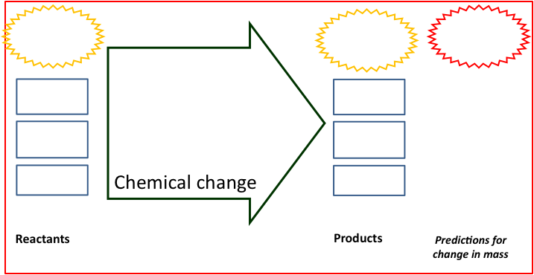

One more prediction: When you grow your plants, you will measure the mass of plants and the mass of soil. Alex and Blake think soil adds the most mass. Carmen thinks air adds the most mass. Write down what you would expect to happen in the investigation if the students are right (even if you don’t agree with them!)
 | If Alex and Blake are right, you would expect… | If Carmen is right,  you would expect…
The mass of the plants will… | ◻ increase  ◻ be the same  ◻ decrease | ◻ increase  ◻ be the same  ◻ decrease
The mass of the soil will… | ◻ increase  ◻ be the same  ◻ decrease | ◻ increase  ◻ be the same  ◻ decrease

Do you think soil will gain mass, lose mass, or stay the same? Why?

Name:_____________________ Period:____ Date:_________
Part 2: Measurements During the Investigation
In this investigation you will make observations of radish plants growing over several weeks. You will measure their growth by recording mass changes. It is important to make careful measurements of mass change in the plants and also of the material (Vermiculite) that they are growing in. Double-check all your measurements as you complete the investigation.

My Observations:

DAY 7 LIGHT DAY 14 LIGHT
 | Start Mass | End Mass | Mass Change |  |  | Start Mass | End Mass | Mass Change
Vermiculite |  |  |  |  | Vermiculite
Plants |  |  |  |  | Plants

RESULTS FOR LIGHT:
Describe the mass change you observed for your plants in the light.

DAY 7 DARK DAY 14 DARK
 | Start Mass | End Mass | Mass Change |  |  | Start Mass | End Mass | Mass Change
Vermiculite |  |  |  |  | Vermiculite
Plants |  |  |  |  | Plants

RESULTS FOR DARK:
Describe the mass change you observed for your plants in the dark.

Our Class Results
DAY 7 LIGHT
Groups | 1 | 2 | 3 | 4 | 5 | 6 | 7 | 8 | Avg
Plant Mass Change
Soil Mass Change

DAY 14 LIGHT
Groups | 1 | 2 | 3 | 4 | 5 | 6 | 7 | 8 | Avg
Plant Mass Change
Soil Mass Change

DAY 7 DARK
Groups | 1 | 2 | 3 | 4 | 5 | 6 | 7 | 8 | Avg
Plant Mass Change
Soil Mass Change

DAY 14 DARK
Groups | 1 | 2 | 3 | 4 | 5 | 6 | 7 | 8 | Avg
Plant Mass Change
Soil Mass Change

Part 3: Explaining Your Results
Claims—your revised explanation: How are reactants changing into products when plants grow?

Using the Process Tool: Show your new ideas about how reactants changed into products on the process tool diagram below.
Evidence—the measurements that support your explanation: What are the key observations and measurements that support your explanation?

Reasoning—connecting claims to evidence and scientific principles
Connecting explanations and evidence: How does the evidence support your explanation?

Connecting evidence and principles. Does your explanation follow the principles that apply to chemical changes?
Yes No Not sure Conservation of matter: Materials (solids, liquids, or gases change into other materials, but matter is not created or destroyed.
Yes No Not sure Conservation of mass: The masses of reactants and products are equal.
Yes No Not sure Conservation of energy: Energy is not created or destroyed.
Yes No Not sure Conservation of atoms: Atoms are not created or destroyed.

Core Lesson 2: A Big Job For Little Seeds

Time/Duration: 55 minutes
Activity 1: Packed With Chemical Energy ~20 to 35 minutes
Activity 2: Zooming Into Plants ~20 minutes

Guiding Question: Why can seeds sprout in the dark?

Model Responses:
Alex | Blake | Carmen
Seeds need to be planted in soil and given water, but seeds are made to grow in the dark. They have nutrients to give them energy to grow. | Seeds get nutrients from the soil and from inside them to help them start to grow. This gives them energy for photosynthesis. | Seeds have starch that has C-C and C-H bonds. The chemical energy in starch helps seeds sprout through a process called cellular respiration.

Carmen explains that seeds sprout through cellular respiration, not photosynthesis—a key understanding at Level 4. Carmen knows that chemical energy is needed for early plant growth. Most of your students will not be aware of cellular respiration in plants or seeds. Level 2 and Level 3 responses might explain that “nutrients” in soil or nutrients inside the seed provide energy for sprouting. Notice that one of the key differences between Blake/Alex and Carmen is that Carmen explains sprouting using chemical energy (C-C and C-H bonds) while Blake and Alex only refer to “nutrients.” This difference becomes particularly important when students must explain mass loss by plants.

Learning Objectives:
Many of your students will not be familiar with the materials that make up plants and seeds. Some students will be familiar with glucose, or more generally with “nutrients,” but the chemical make up of plants and seeds remain something of a mystery.

Objectives for students at Level 2 | Objectives for students at Level 3

Rationale & Background:
Students may never stop to think what makes up a seed. Seeds are packed with energy-rich materials, like carbohydrates, proteins, and fats. The chemical energy found in these materials is critical to the start of a plant’s life. Much of the material found in seeds is starch. Starch is formed in plants by combining sugar molecules. This process is called dehydration synthesis, which is one of many biosynthesis processes that organisms undergo. Plants produce polysaccharides because in order to store and move materials efficiently and quickly. Starch is a carbon-based molecule that contains carbon-carbon (C-C) and carbon-hydrogen (C-H) bonds, which means it is a good source of chemical energy. Most students likely have never thought about what a seed is made of and what it does underground to “grow” when it does not have leaves and cannot use sunlight. This lesson will build on concepts already introduced—organic matter, biomass, and chemical energy—and introduce students to the starch found in seeds that is necessary for sprouting.

Lesson Description:
In this lesson, students look at nutrition labels for different plant seeds, comparing those labels with what they have already learned as part of Systems and Scale and other units. Students find that seeds are made mostly of carbohydrates and some proteins and fats—all carbon-based materials rich with chemical energy (C-C and C-H) bonds. Using a PowerPoint and molecular models, students zoom into a plant and a seed and talk about how plant parts are made of organic materials with chemical energy. The lesson concludes with a discussion about why the chemical energy in seeds is critical for early plant growth when sunlight is not available. This lesson also sets students up to trace carbon in the next two lessons.

Lesson Materials (materials may vary depending on how you complete the indicator lab):
General
- Zooming Into a Plant PowerPoint
- Computer ready to project
- Demonstration Molecular Models (e.g., glucose, amino acid, fatty acid, etc).
Per Student
- Worksheet A Big Job For Little Seeds

Advance Prep:
- Have computer connected to a projector in order to display PowerPoint.

Activity 1: Packed With Chemical Energy

Time: 20 to 35 minutes

Rationale & Description:
We see nutrition labels all around us—at home, at the store—and we read the words “protein,” “fat” and ”carbohydrate,” but we rarely take time to decipher the meaning of these words beyond our everyday use of them in diet and nutrition. These are the same words that scientists use to describe organic materials that make up the majority of our foods, as well as living organisms. Interestingly most of these materials can ultimately be traced back to plants—the main living organisms on Earth that are able to make organic materials from inorganic substances. Nutrition labels can be used to identify materials found in plants, and to determine whether these materials are organic with chemical energy, or inorganic.

Directions:
- Ask students if they know what materials we find in seeds. Do they eat sunflower seeds or pumpkin seeds? Nuts? Beans, peas, or corn? All of these are plant seeds. Have they ever thought about what it is in seeds that help the plant grow?
- Pass out the worksheet A Big Job For Little Seeds to each student. Have students examine the nutrition labels for different plant seeds—corn, lima beans, and peas. Students should note that plants contain carbohydrates, proteins, and fats. These seeds are particularly high in carbohydrates. The total carbohydrate count includes fiber and sugar. The difference between the carbohydrate number—after subtracting fiber and sugar—is often a form of starch. Below is the chemical make-up for the three types of seeds on the student worksheet.

 | Corn | Lima Bean | Pea
Fat | 1g | 0g | 1g
Carbohydrates | 17g | 16g | 18g
Fiber | 2g | 4g | 6g
Sugar | 0g | 1g | 7g
Protein | 2g | 5g | 7g

- Have students note the most abundant material in seeds, but also note that seeds do contain traces of protein and fats. Some seeds, like sunflower seeds and peanuts, contain a lot more protein and fat compared to other seeds. You may want to talk about these seeds being higher in fats/oils, but that fats are also carbon-based materials.
- If you have molecular models available you might want to display models of glucose (Level 2, Middle School and Level 3, High School) and amino acids and fatty acids (Level 3, High School). Observing molecular models might help students visualize and understand the atoms and bonds that make up these three key polymers found in plant materials. If you choose to show glucose, amino acids, and fatty acids to students, you will need to take a moment to explain or review polymers (carbohydrates, proteins, lipids) and monomers, which are the basic building blocks in the polymers. If you have already covered this in the Animal unit, you will want to make connections and review these concepts with students. If this is the first time students are learning about polymers and monomers, you may consider spending more time reviewing the new vocabulary and concepts with students.

Activity 2: Zooming Into A Plant

Time: 20 minutes

Rationale & Description:
Students will now zoom into different parts of a plant and seed, using Powers of Ten, and discuss what makes plant materials energy-rich. Students will revisit concepts already introduced, such as organic materials and chemical energy. This PowerPoint will help students make connections between macroscopic observations of plants and seeds and the atomic-molecular materials that make up the plant, using mostly the subsystem strategy.

Directions:
- Using a PowerPoint, you will zoom into different parts of a plant to show students what types of materials are found in different locations. Start with a large-scale image of a crop field, and then step down through the powers of ten to show close-ups of leaves, stomata, plant cells, chloroplast, and glucose/starch molecules. Point out the difference in scale between atomic-molecular, cellular, and macro scale, reminding students of what they learned about Powers of Ten. Tell students that to understand what plants are made of and how seeds sprout without light, we need to look at a smaller scale than what we see with our eyes.
- Continue through the PowerPoint to point out the atoms and bonds found in carbohydrate molecules, as well as proteins and fats. Shows students that different parts of plants may contain different materials, but all the materials are organic with chemical energy because of the C-C and C-H bonds.
- Using the molecular models, show students a glucose molecule. Point out the C, H, and O atoms. Explain to students that carbohydrates contain these types of atoms. Plants make these materials using the stuff they take inside them. Ask students, “Can carbon atoms come from water? The soil? Or air?” Elicit students’ initial ideas to this question now, which will be revisited later.
Name:_____________________ Period:____ Date:_________
A Big Job For Little Seeds
A tiny seed can grow into a large plant or even a very large tree. Have you ever thought about what is in the seed that starts the plant growing? And why can seeds grow underground without sunlight? There must be something more to those little seeds! Corn, beans, and peas are all seeds that we eat. We also eat sunflower seeds and many fruits, nuts, and vegetables that are seeds. Look at the nutrition labels below. What materials do you find in seeds?
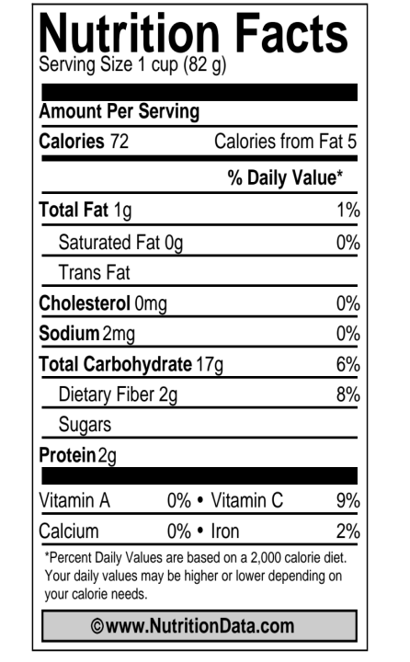
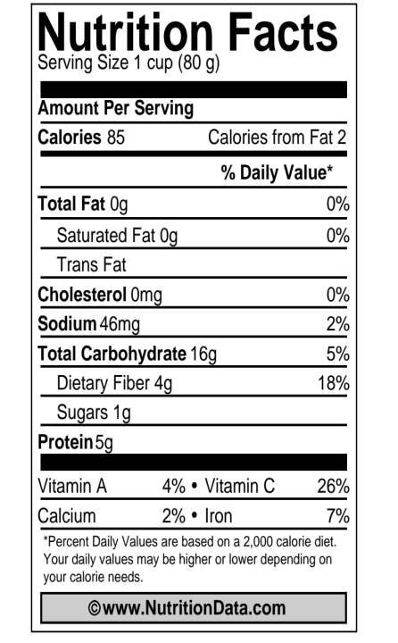
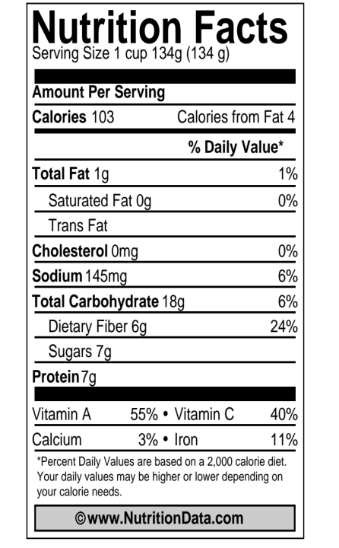
CORN
Lima Bean
Peas
- What is the most abundant material found in these three types of seeds? How do you think this material is made?

- Seeds contain a carbohydrate called starch. Starch is made of carbon, hydrogen, and oxygen atoms and is a good source of chemical energy. Why do you think that little seeds need this energy-rich material? How do they use it?

- Do you think the carbon atoms in carbohydrates come from water, soil, air, or some combination of these places? What evidence do you have for your answer?

Core Lesson 3: A Dirty Job

Time/Duration: 45 minutes
Activity 1: A Dirty Job/Famous Studies of Plants ~30 minutes
Activity 2: What Does It Give To Plants? ~15 minutes

Guiding Question: Where does most plant biomass come from?

Model Responses:
Alex | Blake | Carmen
The plant makes most of its mass itself. It needs soil, water, and sunlight to make the mass. | The plant makes the mass through photosynthesis. Most mass comes from water, but also soil. Air might add a little mass. | Most plant mass comes from carbon dioxide in the air that is changed to organic materials during photosynthesis.

Carmen identifies carbon dioxide gas as the key source of most plant mass (Level 4), while Blake (Level 3) and Alex (Level 2) identify soil and water as contributing most of the mass. Carmen’s explanation treats gases as a form of matter that adds substantial mass to plants over time. While Blake knows that plants change materials in order to build mass, Blake is still reluctant to attribute mass gain to gases. Blake will be looking for more evidence to support mass gain by soil or water because this would support what Blake already believes. Discussion of van Helmont and Woodward data will be particularly important for Blake because these studies show that plants may need water and soil minerals, and may gain some mass from these sources. However, neither soil nor water account for large changes in plant mass. For students with ideas similar to those of Alex, there are additional considerations for instruction. Alex knows that materials move in and out of systems, but has not learned about chemical change in living systems. Alex will need to make connections between the molecules that make up plants and the molecules (especially atoms) that make up materials going in and out of plants. Alex may find it useful to discuss what goes in and out of plants in each of the studies, and name the materials at the atomic-molecular scale. For both Alex and Blake examining what plants get from their “inputs” will be helpful, using the materials strategy.

Learning Objectives:
Something about materials strategy here???

Objectives for students at Level 2 | Objectives for students at Level 3

Rational & Background:
Given the range of experiences young children may have with plants, it is interesting that most develop the same story about plant growth—that small seeds are planted in soil and, given water, grow into mature plants over the course of weeks and months. Sunlight is also necessary for plants to grow. It is no wonder that most students believe most plant mass comes from soil and water since these are the visible inputs they see given to plants. Students are not completely wrong about soil and water. Much of a plant’s total mass is actually water. This water contributes to short-term mass gain, but most water does not contribute to long-term building of plant biomass. The biomass is carbon-based substances. This carbon does not come from soil or water, but rather from carbon dioxide taken in from the air. Scientists have traced specific carbon atoms (Carbon-14) from glucose back to CO₂. Scientists have also shown that most oxygen in glucose comes originally from CO₂. The O₂ plants give off comes mostly from water. Water does contribute some to biomass, through hydrogen atoms, but most of the atoms from water eventually leave the plant. Some minerals—like nitrogen—do add trace amounts of mass when incorporated into proteins inside the plant.

Lesson Description:
The lesson begins with a review of the evidence collected through the Plant Growth Investigation and why they measured both plant material and soil. Students are then divided into groups and given information about famous studies of plants in history. Students use the worksheet, A Dirty Job, to guide them through the different plant studies. The studies that students will read about include:
- Jan Baptiste van Helmont (1640’s)—van Helmont’s studies show that plants gain a lot of mass while soil loses very little mass over time. Van Helmont concluded that water contributes all mass/nutrition to plant.
- John Woodward (1690’s)—Woodward tested van Helmont’s work through a series of studies on plants grown in water (some with additional soil minerals added) and found that plants grow healthier with minerals added. Woodward also found that plants gave off most of the water they take in through transpiration. Woodward concluded that plants get most of their mass/nutrition from soil minerals.
- Joseph Priestley (1770’s)—Priestley did several studies to show that plants change the air around them, finding that over time plants “replenish air” (or produce oxygen).
- Jean Senebier (1790’s)—Senebier did several studies to show that plants take in carbon dioxide and give off oxygen. He placed plants in air with excess carbon dioxide and over several days in sunlight, CO₂ levels went down, but O₂ levels went up. Senebier concluded that plants “fix” carbon from CO₂ and give off the excess O₂.
Students work in groups to read and discuss the different plant studies, which are then discussed aloud as a whole group (and compared back to their own plant investigations). The conclusions from this activity include that plants get a little something from soil minerals, a little something from water, and a little something from air. The lesson shifts to looking closer at the atoms and molecules that make up plants, soil, water, and air through nutrition and ingredient labels. The lesson concludes with students responding to an embedded formative assessment question, “if not from soil or water, where do plants get mass?”

Lesson Materials:
General
- Computer, overhead projector to display information to students
- Overheads of Nutrients for Plants and What Does it Give To Plants
- Our Class Results (from previous lesson)
Per Partner
- Handout Famous Studies of Plants (in color, to be returned and reused)
- Handout Nutrients For Plants (in color, to be returned and reused)
Per Student
- Worksheet A Dirty Job and What Does It Give To Plants

Advance Prep:
- Assemble overheads and have computer ready to project

Activity 1: A Dirty Job/ Famous Studies of Plants

Time: 30 minutes

Rationale & Description:
It is not always possible to conduct firsthand investigations and experiments in class to demonstrate complex scientific principles. But students can examine evidence collected by scientists and see if this evidence supports or contradicts their ideas. In this activity, students see how studies of plant growth evolved over time, beginning with van Helmont’s studies in the 1640’s through Senebier’s work in the late 18th century. While none of these scientists were completely correct in their ideas about plant growth, their findings advanced the field of plant physiology. Each study provides additional evidence for students to consider against their developing models for plant growth. Students also look at materials that provide “nutrients” to plants and examine what atoms plants can get from each of these inputs.

Directions:
- Using Our Class Results review with students what they found through their Plant Growth Investigation. In particular, point out that the vermiculite did not lose a lot of mass across the investigation even though their plants grown in light gained mass. Tell students that over time many scientists have wondered about where plants get their mass. Tell students that today they will look at experiments scientists have conducted on plant growth and mass gain.
- Show students the handout Famous Studies of Plants and the worksheet A Dirty Job. Explain to students that they will work in partners or small groups to read about each experiment and discuss what the scientist found, and then answer questions on their worksheet. You may consider doing this activity as a whole class to discuss the findings in each experiment together. Pass out 1 handout to each partner and a worksheet to each student and give students 12-15 minutes to read and discuss the questions.
- Next discuss each experiment as a whole group. Concentrate on Study # 1 in comparison to Study #2 and how van Helmont’s data and Woodward’s data relate back to students’ Plant Growth Investigations data. Point out that both scientists found that plants get something—but only a little something—from soil and water. Ask students if they agree with this. Some students may still believe that plants get most of their mass from soil and water, so this is an opportunity to gauge whether the evidence they’ve collected in their own investigation and the experiments they just read about are convincing to them or not.
- Review Study #3 (Priestley) and Study #4 (Senebier) and discuss the question on students’ worksheet—Can plants get mass from the air? Remind students that in the previous lesson they learned that plants are made of carbon-based organic matter. Ask students if they think it is possible that the carbon in plants comes from the air?
- Engage students in working on the last page of the A Dirty Job handout to engage in claims, evidence and reasoning (argumentation) about the chemical changes that take place when plants grow. A class discussion about the claims, evidence and reasoning will help all students consider these important ideas.

Activity 2: What Does It Give To Plants?

Time: 15 minutes

Rationale & Description:
Students have determined that most scientific evidence shows that plants get some of their mass from soil minerals and water, but only a very little. Now they will look closer at the atoms and molecules found in plants, and the atoms and molecules that make up soil, air, and water. Students will examine what each material supplies to the plant.

Directions:
- You have the option to complete What Does It Give To Plants as a whole group using an overhead transparency table, or allow students to complete using the worksheet provided. The student worksheet is optional if you prefer to complete this as a whole group.
- Pass out the Nutrients For Plants page to partners and display a copy of this page for the whole class using a projector. This page must be seen in color.
- First point out the plant nutrition information. Here students will see a starch molecule. Remind students that this molecule is what they previously learned about when studying nutrition labels for plants/seeds. They learned that plants/seeds are made mostly of carbohydrates, some proteins and fats. Point out that the starch molecule is made of carbon, hydrogen, and oxygen atoms. Some plant proteins have nitrogen or other trace minerals. Tell students that they will now examine whether water, soil minerals, or air can provide carbon, hydrogen, or oxygen atoms to plants.
- Using either the overhead transparency What Does It Give To Plants or the student worksheet What Does It Give To Plants, ask students to examine each of the materials—water, soil minerals, and air—to find out if these things contribute matter to plants.
  - Water- can potentially contribute oxygen or hydrogen (in reality water mainly contributes hydrogen atoms).
  - Soil Minerals-can potentially contribute phosphorus, calcium, magnesium, etc. (note that students may also say oxygen although oxygen in soil is tied up in phosphates and other compounds).
  - Air—can potentially contribute carbon, oxygen, or hydrogen (in reality plants get their carbon and oxygen atoms from air, but their hydrogen from water).
Since the focus of this activity is on tracing carbon, it is not necessary to get specific about whether certain atoms, like hydrogen or oxygen, come from air or soil minerals or water. The point is that carbon can only come from one place—the air. However, you might want to discuss with students that scientists have the ability to trace atoms, and have found that most of the carbon and oxygen come from carbon dioxide, while hydrogen comes from water. At this point you have a choice about the amount of detail you would like students to learn during this activity.
- Conclude the activity with an embedded formative assessment. Ask your students to respond to the following question, “If not from water or soil, where might plants be getting their mass?” Allow students about 3-5 minutes to discuss this question in small groups. Remind students that they must consider the evidence they have observed and make sure the evidence supports their conclusions.
- Ask each group to share aloud ideas for what supplies the plant with matter. Record the students’ ideas in a public space, making note of students’ ideas that seem to be most popular, as well as those that students disagree about.

EMBEDDED FORMATIVE ASSESSMENT

Question: If not soil or water, where does most plant mass come from?

Name: _____________________ Period: ____ Date: ________
A Dirty Job
Most people would say that plants need water and soil to grow, but they may not know what plants get from these things. Today you will look at several studies on plant growth that happened over the last four centuries. Each study has data you can use to decide what plants get from soil, water, and air. Discuss each study with your classmates, then complete the questions below.
Reviewing the results of scientists who investigated plant growth
- After reading van Helmont’s study, calculate the change in weight of the willow tree and soil.

WEIGHT CHANGE OF TREE | WEIGHT CHANGE OF SOIL
___________ pounds | _________ pounds

2. Although van Helmont was able to show that plants didn’t simply take mass from the soil, he believed that the plant’s material was somehow composed of water, the only thing he added to the bucket other than soil. What do you think about this idea? Can plant mass come mostly from water?

3. How is van Helmont’s finding similar or different from your findings from your own investigation?

4. van Helmont’s study found that plant mass does not come from soil, but comes from water instead. Woodward’s study found that plants need soil minerals, and that most water does not add mass. Where else might plants get their mass if not from water or soil?

5. Priestley and Senebier found that plants change the air around them and Senebier found that plants take in carbon from carbon dioxide (and give off oxygen). Senebier concluded that some plant mass comes from the air. What do you think of this idea?

Explaining the Scientists’ Results
The findings of van Helmont, Woodward, Priestley, and Senebier can be used in an argument from evidence about the chemical changes in materials that take place when plants grow. Try using their evidence as part of an argument.
Claims—your explanation: How are reactants changing into products when plants grow?

Using the Process Tool: Show your new ideas about how reactants change into products on the process tool diagram below.
Evidence: What are the key observations and measurements that support your explanation?

Reasoning—connecting claims to evidence and scientific principles
Connecting explanations and evidence: How does the evidence support your explanation?

Connecting evidence and principles. Does your explanation follow the principles that apply to chemical changes?
Yes No Not sure Conservation of matter: Materials (solids, liquids, or gases change into other materials, but matter is not created or destroyed.
Yes No Not sure Conservation of mass: The masses of reactants and products are equal.
Yes No Not sure Conservation of energy: Energy is not created or destroyed.
Yes No Not sure Conservation of atoms: Atoms are not created or destroyed.
Name:_____________________ Period:____ Date:_________
What Does It Give To Plants?
When you look at a plant, it is obvious it is not made only of water or only of soil minerals. What makes up a plant must be more complex than that, right? Let’s take a closer look at what plants are made of, and whether they get these things from soil, soil minerals, water, or air.
1. You will need to look at the nutrition information for water, soil minerals, and air and then decide if each gives plants the things they need. If so, place an X in the box. If not, leave the box blank.
Plants are made of…. | Can plants get these things from WATER? | Can plants get these things from SOIL? | Can plants get these things from AIR?
CARBON
OXYGEN
HYDROGEN
2. Fill in the table below about the kinds of atoms and molecules in air, plants, and soil.
Material | What kinds of atoms are in this material? | What kinds of molecules or ions are in this material? | Do these molecules have stored chemical energy (in C-C or C-H bonds?
Air

Plants

Soil (include only water and minerals that plants can absorb through their roots)
3. The most abundant materials in plants (except water) are carbohydrates such as starch and cellulose. They are organic materials (they have high-energy C-C and C-H bonds), and they are made of carbon, hydrogen, and oxygen atoms.
a. Where do you think the ATOMS in plant carbohydrates came from?

b. Where do you think the CHEMICAL ENERGY in carbohydrate C-C and C-H bonds came from?

What Does It Give To Plants?

Plants are made of…. | Can plants get these things from WATER? | Can plants get these things from SOIL? | Can plants get these things from AIR?
CARBON
OXYGEN
HYDROGEN

WHERE DO PLANTS GET THEIR CARBON?

Core Lesson 4: Something In The Air

Time/Duration: About 1½ hours
Activity 1: Initial Explanations and Predictions ~25 minutes
Activity 2: There’s Something In The Air—CO₂ Measurements ~30 minutes
Activity 3: Accounting For Results with CER ~30 minutes

Guiding Question: Can air add mass to a plant?

Model Response:
Alex | Blake | Carmen
Plants clean the air and make oxygen, but air cannot add mass to plants. | Plants take in carbon dioxide during photosynthesis, so air may add a little bit of mass. | Plants are mostly carbon-based. They get their carbon from carbon dioxide, so most plant mass comes from the air.

The goal of the unit is to help students see that gases—carbon dioxide in particular—add mass to plant biomass. Carmen’s response (Level 4) demonstrates this level of understanding. Carmen traces the carbon from carbon dioxide to plant material (materials strategy) and attributes mass gain in plants to matter taken in from air (mass-gas strategy). Alex (Level 2) and Blake (Level 3) show more typical ideas students have about how plants use air. Alex focuses on plants’ production of oxygen, which is common for students using the gas-gas cycle to explain how plants change air. The gas-gas cycle says that plants take in CO₂ and turn it into O₂, which is given off for people. Students like Blake may also use the gas-gas cycle to explain how plants use air, but Blake also knows that at least some carbon dioxide is somehow incorporated in the plant during photosynthesis. Blake will need to make the connection between plants taking in CO₂ and plants gaining mass.

Learning Objectives:
Students need to learn that plants not only take in carbon dioxide, but that this carbon dioxide is actually incorporated into the plant as it builds its structure—this is the mass/gases strategy. When plants lose mass, most of their mass is lost to the air as carbon dioxide. A key goal for this lesson is for students to make the connection between mass gain and loss, with plants taking in CO₂ or giving off CO₂.

Objectives for students at Level 2 | Objectives for students at Level 3

Rationale & Background:
Even if students explain that plants take in carbon dioxide during photosynthesis, they likely do not identify the gas as a potential source for mass. In reality, most plant biomass comes from carbon dioxide in the air (absorbed through leaves). Small openings in the leaves called stomata take in carbon dioxide molecules. Through the process of photosynthesis, plants acquire carbon atoms from carbon dioxide that they then use to build organic compounds, like sugars, starches, and more complex polysaccharides. From a young age, students learn that plants “breathe in” carbon dioxide and “breathe out” oxygen. Students may hear that plants “clean” the air for people, and may believe that during this cleaning process carbon dioxide actually becomes oxygen. Interestingly, science shows that most of the oxygen given off by plants comes from oxygen originally found in water molecules as opposed to oxygen found in carbon dioxide. Students’ ideas about carbon dioxide becoming oxygen are early evidence of students tracing matter through the gas-gas cycle. This informal conception may be useful for students first learning about gas exchange around plants, but ultimately it does not help move students forward in their understanding of plant growth and the transformation of carbon between organic and inorganic forms.

Lesson Description:
This lesson is designed to connect students’ prior observations of mass change in plants to gas exchange around plants in light and dark. Students will use the process diagrams to make predictions about how plants change materials around them. They will then make observations of plants in light taking in carbon dioxide, and plants in dark giving off carbon dioxide—either using a demonstration with BTB, a CO₂ probe, or a video of the probe investigation. They will set-up extra radish plants (or spinach leaves) with samples of soda lime to examine mass change in plants and soda lime over a period of 24 hours. The goal of these investigations is to scaffold a discussion about how carbon moves between a plant and the environment, and how CO₂ going in or out of a plant is related to mass changes.

Materials:
General
- Computer ready to project
Per Student:
- Worksheet Something In The Air, Parts 1,2 and 3 (choose which version)

*****Lab Materials will vary depending on investigation chosen. See Activity 2 options for specific materials.

Advance Prep:
- You will need to keep some of your plant samples in light and some in dark for at least 1 to 2 days before conducting the demonstration.
- You will also need to choose which version of this activity to complete with your students. The three versions include (1) Soda Lime and BTB, (2) Plants and BTB, or (3) CO₂ Probe. Read through the three different versions and decide which is best for your classroom.

Activity 1: Initial Explanations and Predictions

Time: 25 minutes

Rationale & Description:
Students express their ideas about what happens when plants gain mass (especially what happens to the air around plants as they gain mass). Students use the Process Tool as a way to express their ideas. They make predictions about what will happen to the air around plants in a closed container, when the container is placed in both light and dark conditions.
Directions:
- Pass out part 1 of the worksheet There’s Something In The Air. Tell students that today they are going to take a closer look at what is really happening to the air around plants when they gain or lose mass.
- Using Our Class Results from the Plant Growth Investigation, review students’ findings again. Plants in light gained mass over time. Plants in dark lost mass over time.
- Using part 1 of the There’s Something In The Air worksheet, have students answer the discuss in small groups, answer the questions, and construct a process diagram to predict how plants in light will change matter and energy, focusing especially on gases. Then have students use the worksheet to construct process diagrams to predict how plants in dark will change matter and energy. Discuss students’ predictions as a whole class. You can project the process diagrams from the worksheet to support the discussion.

Activity 2: Something In The Air: CO₂ Measurement

Time: 30 minutes

Rational & Description:
This activity can take one of many formats, depending on the resources available to you and the amount of time you can spend on these investigations. The purpose of the activity is for students to observe that when plants are placed in light, the CO₂ levels around plants decrease indicating that plants are taking in CO₂. When placed in the dark, the CO₂ levels increase around plants, indicating that plants are giving off CO₂. Several suggested investigations are provided below. Choose at least one of the following to complete as part of this activity.

Option 1: Plants with BTB/Soda Lime

Time: 25-30 minutes

Description:
Soda lime absorbs carbon dioxide and water from the air. When plants undergo cellular respiration they give off CO₂ and water, which the soda lime can absorb, consequently showing a mass increase. In the light, plant cellular respiration rates are exceeded by plant photosynthesis rates, and plants will actually compete with soda lime for CO₂. The investigation below uses both soda lime and BTB to show that plants are changing the amount of CO₂ in the air around them.

Materials:
- Radish plants (grown in light and dark)—make sure the plants do not have a lot of water
- Digital scale
- Soda lime
- Bromothymol blue (BTB) indicator solution
- Petri dishes
- 4 airtight containers (e.g., sealable Ziploc containers)
- Lamp and a dark area to place containers

Directions:
- Mass one set of radish plants and record mass on data table. Place plants inside airtight container. Add 20-30g of soda lime to a petri dish and record the start mass for soda lime. Then add to airtight container. Seal container.
- Mass a second set of radish plants and place in another container. Pour 50-100ml of BTB indicator solution (light, light baby blue) into a petri dish. Note the color and place inside airtight container. Seal the container.
- Repeat steps 1 and 2 with two additional containers.
- Place one soda lime and one BTB container in the dark and one soda lime and one BTB container in the light for at least 24-48 hours.
- Re-mass the plants and soda lime, and note BTB color change after 24-48 hours. Record on data table.

Option 2: Aquatic Plants with BTB

Time: Set-up is 10 minutes, Results in 50-60 minutes

Description:
Using BTB indicator with aquatic plants is another way to show changes in CO₂ around plants in light and dark. This can be easily adapted into small group lab investigations or conducted as a demonstration.

Materials:
- 200-400 ml BTB solution (see recipe in Advance Prep below)
- Two containers that can be sealed (such as screw top jars or stoppered flasks)
- 2-4 fronds of an aquatic plant (type that is submerged; either store-bought or wild-caught)
- Drinking straw
- Light source (natural light or fluorescent light)
- Dark area (such as a cabinet or drawer)

Advance Prep:
- Obtain broad-leaved aquatic plant (Elodea works well if you can get it).
- Mix distilled H₂O and BTB in a flask. Add NaOH 1ml at a time, swirling thoroughly between until solution is true blue. (396ml distilled water + 4ml 0.04% BTB solution + 1-5ml 0.01M NaOH).
- When mixing the BTB solution, two things are very important: use distilled water and the sodium hydroxide. Without those two things, the BTB won’t be very blue to start with, the yellow color will take a LONG time to develop and change back to blue.

Directions:
- Pour BTB to fill two containers (sample data/photos below show 100ml in container).
- With the drinking straw, blow bubbles from your breath into the BTB in each container until the BTB just turns yellow.
- Submerge aquatic plant in the containers, seal.
- Record BTB color.
- Place one container under a light source. Place the other in a dark area. An hour will be required to show color change. Record BTB color after 1 hour or even wait for 24 hours.
- Note that you can also have 2 sets of containers with plants that have not been blown into (as controls) for light and dark. The one in the dark should show color change to yellow, but the one in the light should stay blue if it is under a light source.
- Small group labs are an alternative to the demonstration. This could be completed easily using test tubes and elodea, but you will want to prepare a large batch of BTB for all students to use.

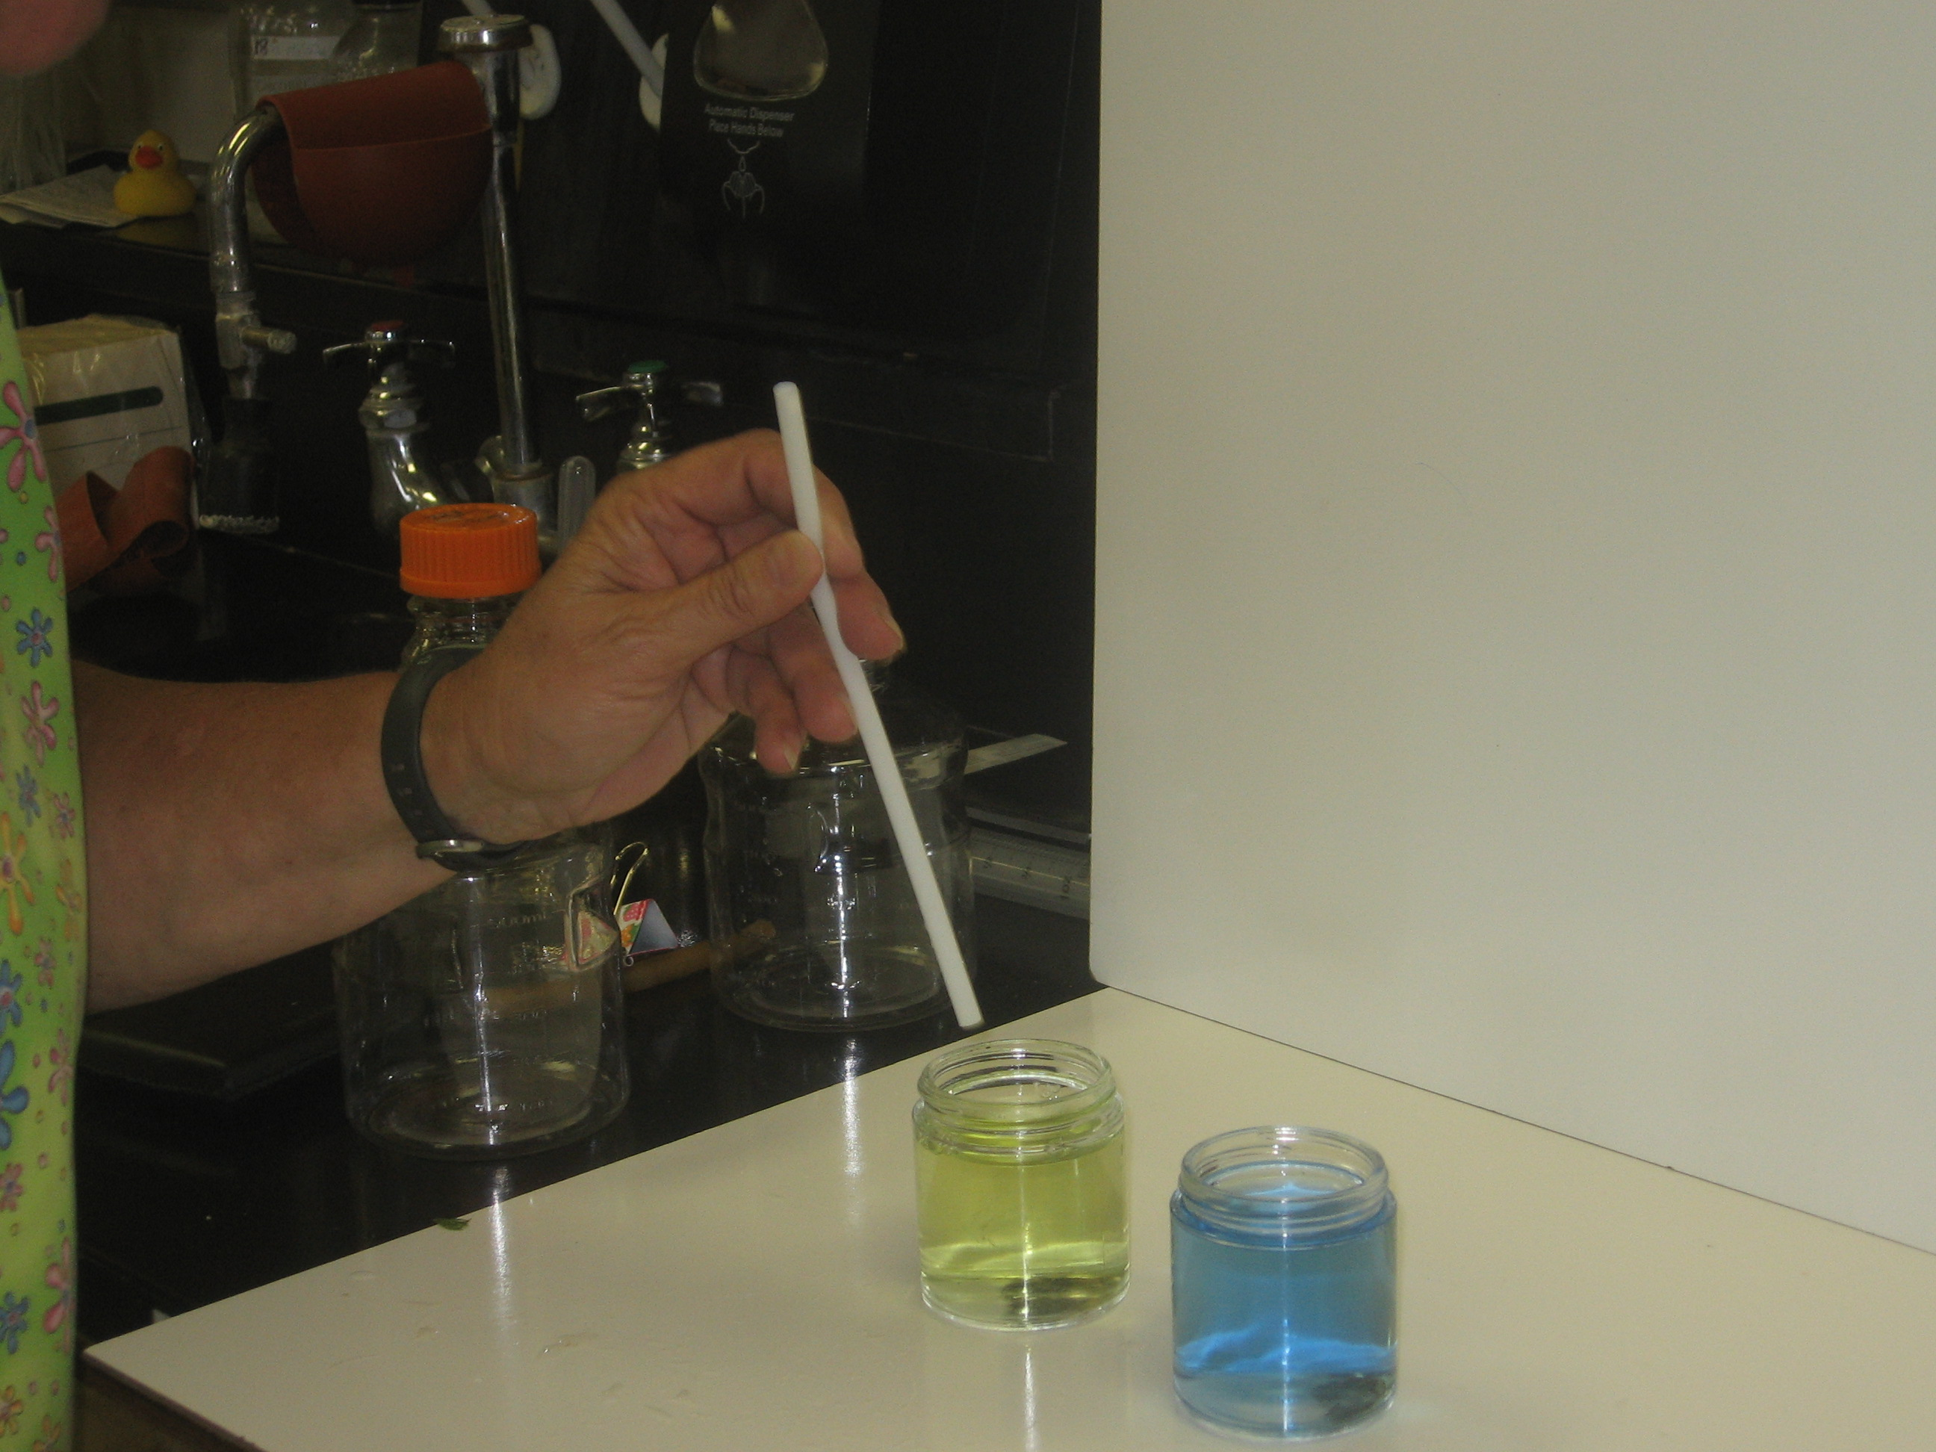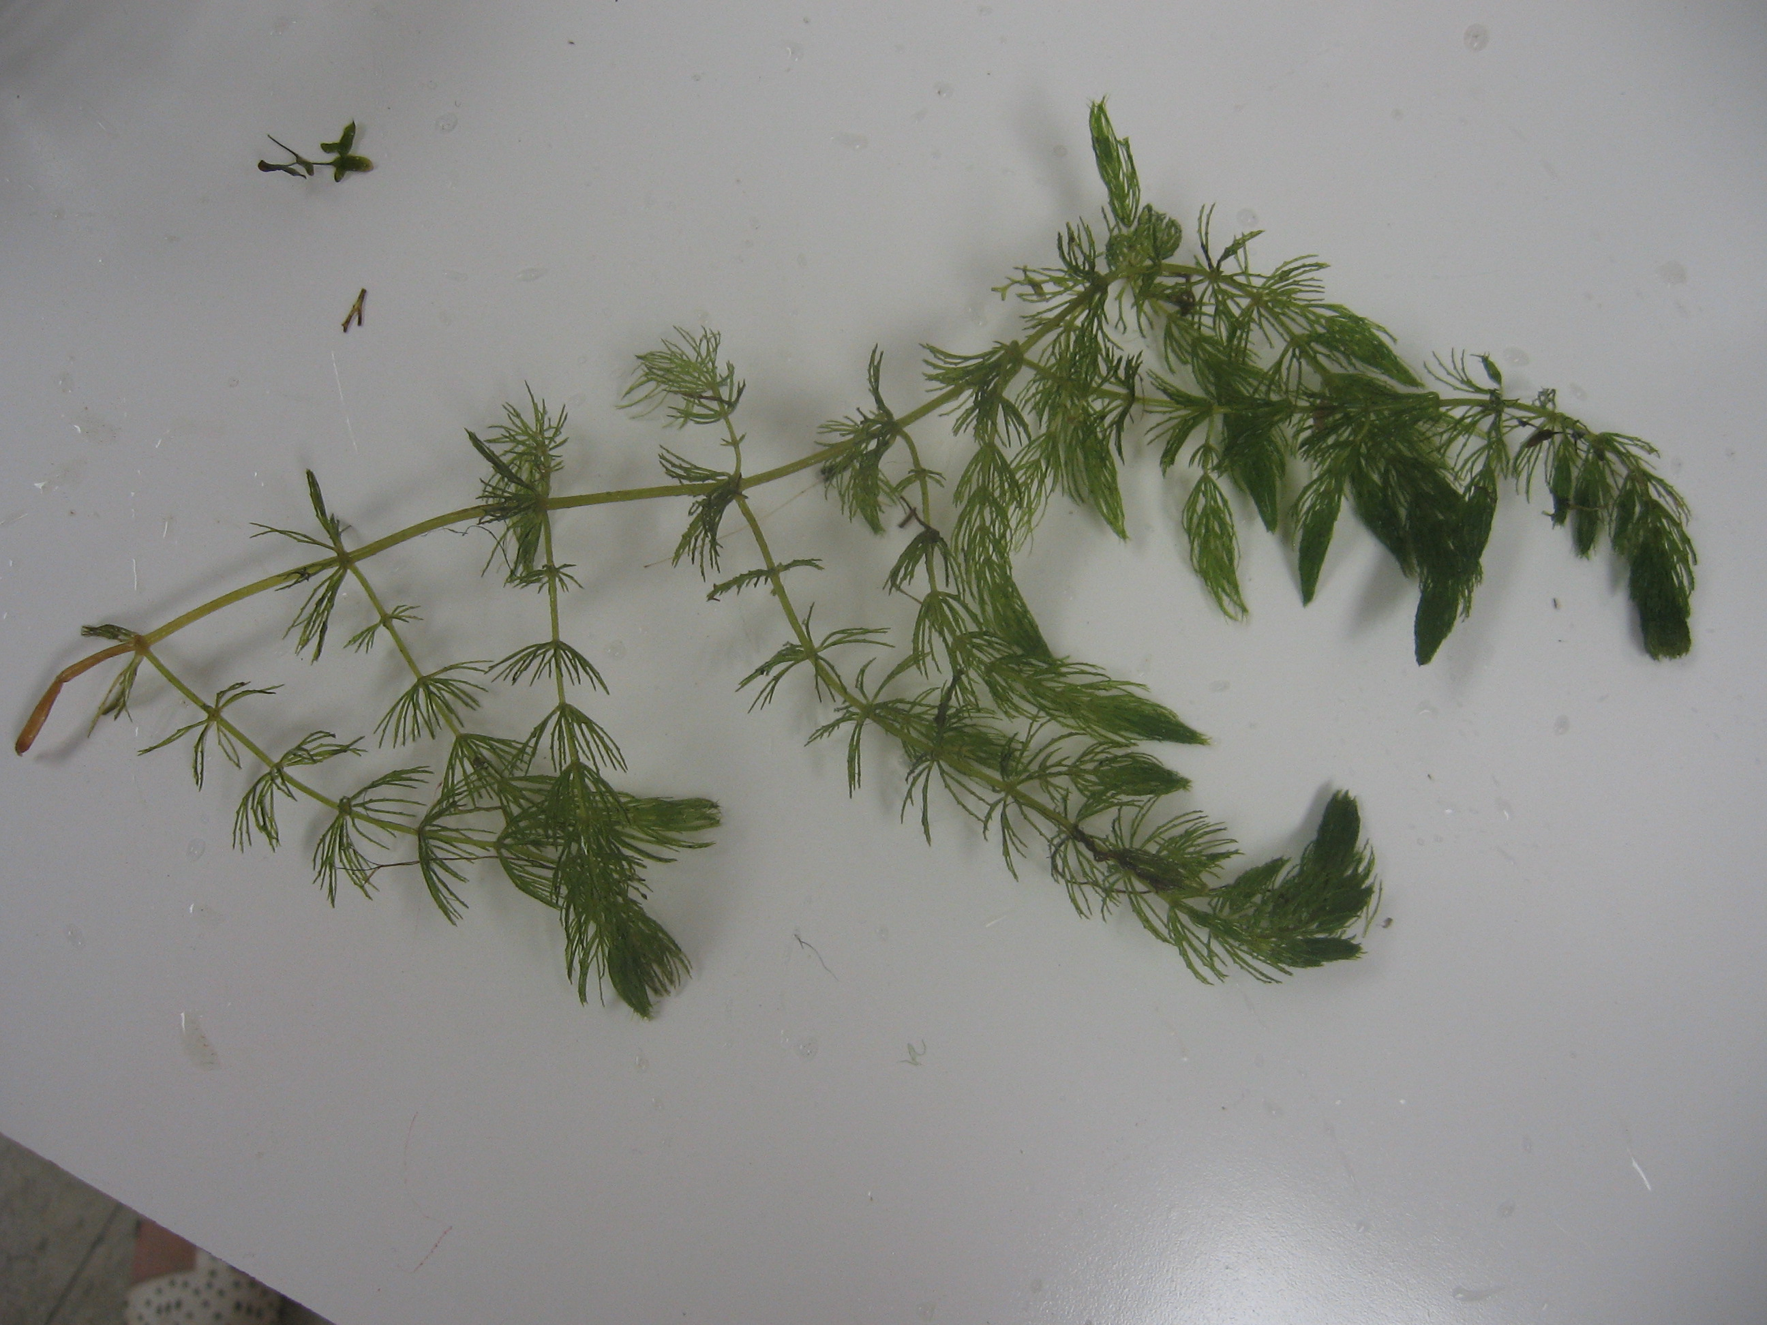
BTB after breath added

“wild-caught” aquatic plant, cut apart to put in containers

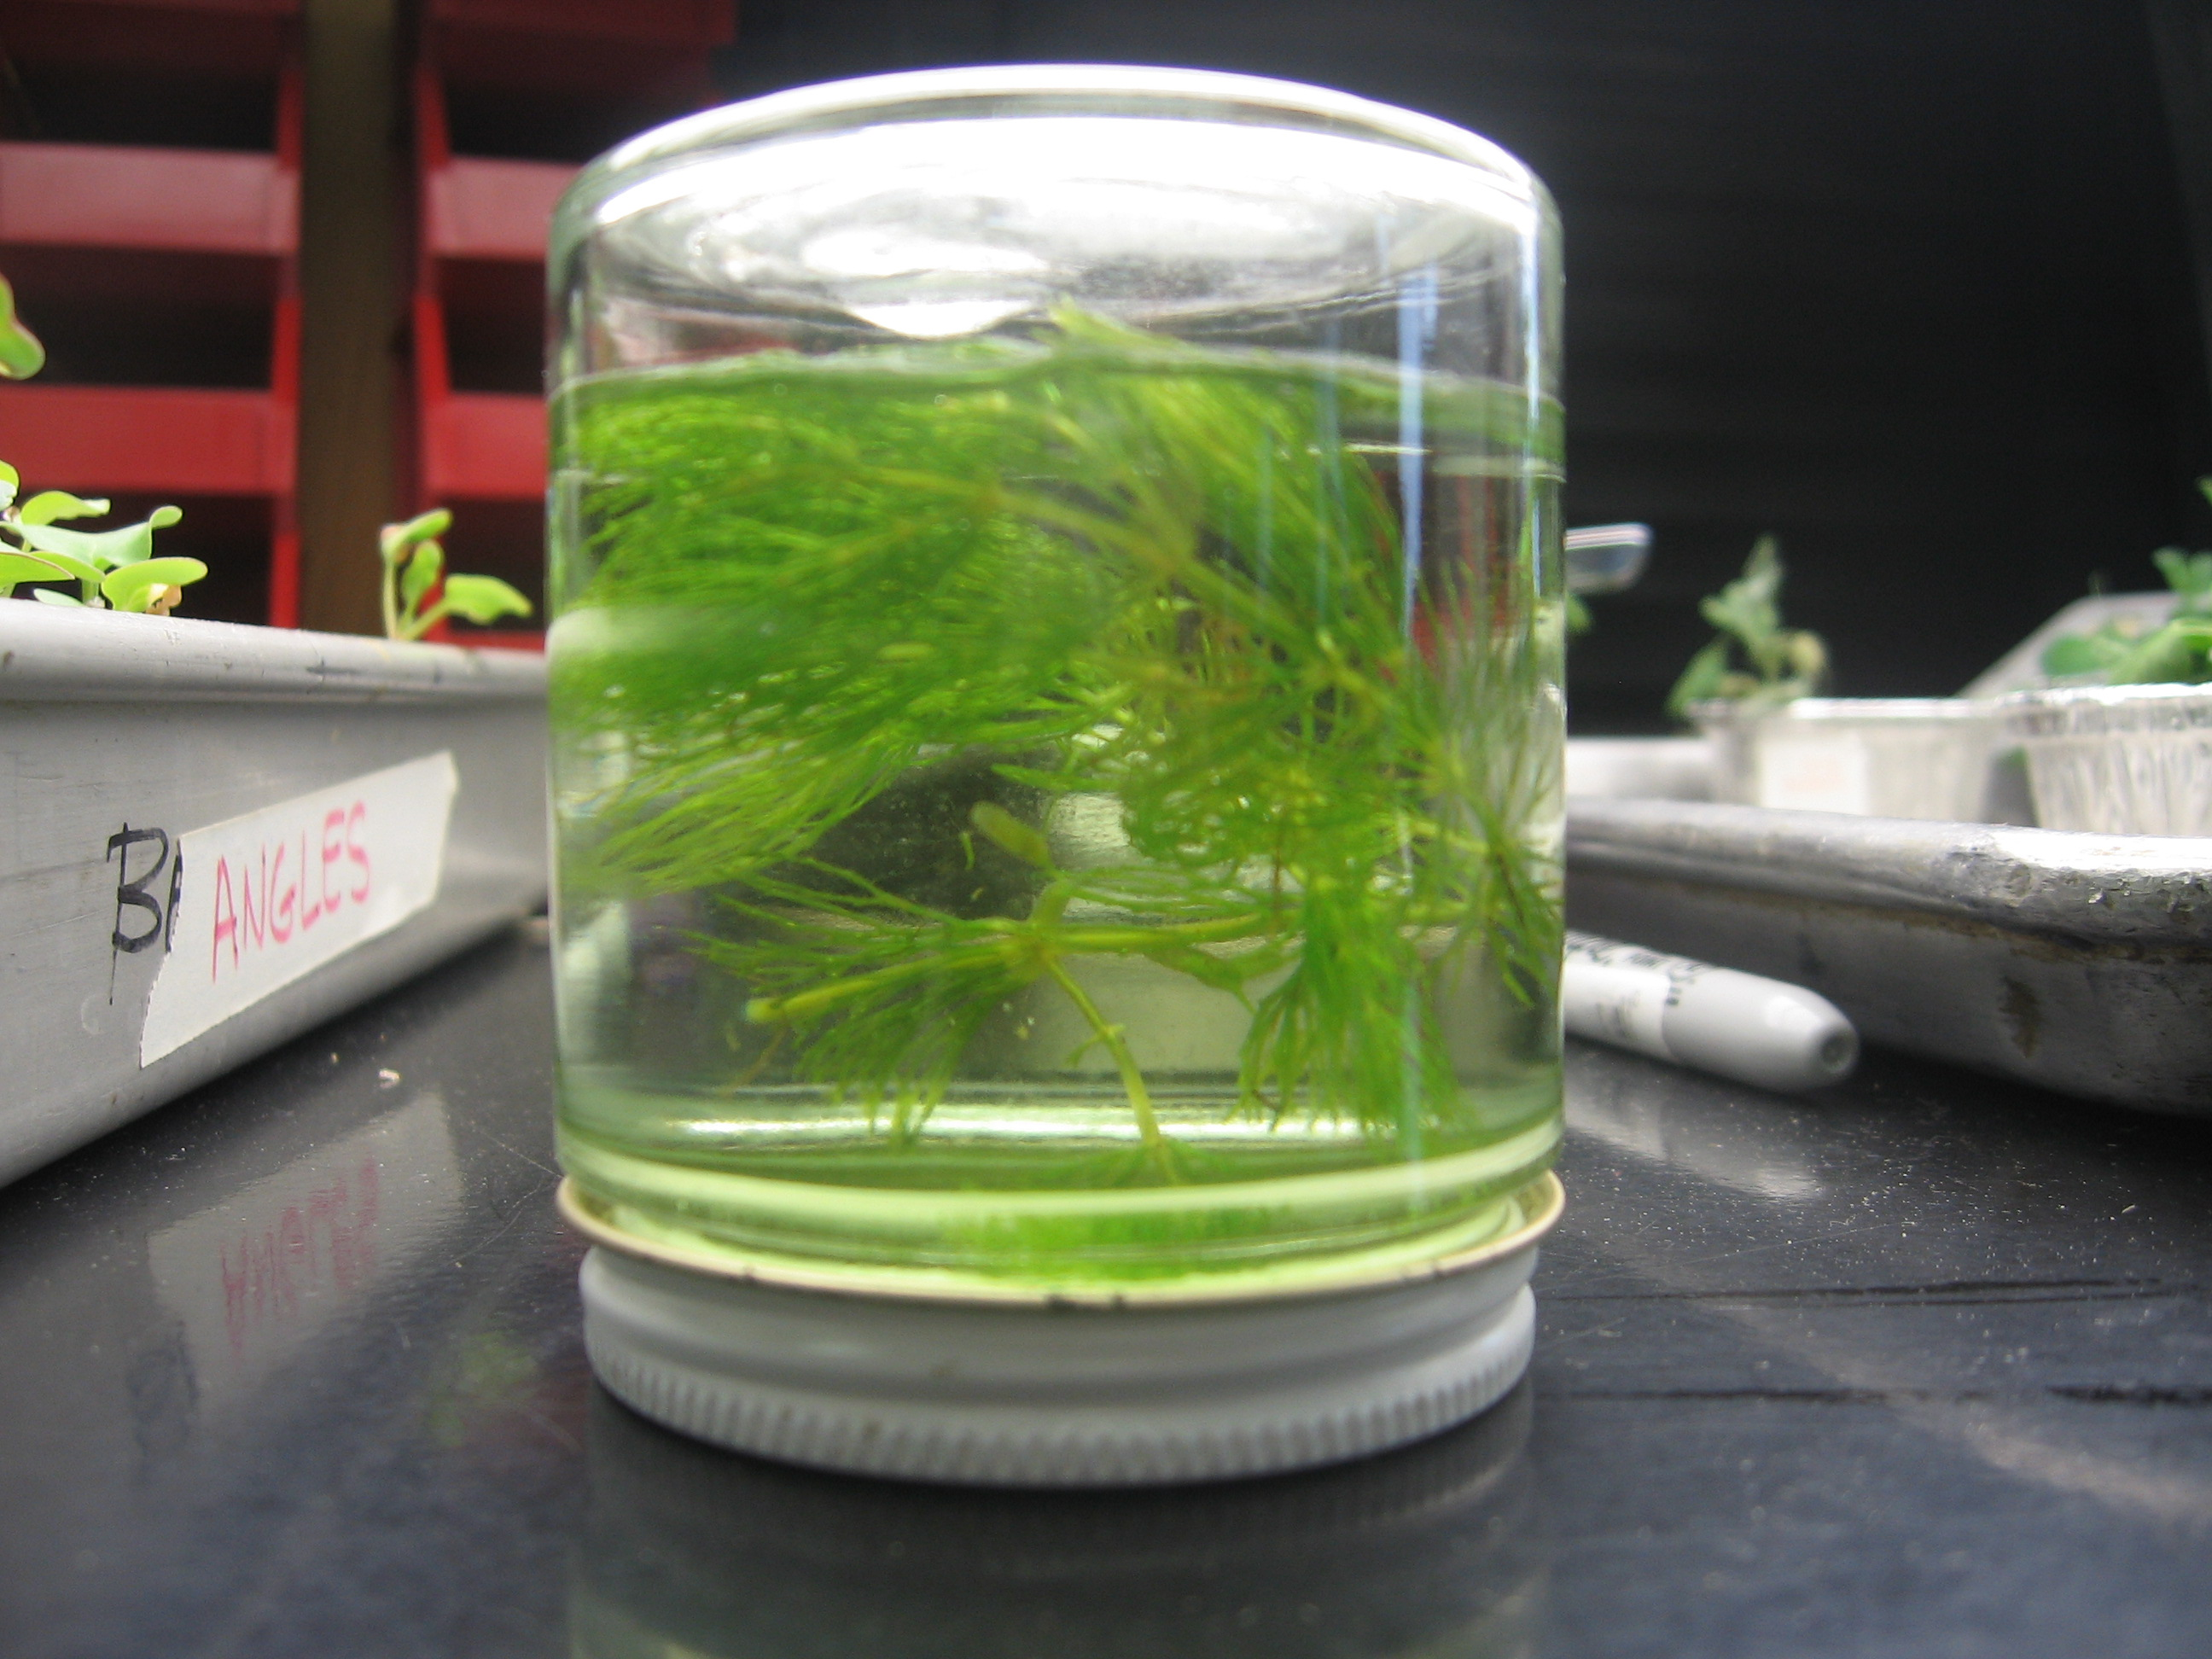
Submerged aquatic plant in light set up

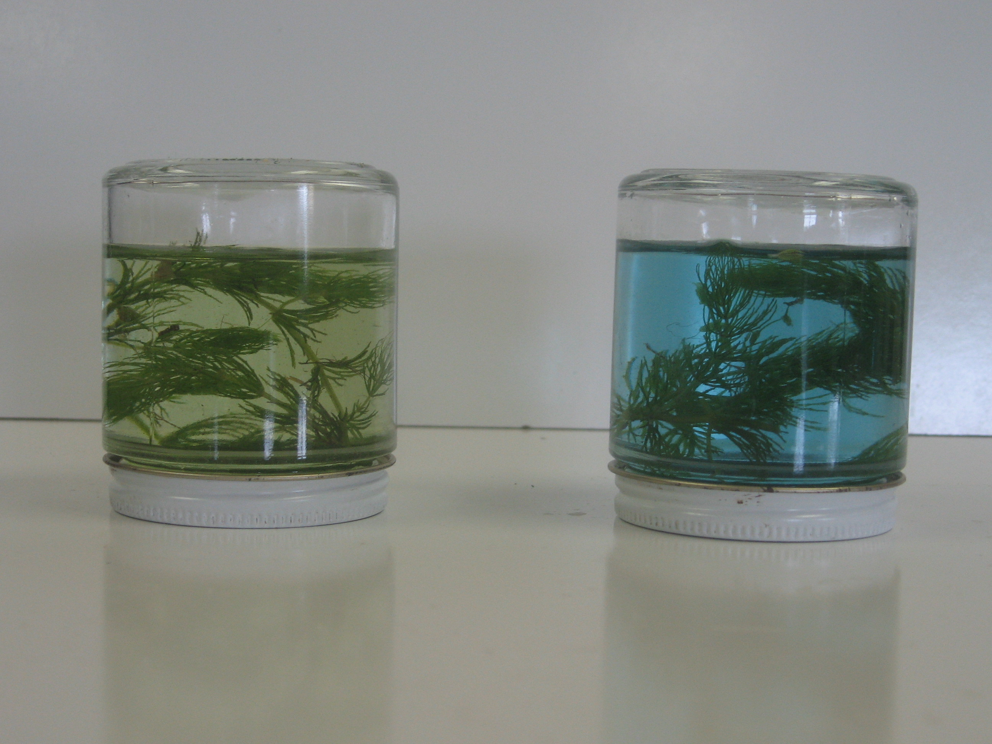
Results after 1 hour.

Left: plant in dark

Right: plant in light

Sample Data
Container contents | Container location | BTB color at beginning | BTB color at end
Plant and BTB | Dark | Yellow | Yellow
Plant and BTB | Light | Yellow | Blue

Option 3: Vernier CO₂ Probe (or video of CO₂ probe)

Time: 30 minutes

Description:
This investigation option uses a CO₂ probe to measure carbon dioxide gas levels around plants in both light and dark. You will need at least 15 minutes to collect data from each of the chambers (light and dark, approximately 5 minutes for set up and 10 minutes for data collection). Note that if this investigation is selected you will want to place your plant samples in light and dark for at least 24 hours prior to the demonstration with the probes.

Materials
- 2 Aluminum cups of radish plants (7 cm tall) kept in light and dark for 24 hours
- Vernier CO₂ probe (O₂ probe optional)
- 2000mL respiration chambers
- Lamp
- Foil or black plastic

Advance Prep:
- Make sure you are familiar with how to use Vernier probes and interface and software (see manuals or go to http://www.vernier.com). The real-time data output can be projected to a screen from a laptop computer. This will probably be the best way to do these activities as demonstrations in front of a class. Set-up, calibrate and test probes, interface, computer and projection system in advance of class. You may also verify that the light source you have chosen will induce photosynthesis in the bean plants with a trial the day or evening before. Also ensure that the plants being tested in the light are in a lighted environment and plants being tested in the dark are in a dark environment throughout the day before using them in observations. Wrap two chambers in foil ahead of time. Other useful tips:
- If O₂ sensor is used, be aware that the O₂ sensor must be upright at all times.
- Use parafilm around the connection of the respiration chamber to make a seal.
- Change units to ppm (parts per million) before collecting data.
- Calibrate sensors as necessary before demonstrations.
  - The CO₂ sensor should read between 350-450 ppm. If the sensor is not reading consistently in this range it will need to be calibrated. Take a paper clip/pin and press the CAL Button on the sensor until the red light flashes 3 times, then release. Repeat until the sensor consistently reads within the 350-450 range.
  - The O₂ sensor should read close to 209,000.00 ppm. To calibrate press the ‘zero’ located on top of the probe. O₂ can be measured in percentage too.

Directions:
- You will first need to explain the investigation to your students and set-up the different conditions. Tell students that they are going to test how plants change the air around them. Remind them of the studies by Priestley and Senebier from the previous lesson.
- Allow students to see the empty chambers and probes. Explain how the probes work and that they measure CO₂ concentration in the air. It’s not necessary to get into the mechanical intricacies of the probes, but if students ask, you can explain that it essentially works by reflecting infrared light out of the air sample and looking for the particular wavelength signature of CO₂. For the really curious, see... http://www.vernier.com/innovate/making-the-invisible-visible/.
- Using the following procedures, set-up the two chambers that will be measured.
- Place plants in chambers. One chamber will contain plant sample recently exposed to light. The second chamber will contain plant sample recently exposed to dark. The more plant material that fits inside the chamber, the better. Results will be quicker and more dramatic. Note that you will need to wrap one chamber in foil prior to set-up.
- Measurements around Plants in Light: Place CO₂ probe into the hole of the chamber with the plant in the light. Place the chamber under the lamp. Wait at least 3 minutes before sealing off chambers and beginning data collection. This allows the probe to adjust to new conditions. Just prior to collecting data make sure to seal the chambers with parafilm tape if there are potential leaks. Read the starting CO₂ level to students and then start data collection for 10 minutes.
- Repeat the same procedures for the plants in the dark. Cover the chamber with foil or black plastic to make the chamber completely dark. Attach the probe, allow a couple minutes for probe to adjust, then seal, and collect data for 10 minutes.
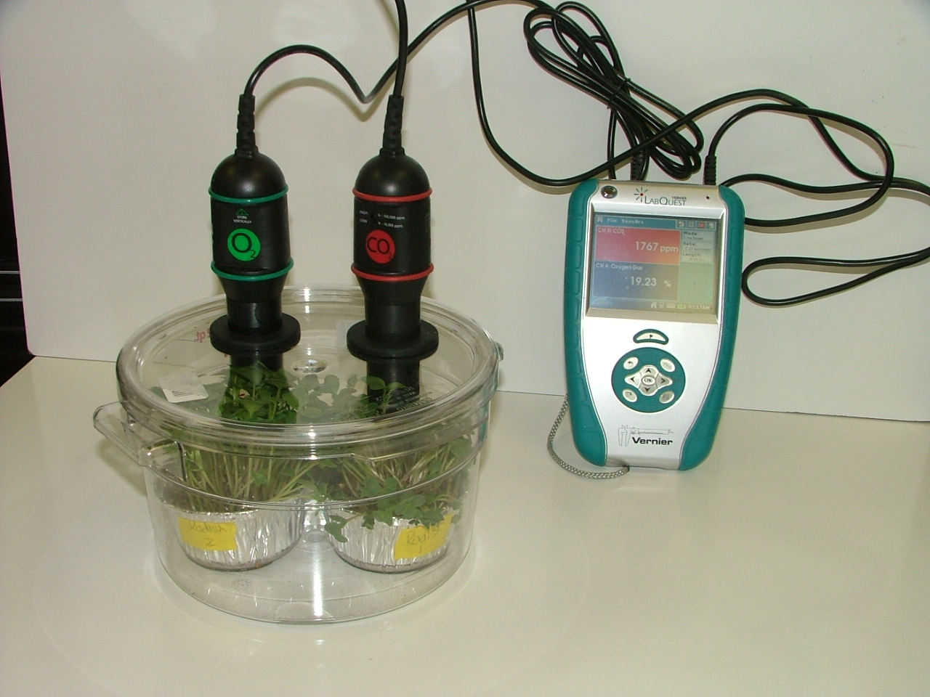
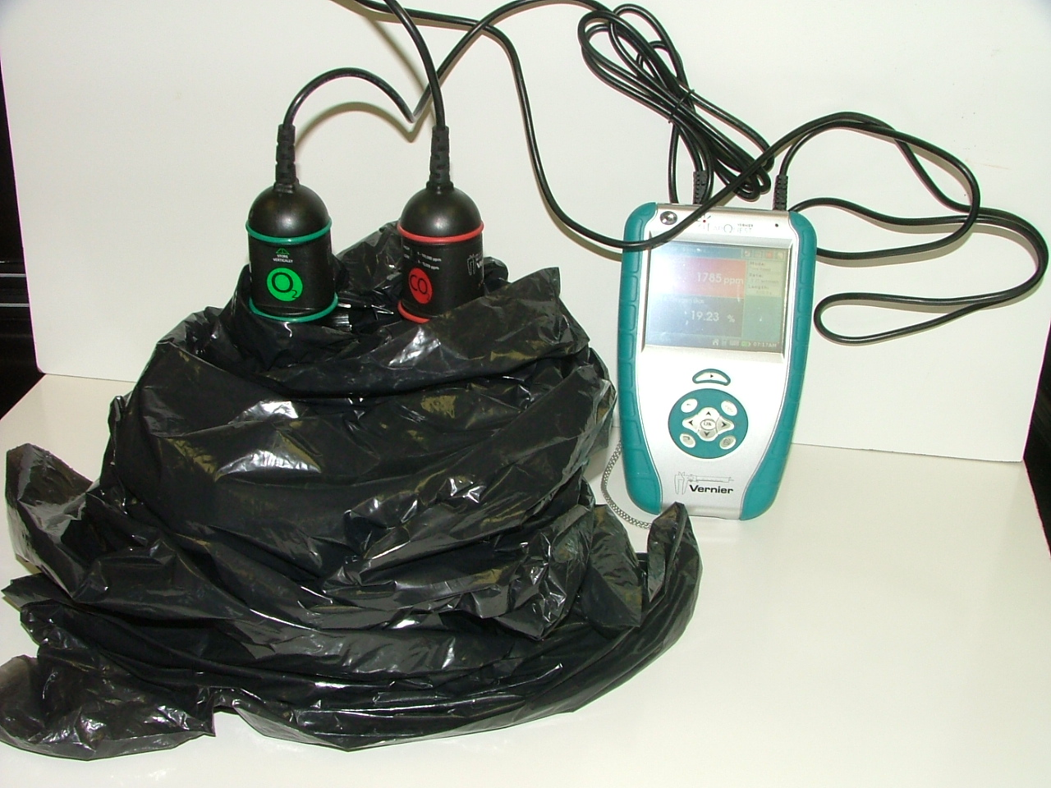

- Read aloud the final CO₂ (and O₂) levels, and have students record the numbers on their data sheet. The chamber in the light will show decreasing CO₂ levels (and increasing O₂ levels). The chamber in the dark will show increasing CO₂ levels (and decreasing O₂ levels).
- Make sure to save the results in a LabQuest file.

Sample Data for Radish Plants:

Radish in Light
 | CO₂ (ppm) | O₂ (%)
5 minutes | 2649 | 19.06
10 minutes | 1862 | 19.19
20 minutes | 1461 | 19.32

Radish in Dark
 | CO₂ (ppm) | O₂ (%)
5 minutes | 1600 | 19.25
10 minutes | 2598 | 19.05
20 minutes | 3607 | 18.89

Video Alternative: If a CO₂ probe is not available, you can use sample data and Vernier CO₂ video to create a vicarious experience for your students. Show students the video of the set-up of the probes, then watch the video. Have students record the data from the video onto the handout and discuss the sample data. Note that the videos use spinach leaves instead of radish plants and you may need to pause the videos at certain points to discuss the set up and the data being collected.

PLANT IN LIGHT Video Link: http://www.youtube.com/watch?v=SIhLLK4m26w
PLANT IN DARK Video Link: http://www.youtube.com/watch?v=2cc5go14bUA

Spinach in Light
 | CO2 (ppm)
0 minutes | 854
10 minutes | 189

Spinach in Dark
 | CO2 (ppm)
0 minutes | 353
10 minutes | 647

Activity 3: Accounting For Results with Claims, Evidence, and Reasoning

Time: About 30 minutes

Rationale & Description:
This activity will support students in synthesizing their ideas about the primary source of plant biomass Students will engage in:
- Constructing an argument from evidence that includes claims, evidence and reasoning
- Using the process tool to represent explanations of plant growth
- Using the principle of conservation of matter to evaluate their explanations.

Directions:
- “Explaining Your Results” is part 3 of the Something in the Air Investigation worksheet. Give the students time to discuss the questions in pairs and write down their ideas.
- Have students share their claims and explanations, using both explanations in words and explanations using the process tool.
- Discuss the question about reasoning. How well do different explanations fit with the evidence? After discussing, ask students to refine what they wrote about how the evidence supports their explanations.
- Discuss the question at the bottom of the page. Ask the students to evaluate how well their explanations fit the principle of conservation of matter by circling one of the three choices and discussing their ideas.
Name: _____________________ Period: ____ Date: ________

There’s Something In the Air: Soda Lime & BTB

In this investigation, we will use BTB indicator and soda lime to study how plants change the air around them. We will test plants under two different conditions: 1) plants in the light, and 2) plants in the dark.

Part 1: Initial Explanation and Predictions
 | Plants in Light | Plants in Dark
The amount  of CO₂ will… | ◻ increase  ◻ be the same  ◻ decrease | ◻ increase  ◻ be the same  ◻ decrease
What will happen to the color? | ◻ stay blue  ◻ turn yellow | ◻ stay blue  ◻ turn yellow
What will happen to soda lime mass? | ◻ increase  ◻ be the same  ◻ decrease | ◻ increase  ◻ be the same  ◻ decrease

We will look for color change in the BTB indicator. BTB is normally blue to light blue. If BTB changes to yellow that means more CO₂ is in the container. We will also look for mass change in soda lime. Soda lime absorbs CO₂ and water.

What do you predict will happen to the amount of CO₂ in each chamber?

Explain your prediction for the plant in the LIGHT.

Explain your prediction for the plant in the DARK

Use the Process Tool to show your explanation and prediction of how plants change the air around them, for both plants in the light and plants in the dark: Show your ideas about how matter and energy change when plants are put in light and dark conditions.

Process Tool for Plants in the LIGHT

Process Tool for Plants in the DARK

Part 2: Observations of BTB Color and Soda Lime Mass
Record the color of the BTB and the mass change of soda lime for your plants.
Record Color of BTB Record Mass Change in Soda Lime
 | Plant in LIGHT | Plant in DARK |  |  | Plant in LIGHT | Plant in DARK
0 minutes |  |  |  | 0 minutes
24 hours |  |  |  | 24 hours
48 hours |  |  |  | 48 hours

Explain where you think the carbon dioxide that you measured using BTB and soda lime mass (remember that soda lime absorbs carbon dioxide) is coming from in your experiment?

Explain where you think the carbon dioxide that you measured using BTB and soda lime mass (remember that soda lime absorbs carbon dioxide) is going to in your experiment?

Part 3: Explaining Your Results
Claims—your revised explanation: How are reactants changing into products when we put plants into LIGHT condition with BTB and soda lime?

Claims—your revised explanation: How are reactants changing into products when we put plants into DARK condition with BTB and soda lime?

Using the Process Tool: Show your new ideas about how reactants changed into products on the process tool diagram below for the LIGHT condition.

Using the Process Tool: Show your new ideas about how reactants changed into products on the process tool diagram below for the DARK condition.

Evidence—the measurements that support your explanation: What are the key observations and measurements that support your explanation?

Reasoning—connecting claims to evidence and scientific principles
Connecting explanations and evidence: How does the evidence support your explanation?

Connecting evidence and principles. Does your explanation follow the principles that apply to chemical changes?
Yes No Not sure Conservation of matter: Materials (solids, liquids, or gases change into other materials, but matter is not created or destroyed.
Yes No Not sure Conservation of mass: The masses of reactants and products are equal.
Yes No Not sure Conservation of energy: Energy is not created or destroyed.
Yes No Not sure Conservation of atoms: Atoms are not created or destroyed.
Name: _____________________ Period: ____ Date: ________

There’s Something In the Air: Plants and BTB

In this investigation, we will use BTB indicator to study how plants change the air around them. We will test plants under two different conditions: 1) plants in the light, and 2) plants in the dark.

Part 1: Initial Explanation and Predictions

We will look for color change in the BTB indicator. BTB is normally blue to light blue. If BTB changes to yellow that means more CO₂ is in the container.
 | Plants in Light | Plants in Dark
The amount  of CO₂ will… | ◻ increase  ◻ be the same  ◻ decrease | ◻ increase  ◻ be the same  ◻ decrease
What will happen to the color? | ◻ stay blue  ◻ turn yellow | ◻ stay blue  ◻ turn yellow

What do you predict will happen to the amount of CO₂ in each chamber?

Explain your prediction for the plant in the LIGHT.

Explain your prediction for the plant in the DARK

Use the Process Tool to show your explanation and prediction of how plants change the air around them, for both plants in the light and plants in the dark: Show your ideas about how matter and energy change when plants are put in light and dark conditions.

Process Tool for Plants in the LIGHT

Process Tool for Plants in the DARK

Part 2: Observations of BTB for Plants in Light and Dark Conditions

Record the color of the BTB in the table.
 | Plant in LIGHT | Plant in DARK
0 minutes
60 minutes
__ minutes

Explain where you think the carbon dioxide that you measured using BTB is coming from in your experiment?

Explain where you think the carbon dioxide that you measured using BTB is going to in your experiment?

Part 3: Explaining Your Results
Claims—your revised explanation: How are reactants changing into products when we put plants into LIGHT condition with BTB?

Claims—your revised explanation: How are reactants changing into products when we put plants into DARK condition with BTB?

Using the Process Tool: Show your new ideas about how reactants changed into products on the process tool diagram below for the LIGHT condition.

Using the Process Tool: Show your new ideas about how reactants changed into products on the process tool diagram below for the DARK condition.

Evidence—the measurements that support your explanation: What are the key observations and measurements that support your explanation?

Reasoning—connecting claims to evidence and scientific principles
Connecting explanations and evidence: How does the evidence support your explanation?

Connecting evidence and principles. Does your explanation follow the principles that apply to chemical changes?
Yes No Not sure Conservation of matter: Materials (solids, liquids, or gases change into other materials, but matter is not created or destroyed.
Yes No Not sure Conservation of mass: The masses of reactants and products are equal.
Yes No Not sure Conservation of energy: Energy is not created or destroyed.
Yes No Not sure Conservation of atoms: Atoms are not created or destroyed.
Name: _____________________ Period: ____ Date: ________

There’s Something In The Air: CO₂ Probe

In this activity, we will use probes to study how plants change the air around them. We will test plants under two different conditions: 1) plants in the light, and 2) plants in the dark.

Part 1: Initial Explanation and Predictions


CO₂ Probe
Light
Dark
CO₂ Probe
Reader
Reader

What do you predict will happen to the amount of CO₂ in each chamber? |  | Plants in Light | Plants in Dark
 | The amount  of CO₂ will… | ◻ increase  ◻ be the same  ◻ decrease | ◻ increase  ◻ be the same  ◻ decrease

What do you predict will happen to the amount of CO₂ in each chamber?

Explain your prediction for the plant in the LIGHT.

Explain your prediction for the plant in the DARK

Use the Process Tool to show your explanation and prediction of how plants change the air around them, for both plants in the light and plants in the dark: Show your ideas about how matter and energy change when plants are put in light and dark conditions.

Process Tool for Plants in the LIGHT

Process Tool for Plants in the DARK

Part 2: Observations of CO₂ for Plants in Light and Dark Conditions

Record the CO₂ level in the table. Make sure to record in parts per million (ppm).
 | Plant in LIGHT | Plant in DARK
0 minutes
5 minutes
10 minutes

Explain why you think the carbon dioxide levels change the way they do in the LIGHT condition?

Explain why you think the carbon dioxide levels change the way they do in the DARK condition?

Do you think carbon dioxide could add mass and take mass away from plants? Why or why not?

Part 3: Explaining Your Results

Claims—your revised explanation: How are reactants changing into products when we put plants into the LIGHT condition?

Claims—your revised explanation: How are reactants changing into products when we put plants into the DARK condition?

Using the Process Tool: Show your new ideas about how reactants changed into products on the process tool diagram below for the LIGHT condition.

Using the Process Tool: Show your new ideas about how reactants changed into products on the process tool diagram below for the DARK condition.

Evidence—the measurements that support your explanation: What are the key observations and measurements that support your explanation?

Reasoning—connecting claims to evidence and scientific principles
Connecting explanations and evidence: How does the evidence support your explanation?

Connecting evidence and principles. Does your explanation follow the principles that apply to chemical changes?
Yes No Not sure Conservation of matter: Materials (solids, liquids, or gases change into other materials, but matter is not created or destroyed.
Yes No Not sure Conservation of mass: The masses of reactants and products are equal.
Yes No Not sure Conservation of energy: Energy is not created or destroyed.
Yes No Not sure Conservation of atoms: Atoms are not created or destroyed.

Core Lesson 5: Photosynthesis, What’s It All About?

Time/Duration: 55 to 75 minutes
Activity 1: What Is Photosynthesis? ~30 minutes
Activity 2: Modeling Photosynthesis ~25 minutes

Guiding Question: How do plants make their mass from air?

Model Response:
Alex | Blake | Carmen
Plants clean the air and make oxygen, but air cannot add mass to plants. | Plants may gain some mass from the air through photosynthesis, but they mainly turn air into oxygen. | Plants gain mass from the air when they incorporate carbon (from CO₂) into their body during photosynthesis.

The goal of the unit is to help students see that carbon dioxide adds the majority of mass to plant biomass. The incorporation of carbon happens during the process of photosynthesis first, then through different biosynthesis processes. Carmen (Level 4) traces the carbon from carbon dioxide to plant material and knows gases are a major contributor of mass. Blake (Level 3) knows that carbon dioxide is somehow incorporated in the plant during photosynthesis, but Blake is still reluctant to attribute the mass of the “solid” plant material back to gases. Alex (Level 2) is also reluctant to attribute mass to gases and focuses mostly on plants taking in carbon dioxide to clean and produce oxygen. Both Blake and Alex need to learn the scientific account for photosynthesis, and also need to coordinate this account with their evidence to show that mass must be coming from the air.

Learning Objectives:

Objectives for students at Level 2 | Objectives for students at Level 3

Rationale & Background:
Photosynthesis is a topic taught to students at multiple points in school science, often beginning as early as 4th grade, then again in middle school life science, and again in high school biology. Even given this attention in the curriculum, students still struggle to use photosynthesis to explain how plants gain mass. In this lesson, students will learn about scientists’ explanation of photosynthesis, AND consider how their evidence from prior investigations shows that plant biomass is made during this process, with most of the mass originating from the air.

Lesson Description:
This lesson reinforces with students how plants make their own food via photosynthesis. Many students may be familiar with photosynthesis. However, it is likely they do not understand how photosynthesis explains how matter (atoms & mass) changes in plant processes. At this point, students should understand that plants cannot get the majority of their mass from soil, water, or soil minerals/vitamins. Students also know that plants take in CO₂ gas. They are ready to take a look at the scientific account of photosynthesis in light of the evidence they have recently collected. Photosynthesis is introduced to students through a reading activity that is completed as a whole group. Students then use molecular models to demonstrate the transformation of matter and energy during photosynthesis, and follow-up this molecular model activity with process diagrams illustrating transformations of matter and energy during photosynthesis. An optional activity about biosynthesis is also provided.

Lesson Materials:
General
- Plant VTTs PowerPoint
- Computer ready to project
- Demonstration molecular model set
Per Group
- Modeling Photosynthesis Instructions handout (to be returned and reused)
- Molecular Model Kit, including:
  - 6 carbon atoms
  - 12 hydrogen atoms
  - 18 oxygen atoms
  - 36+ bond links
Per Student
- Reading What Is Photosynthesis? (to be returned and reused)
- Worksheet Photosynthesis: What’s It All About?

Advance Prep:
- Make sure molecular model kits have an accurate number of atoms and bonds for the modeling activity. Assemble example or display molecules of carbon dioxide, water, oxygen, and glucose for students to view as they work on their own models.

Activity 1: What Is Photosynthesis?

Time: 30 minutes

Rationale & Description:
During the past lessons, students have shared their ideas about how plants grow and gain mass. Today, they will read about scientists’ ideas about plant growth and photosynthesis and use process diagrams to construct a scientific account of photosynthesis. Students will need to discuss how the data they collected during past lessons supports the idea that photosynthesis is the process where plants build mass—thus identifying carbon dioxide and water as the only major sources of mass for plants. Note that you may want to add additional details to the reading, depending on what you want students to learn from this activity (for example, you may want to add more details about plant cells and cellular activity if these are part of your learning goals for students).

Directions:
- Have the Plant VTTs PowerPoint ready to project. You can choose to work with the PowerPoint only or in combination with the reading. If the reading is also used, pass out What Is Photosynthesis? and worksheet Photosynthesis: What’s It All About? to each student.
- Students have been investigating how plants grow and gain mass, and where plant mass comes from. Remind students that in their Plant Growth Investigation they saw that plants grown in light gained mass. They also learned that this mass cannot come mostly from soil or water and observed that plants take in CO₂ when grown in the light. Today, they will connect these observations with a scientific explanation of photosynthesis.

Information about Reading
- The reading provides a lot of information for students, so it will be necessary to stop at several points to point out key ideas, as suggested below. At the various stopping points, help students connect back to what they observed in prior investigations:
  - After the first paragraph: Discuss the question, “Have you seen evidence to support these findings (that plants need sunlight to grow)?” Ask students to connect back to their plant investigations and CO₂ probe demonstration. It is important that students realize sunlight is energy, but it is not a material--explained in the next paragraph.
  - After the bold font: Discuss the question, “How can plants make their own food?” At this point ask students if they are aware that plants make their own food, and what they know about this.
  - After the image of the glucose molecule: Discuss the question, “Where might plants get their carbon atoms?” This was the key question explored in the CO₂ probe demonstration.
  - The last paragraph on the first page: Stop to check whether students understand that carbon dioxide is a gas (and a material/matter). Help them connect back to CO₂ probe demonstration.
  - After reading the explanation of photosynthesis, explain to students that the molecules of water and CO₂ do not have much energy—they are inorganic. But that plants combine the two using light energy to make sugar, which has lots of energy because of the C-C and C-H bonds. So water and CO₂ are matter, and sunlight is energy, and plants carry out photosynthesis using water and CO₂ (matter) and sunlight (energy) to make an energy-rich material called sugar. Importantly, all of this happens in cells in plant leaves that contain chlorophyll.

Information about Photosynthesis Part of the Plant VTTs PowerPoint
- The Plant VTTs PowerPoint uses a series of process diagrams to construct macroscopic, cellular/microscopic, and atomic-molecular accounts of photosynthesis. The PowerPoint can be used in combination with the reading about photosynthesis, the student worksheet: Photosynthesis: What’s It All About?, and/or the molecular model activity that is described below. You may want to integrate the Photosynthesis PowerPoint with both the reading and molecular models as a way to bridge the different activities for your students.
  - Slides 5-10 are macroscopic process diagrams of matter and energy moving in and out of a tree.
  - Slide 7 focuses on matter moving in and out of a single leaf.
  - Slides 11-16 are cellular/microscopic diagrams of matter and energy moving in and out of plant cells (note that cellular structures are not labeled or incorporated into the reading). Depending on your goals, you may need to add details that you want students to learn.
  - Slides 17-22 are process diagrams showing the atomic-molecular account of photosynthesis.

Activity 2: Modeling Photosynthesis

Time: 25 minutes

Rationale & Description:
Molecular models allow students to physically rearrange atoms from reactants to products to demonstrate conservation of atoms during chemical reactions. This rearrangement of atoms through photosynthesis also gives students a visual for where carbon atoms come from and go to during this chemical change process. This activity could be used in combination with slides 17-22 in the Photosynthes Part of the Plant VTTs PowerPoint.

Directions:
- Pass out Part 1 of the Photosynthesis: What’s It All About worksheet. Allow students to complete this worksheet and discuss as a class.
- Pass out model kits to groups of 3-4 students along with Modeling Photosynthesis Instructions and Part 2 of the Photosynthesis: What’s It All About worksheet. Students will first build water and carbon dioxide molecules, answering questions about the type of atoms and bonds on Part 2 of the Photosynthesis: What’s It All About worksheet. They will then rearrange these into glucose and oxygen. They need to be aware that matter is conserved and that light energy from the sun is transformed into chemical energy in glucose. You may want to use an animation of photosynthesis at the molecular level before your students attempt their modeling (time stamp 51:07-53:17) http://www.learner.org/vod/login.html?returnurl=/workshops/energy/workshop5/&pid=1712
- Demonstrate for students how to use the molecular model kits. Then, as a class, build water and carbon dioxide molecules. Use your display set if students need a visual. Have students respond to questions on their handout. Make sure to point out that water and carbon dioxide are inorganic materials that do not have chemical energy.
- Then have groups break apart their molecules and begin to build glucose and oxygen. Have a display glucose molecule ready for students to view as they build. Give students time to complete their worksheet pointing out that glucose is an organic material because it has C-C and C-H bonds, which means it’s a source of chemical energy.
- Pass out Part 3 of the worksheet, allow students to work on the sheet individually or with a partner, and then discuss the questions as a class to conclude the activity.
  - Suppose you heard someone claim that most of a plant’s mass came originally from carbon dioxide in the air. Explain how this might be correct or incorrect. Plant mass coming from the air is actually a correct statement because plants take in carbon dioxide and they incorporate the carbon atoms into glucose during photosynthesis.
  - You modeled that photosynthesis is a process where plant cells take inorganic matter and rearrange the atoms into high-energy organic matter (glucose). Where do plant cells get energy for this process and how does energy change? Plants get the energy from the sun. Sunlight enters the plant as light energy but, during photosynthesis, the light energy is transformed to chemical energy in the C-C and C-H bonds of glucose.
Name:_____________________ Period:____ Date:_________

Photosynthesis: What’s It All About?

Part 1: My Ideas Before Viewing the PowerPoint

When plants make food, they change matter and energy. They change the materials they take inside their leaves into other materials. They change sunlight that is absorbed by the leaves into another type of energy. Use the diagram below to show how plants change matter and energy.

You collected a lot of evidence about plant growth. What evidence do you have to support that plants change matter and energy like they do in your diagram?
Part 2: Using Molecular Models

Use the molecular models to figure out how water combines with carbon dioxide during photosynthesis:
- Follow the instructions on the handout to make models of water molecules and carbon dioxide molecules (steps 1 and 2).

- Use the table below to answer the questions about the water and carbon dioxide molecules (step 3).
 | Matter |  |  | Energy
 | How many  carbon atoms | How many  oxygen atoms | How many  hydrogen atoms | Chemical energy: Yes or No?  (C-C; C-H Bonds)
Began with…
Carbon dioxide
Water
End with…
Glucose
Oxygen

- In the process of photosynthesis, plants rearrange water and carbon dioxide molecules into glucose and oxygen molecules. Follow steps 4 through 6 in your handout to model how the atoms and bonds in carbon dioxide and water molecules are rearranged to form glucose and oxygen molecules during photosynthesis.

- Now write the chemical equation for the photosynthesis reaction here:

- Confirm that the numbers of different types of molecules in the equation matches what you modeled. Do the numbers of carbon dioxide and water molecules that you began with and the number of glucose and oxygen molecules that you ended with match the numbers in the chemical equation above?

- Which type of molecule involved in the photosynthesis process (water, carbon dioxide, glucose, oxygen) has the highest amount of chemical energy?

Part 3: Explaining Photosynthesis
Use the process tool below to show your revised ideas about what happens in photosynthesis.

Answer the follow questions to explain the transformations of matter and energy involved in the process of photosynthesis.

1. Two construction workers, Luis and Ana, were having a discussion while they were building a log house one day. Ana said, “Isn’t it amazing that the mass of these heavy logs came originally from a gas, carbon dioxide in the air?” Luis couldn’t believe his ears. He said, “There’s no way that the mass of these logs came from the air. Air doesn’t weigh anything. You are absolutely crazy Ana! The mass of these logs came from water and nutrients in the soil.” Do you agree with Ana or Luis? Explain your ideas about what provides most of the mass that makes up a log.

2. You modeled that photosynthesis is a process where plant cells take inorganic matter (water and carbon dioxide molecules) and rearrange the atoms in these molecules into high-energy organic matter (glucose) plus oxygen. Where do plant cells get energy for this process and how does the energy change during photosynthesis?

3. Do plants create energy during photosynthesis? Explain why you think they do or do not.

Core Lesson 6: Biosynthesis

Time/Duration: 50 minutes to about 3 hours
Activity 1: PowerPoint and Worksheet ~50 minutes
Optional How Food is Used in Plants Activity ~50 minutes
Optional Telling a Starch Story Activity ~40 minutes
Optional Paperclip Biosynthesis Activity ~30 minutes

Guiding Question: How does a tree trunk grow, making the tree bigger?

Activity 1: Biosynthesis PowerPoint and Worksheet

Time: 50 minutes

Rationale & Description:
Students may wonder why trees are made of wood and other substances and not glucose. Wood is a mixture made of many different substances. The ratio of these substances varies depending on the plant, but in general wood is made of a few key substances—cellulose and lignin. Cellulose can account for more than a third of woody matter (with hemicellulose accounting for even more). Lignin makes up a majority of the rest of wood (often a quarter to a third of dry woody matter). Other plant parts—such as leaves, roots, fruits/seeds—are composed of other substances, including simple sugars and starch. Importantly, at the heart of all of these molecules is a carbon-based ring. This carbon comes from carbon dioxide molecules taken in from the air. Plant material also contains numerous other substances, many of which require minerals taken from the soil, like nitrogen and phosphorus, but the majority of plant dry matter is carbon-based organic materials. This activity addresses the basics of biosynthesis. Molecular models and PowerPoint/diagrams are used to show students how more complex molecules—like starch, protein, and fats—are built.

Activity Materials:
General
- Plant VTTs PowerPoint
- Biosynthesis worksheets for students
- Computer ready to project
- Molecular model of two or three glucose molecules

Directions:
- Have computer ready to project Plant VTTs PowerPoint. Pose the question to students, “If plants make sugar during photosynthesis, then why are plants not made all of sugar?” Students should have some initial ideas about starch, proteins, or fats based on prior reading of nutrition labels, but if they do not readily mention these, ask students how plants get from sugar to starch.
- Have students work in small groups to complete Part 1 of the Biosynthesis worksheet. After students have completed Part 1 in small groups, lead a whole group discussion allowing students to share their ideas. If possible, project the worksheets and record the most common student ideas for all students to see and consider.
- Show students two or three molecular models of sugar. Tell students the molecules are floating around in plant cells in the leaves. They’ve just been made through photosynthesis. Now the plant needs to get these materials to other parts of the plant to be used to help grow new structures. How best to get the glucose all around the plant?
- Explain that plants can move sugar from leaf cells to other cells in the plant. (Note: The sugar actually moves in the form of a disaccharide called sucrose—table sugar. This probably is not an important detail for students to remember.)
- Work through the macroscopic and microscopic biosynthesis slides with the students, helping them consider how matter and energy are transformed at these scales.
- Point out that proteins include nitrogen atoms. Asks students where plants get this nitrogen? They should have learned in prior lessons that air and soil could be sources of nitrogen.
- Work through with students the atomic-molecular scale slides for biosynthesis. The take home message is: Plants make organic material as glucose first, through photosynthesis, but they do a lot of other things with those atoms to build more complex molecules to make their different plant parts. Photosynthesis just helps to get the carbon atoms, and harness the light energy into chemical energy. Then plants go through biosynthesis from there.

Name: _____________________ Period: ____ Date: ________
Biosynthesis
Part 1: My Ideas About Biosynthesis Before Viewing the PowerPoint
When a tree grows, all of its parts get bigger. Let’s consider one part of a tree, the tree’s trunk. Below, please describe your ideas about how a tree trunk grows, making the tree bigger.

- Using Sugar and Soil Minerals To Grow:
When a tree trunk grows, the cells in the trunk are dividing so that the trunk can get bigger. Where do the cells get the materials they need in order to grow and divide? When you learned about photosynthesis, you learned that plants carry out photosynthesis to create their own food, sugar. Plants also use some minerals in the soil in the process of growing. How do plants use sugar and soil minerals to grow?
Materials in sugar and soil minerals: List your ideas about the main organic and inorganic materials in sugar and soil minerals. (Hint: You might take a look at the Nutrients for Plants Handout?)  1.  2.  3.  4. | Transformation of materials in growth: Explain how you think those materials might be changed when the plant uses them to grow.

Use the process tool to show your ideas about what happens to one material that plants use to grow.

2. Movement of materials to a tree’s trunk
In order for the tree’s trunk to get bigger, it must get materials from somewhere. Explain your ideas about how the materials the tree needs to grow get to the woody material of tree’s trunk.

3. Transformation of materials inside cells in a tree’s woody material
Materials in wood: List your ideas about the main organic and inorganic materials in wood.  1.  2.  3.  4. | Transformation of materials in biosynthesis: Explain how you think those materials might be made when cells within the tree’s trunk grow and divide.

Use the process tool to show your ideas about what happens to one material in the woody part of the tree’s trunk when the tree grows.

4. Checking your explanation
Does your explanation follow the principles that apply to chemical changes?
Yes No Not sure Conservation of matter: Materials (solids, liquids, or gases) change into other materials, but matter is not created or destroyed.
Yes No Not sure Conservation of mass: The masses of reactants and products are equal.
Yes No Not sure Conservation of energy: Energy is not created or destroyed.
Yes No Not sure Conservation of atoms: Atoms are not created or destroyed.

Name: _____________________ Period: ______ Date: _________
Part 2: Building Molecules to Simulate Biosynthesis
In this activity, your teacher will demonstrate how different molecules in plants are produced through biosynthesis. For each example of biosynthesis, describe what is happening to the materials the plant is using.

Biosynthetic Process #1: Making Starch
What materials are needed?

Describe what is happening.

Biosynthetic Process #2: Making Cellulose/Fiber
What materials are needed?

Describe what is happening.

Biosynthetic Process #4: Making Proteins
What materials are needed?

Describe what is happening.

Name: _____________________ Period: ____ Date: ________
Part 3: My Ideas About Biosynthesis After Viewing the PowerPoint
Please describe your revised ideas about how the tree trunk grows, making the tree bigger.

- Using Sugar and Soil Minerals To Grow:
Materials in sugar and soil minerals: List the main organic and inorganic materials in sugar and soil minerals.  1.  2.  3.  4. | Transformation of materials in growth: Explain how those materials are changed when the plant uses them to grow.

Use the process tool to show what happens to one material that plants use to grow.

2. Movement of materials to a tree’s trunk
In order for the tree’s trunk to get bigger, it must get materials from somewhere. Explain how the materials the tree needs to grow get to the woody material of tree’s trunk.

3. Transformation of materials inside cells in a tree’s woody material
Materials in wood: List the main organic and inorganic materials in wood.  1.  2.  3.  4. | Transformation of materials in biosynthesis: Explain how those materials are made when cells within the tree’s trunk grow and divide.

Use the process tool to show your ideas about what happens to one material in the woody part of the tree’s trunk when the tree grows.

4. Checking your explanation
Does your explanation follow the principles that apply to chemical changes?
Yes No Not sure Conservation of matter: Materials (solids, liquids, or gases) change into other materials, but matter is not created or destroyed.
Yes No Not sure Conservation of mass: The masses of reactants and products are equal.
Yes No Not sure Conservation of energy: Energy is not created or destroyed.
Yes No Not sure Conservation of atoms: Atoms are not created or destroyed.

Optional Activity: How is food used in plants?

General Overview:
Introduction ~5 minutes
How is food used in plants? Reading and modeling ~20 minutes
How is food used in plants? Process tool and review question ~15 minutes
Class review ~10 minutes

Total Estimated Time: 50 minutes

Purpose:
This activity follows up on the question of how plants use the food they make. Students should understand that plants cells need energy and they get it from food. In this activity students learn more about the details of how and why plants use energy. Students also compare this process with those of animals. They will use the process tool to explain the matter and energy changes associated with the use of food for energy and the potato plant poster to be spatially explicit about where energy use occurs.
The teaching goals of this activity are:
- Each cell in each plant part uses glucose in two ways: 1. as a source of atoms for growing (making new molecules) and 2. as a source of energy (for life’s processes--detailed below).
- Cellular respiration is the process by which cells change chemical energy found in energy-rich substances (food) into usable motion energy and heat.
- In cellular respiration glucose and oxygen are changed into water and carbon dioxide. The chemical energy in glucose is transferred into either mechanical or chemical energy and heat.

Materials:
Student copies of How is food used in plants? Handout
Potato Plant poster and process tool: overhead and projector or e-copy and computer projector
Plants growing videos

Advance Preparation/ Safety Considerations:
Make copies of student handouts if not provided by MSU
Make overheads of student handouts if needed and not provided by MSU

Detailed Procedures:

Introduction 5 minutes
Ask students to describe what they learned about how plants make food and how they move food around their parts. You may want to use process tool or plant poster from Activity 4 to review that plants use the matter in water (from the soil) and carbon dioxide (from the air) and light energy (from the sun) make food, a sugar called glucose. You will especially want to review where in the plant students moved the glucose after they made it emphasizing the glucose can move to any cell. Tell students that today they will learn how plants use food.

How is food used in plants? Discussion 5 minutes
Lead a discussion about how students think plants use food by asking students “What are the kinds of things plants do with food, once they make it?” Record students’ ideas on the board or overhead. The discussion should end with students knowing plants use food for matter and energy.

How is food used in plants? worksheet: matter 15 minutes
Pass out How is food used in plants? worksheet. The first part of the worksheet (first page and a half of questions and readings) focuses on how plants use food as a source of matter for growth. As they are answering the questions on the first page about where and how plants get the atoms they are made of, students may need a reminder about what types of atoms make up the various macromolecules. After students complete the questions on the first page, lead them in a discussion of their answers and the reading on the first half of the second page. Students should leave this section with a clear understanding of what materials plants use for growth and how they use them.

How is food used in plants? worksheet: energy 25 minutes
The second part of the worksheet (second half of the second page and page 3) focuses on how plants use food as a source of energy. Before moving on to this portion of the worksheet, show students the plants growing video clips. You may need to explain how time-lapse videos are made. Lead students in a discussion of what they think the plants in the videos are using energy to do. They should notice plants are growing and moving their leaves. Remind them to think about what might be happening inside of the plants while these things are happening (“life’s processes” e.g. transport: moving materials from soil to roots to various plant parts, moving sugar made in leaves around to other parts of the plant, opening and closing stomata; chemical: building molecules of fats, carbohydrates, and proteins (and various others) from simple sugars). Students should record the outcomes of this discussion on the bottom of page two of the worksheet. Now students will answer read and answer questions about how students get the energy stored in food. You may want to work through this part of the worksheet as a class, or have students work independently and review after. The final part of page three is to have students use the process tool lead students to show how plants change matter and energy when plants use food. For more practice counting atoms during cellular respiration using the molecular ball and spring models, you can have your students model the process of cellular respiration using the molecular models. Activity 6 in the Animals unit has a good activity of the process.

How is food used in plants? radish questions 20 minutes Have students work in groups to respond to questions on their radish experiment. Students now have the tools to explain the results of the experiment at the atomic-molecular level. You may choose to give this page 4 for homework and have a class discussion the next day. It is important to probe students’ thinking for potential misconceptions about similarities or difference in plants and people, especially the idea that plants and people “breathe” in opposite ways (i.e., plants take in CO₂ and breathe out O₂ and people do the opposite). Both need O₂ to release energy from food, and thus both release CO₂, although living plants take up more CO₂ than they emit. The key idea in this activity is that plant cells are very similar to people/animal cells because they need food and air to get energy for the cells. They are different because plants have to first make their food. But plant cells undergo cell respiration just like animal cells.

Class review 10 minutes
Review the critical ideas of the lesson using the potato poster and process tool. Have students to come up to the board or use their own poster and trace how matter and energy enter and leave a plant: H₂0 and minerals in from soil, CO₂ into leaves, CO₂ out and O₂ in the rest of cells. Then use the process toll and have students understand glucose is used for growth and energy in many parts of the plant.

Name: _____________________ Period: ____ Date: ________

How Is Food Used In Plants?

Each cell in each plant part uses glucose in two ways:
1. as a source of atoms for growing (making new molecules)
2. as a source of energy (for doing life’s processes)

The table below describes how much of a plant’s mass (in g) is made up of different molecules.
 | Apple fruit (100 g) | Peanut seeds (100 g) | Spinach leaves (100 g)
Water | 85.6 | 6.5 | 91.4
Carbohydrates | 13.8 | 16.1 | 3.6
Fats | 0.2 | 49.2 | 0.4
Proteins | 0.3 | 25.8 | 2.9
Other | 0.1 | 2.4 | 1.7

Using the table above, answer the following questions.
 | Apple fruit | Peanut seeds | Spinach leaves
What molecule makes up the most mass of the plant?
What types of atoms make up this molecule?
Where did the plant get these atoms?
How did these atoms get inside the plant?
What molecule makes up the next biggest amount of mass?
What types of atoms make up this molecule?
Where did the plant get these atoms?
How did these atoms get inside the plant?

The table below describes how much of a plant’s mass (in g) is made up of the different atoms of minerals from the soil. Notice that compared to the amount of a plant’s mass made up of water, fats, proteins, and carbohydrates, the amount made up of minerals is very small.

 | Apple fruit (100 g) | Peanut seeds (100 g) | Spinach leaves (100 g)
Calcium | 0.006 | 0.092 | 0.099
Iron | 0.0001 | 0.005 | 0.003
Magnesium | 0.005 | 0.168 | 0.079
Nitrogen | 0.048 | 4.128 | 0.464
Phosphorus | 0.011 | 0.376 | 0.049
Potassium | 0.107 | 0.705 | 0.558
Sodium | 0.001 | 0.018 | 0.079
Zinc | 0 | 0.003 | 0.001
Copper | 0 | 0.001 | 0.0001
Manganese | 0 | 0.002 | 0.001

As you have seen, plants cells are made of mostly water, fats, proteins, carbohydrates and some minerals.

When a plant grows bigger, what is happening inside the plant? When they grow, plants take the food they make, the simple sugar glucose, and use enzymes to build bigger molecules such as fats, proteins, and carbohydrates. These molecules are the building blocks for the new cells and organelles of the plant. Proteins and some other molecules require the atoms from minerals, such as calcium or nitrogen, to work properly. Therefore, even though plants get most of their mass by making food and taking up water from the soil, plants also need a small amount of nutrients from the soil.

- What do plants need energy to do?

- Where does this energy come from?

How do you think plants release this energy to use it to do work? To use the energy stored in food, plants break down food molecules in a process called cellular respiration. Breaking down the molecules releases the stored energy and allows plants to use the energy for work. This process is identical to the way you, dogs, mushrooms, and bees (and many, many other living things) use food for energy, so it also requires oxygen.

Enzymes located in the cells of plants, break apart molecules of food and oxygen and change them into molecules of carbon dioxide and water. These are the same byproducts that animals make!

Cellular respiration is the process by which cells change (transform) the chemical potential energy found in energy-rich substances (food) into usable, motion energy and heat.

MATTER Glucose + Oxygen → Carbon dioxide + Water
ENERGY Chemical Potential Energy → Motion Energy + Heat

- After plants use food for energy, where do you think the carbon atoms in the food go?

- When plants break down food in cellular respiration, what happens to the chemical potential energy that was stored in the food?

- When plants use the glucose molecules they make in photosynthesis to build fats, carbohydrates, and proteins to grow, what happens to the chemical energy in those glucose molecules?

- Can the plant use these molecules as a food source later?

- Use the matter and energy process tools below to show how plants use the food they make during photosynthesis (glucose) to synthesize (make) large carbohydrate molecules.

Energy
Matter
Building large carbohydrate molecules
Growth

Energy
Matter
Energy
Matter
Using energy to build large molecules
Cellular Respiration

Energy
Matter

- Besides these two processes, what other kinds of things can plants use the sugar they make to do?
Now think back to the results of your radish experiment.

- Why did the radishes grown in the light gain weight?

- Where did the weight come from?

- Was all the new weight glucose? If not, what other types of molecules do you think the radish plant made as it was growing?

- Why did radish seeds that were grown in the dark lose weight even as they sprouted and started to grow?

- Where did these seeds grown in the dark get their food?

- What happened to the weight that was lost?

- People frequently get confused about plants. They may think that plants and people are exact opposites—that people breathe in oxygen for their cells to work and plants “breathe” in carbon dioxide for their cells to work. They also think that plants “breathe out” oxygen for people to use. This is not the whole story! What would you say to a friend who believes this?

Optional Activity: Telling a Starch Story

General Overview:
Introduce the activity ~ 5 minutes
Partner work ~ 15 minutes
Whole class discussion ~ 20 minutes
(Extension ~20 minutes)

This is an only plants version of Animals Unit Optional Account Activity 1

Estimated Time: 40 minutes (up to 60 minutes)

Purpose:
The purpose of this activity is for students to trace matter and energy through the processes of photosynthesis, biosynthesis, and cellular respiration. This activity is about Accounts—that is, this is a chance for students to develop principle-based explanations about various processes, and to trace materials at the atomic-molecular scale.

This is an opportunity to assess whether students believe matter can be converted into energy. It is important for students to see that materials can contain energy in their bonds (particularly C-C and C-H bonds), and that energy is transformed from chemical energy to other forms of energy (motion/kinetic, heat, or other types of chemical energy).

Materials:
Student copies of Telling a Starch Story
Overhead transparency or e-copy of Starch Table

Advanced Preparation:
Make copies of student handout
Make overhead transparency of Starch Table if needed

Procedures:

1. Introduce the activity to students by reading through page 1 together.

2. Have students complete their Starch Story in partners.

3. After students have completed the Starch Tables, the teacher can choose to do one of two things:
- Have a class discussion about the stories, filling in an overhead diagram as students share their tables
OR
- Put students into groups of four and ask them to think of a creative way to tell their starch stories. The groups could make diagrams on overhead transparencies, poster boards, do role playing, or comic strips. This option may be more creative for students, but could potentially take 20-30 more minutes.

Name: _____________________ Period: ____ Date: ________

Telling A Starch Story
Work with your group to tell the story of a starch molecule. The starch molecule was in a potato (still growing and attached to a potato plant) yesterday and right now it is supplying the potato plant’s stem cells with energy to move sugar around. Tell a story that includes:

• What raw materials (matter) and energy source did the plant combine in order to make a starch molecule?
• What happened within in the leaves, stem, and roots of the potato plant to result in a starch molecule stored in the potato?
• What happened to the starch molecule when the plant needed to use the stored energy?
• What forms of matter and energy were left when the plant used the starch molecule?

You will need to complete this story in partners. Everyone should fill out the chart on the next page as best as you can. The lists below suggest what might go in each column for some key stages in the process. Do you think that you could trace what happens to the individual carbon, oxygen, and hydrogen atoms as they go through the entire process? Each group should also figure out an interesting way to tell the story that includes the essential information from the chart and share their story with the other groups.

Some important chemical processes include:  --photosynthesis  --biosynthesis  --cellular respiration | Some important forms of matter include:  --carbon dioxide  --oxygen  --water  --glucose  --starch | Some important forms of energy include:  --light energy  --chemical potential energy in C-C and C-H bonds  --heat energy | Some important locations include:  --air and soil  --leaf, stem, root and potato cells of potato plants

Starch Table (You may not need every row in the table)
Name of process | Change in matter (from --- to ---) | Change in form of energy (from --- to ---) | Change in location (from ---- to ----)

Optional Respiration Lesson: Cellular Respiration In Plants

Time/Duration: 80-105 minutes
Activity 1: Plants In The Dark: Our Evidence & Ideas ~25 minutes
Activity 2: The Air Around A Young Seed ~30 minutes
Activity 3: Respiration In Plants: What’s It All About? ~25 minutes
Optional Activity: Modeling Cellular Respiration ~25 minutes

Guiding Question: Why do seeds in light or dark lose mass when they first sprout? Where does the mass go?

Model Response:
Alex | Blake | Carmen
Seeds lose mass because they do not have roots to absorb nutrients or leaves to get sunlight, so they just get smaller. Some mass may go into the ground. | Seeds lose mass because they cannot do photosynthesis. The mass probably is used for energy to start growing until the seed gets sunlight. | Seeds lose mass because they do cellular respiration. The starch in the seed is changed to carbon dioxide and water and given off to the air.

Young germinating seeds lose mass when they first sprout because their cells are oxidizing organic starch and giving off carbon dioxide and water through the process of cellular respiration. Plants are always doing cellular respiration, which becomes the dominant process in many plants in the dark and wintertime. Carmen (Level 4) recognizes that the mass lost by seeds as they sprout goes into the air. Unless you have taught cellular respiration already, most of your students may not recognize that plants do cellular respiration, just like other organisms on Earth. Likely, students will show a similar understanding to Blake (Level 3) who believes the mass of the seed changes to energy until the seed can do photosynthesis. Photosynthesis plays a dominant role in Blake’s understanding of plants, overshadowing other plant processes. Blake allows matter to convert to energy because Blake knows the young seed needs an energy source because sunlight is not available. Alex (Level 2) focuses on the seed losing mass to the surrounding soil. Alex will need to know more about the materials found in seeds, and will need help in tracing carbon atoms from the seed to the surrounding air.

Learning Objectives:

Objectives for students at Level 2 | Objectives for students at Level 3

Rationale & Background:
Students usually do not think about plants doing cellular respiration. They learn that plants do photosynthesis, and often cellular respiration is overlooked. Students may not even wonder how seeds actually sprout when they have no leaves, no chlorophyll, and no way to photosynthesize. Fully grown plants also undergo cellular respiration on a continuous basis. This is the primary process happening in plants during the night, as well as in winter months, when many trees lose their leaves. During cellular respiration, plants take organic materials and oxidize them, giving off inorganic carbon dioxide and water as wastes. Cellular respiration refers to the process of converting the chemical energy of organic molecules into a form immediately usable by organisms. The process is expressed as:
C₆H₁₂O₆ + 6O₂ →  6 H₂O + 6 CO₂ + energy
All organisms, including plants and animals, oxidize glucose for energy. Often, this energy is used to convert ADP and phosphate into ATP. Some of your students may believe that ATP is a form of energy and not a form of matter, so pay particular attention to how students describe ATP when learning about cellular respiration.

Lesson Description:
Students have gathered data on seeds losing mass over time, and plants in the dark continuing to lose mass even when the plants in the light gained mass. Students have also seen that plants in the dark give off CO₂. In today’s lesson students briefly review their evidence for plants in the dark, constructing an initial explanation for what happened to matter and energy during these investigations. Students use the process diagrams to evaluate whether their current evidence supports different explanations for mass loss. Students then see a demonstration of germinating peas giving off CO₂ and consider whether mass loss to the air is the best explanation for where the mass is going. Students construct a scientific account of cellular respiration in plants to explain their results and can complete an optional activity for modeling cellular respiration.

Lesson Materials:
General
- Plant VTTs PowerPoint
- Computer ready to project
- Our Class Results (from the Plant Growth Investigation).
- Previous mass/CO₂ data on plants or seeds in the dark
Per Student
- Worksheet: When Plants and Seeds Lose Mass
- Worksheet: The Air Around Seeds (choose your investigation and then copy to the backside of the worksheet When Plants and Seeds Lose Mass)
- Reading What Is Cellular Respiration in Plants? (optional) (to be returned and reused)
- Worksheet How Do Plants Use Glucose? (optional)

Investigation Materials:
Option 1: Germinating Seeds with BTB and Soda Lime
- 4 flasks with stoppers and tubing to connect between 2 flasks at a time (see pictures)
- 100 or more germinated pea seeds
- 200mL BTB solution
- 40-50g soda lime
- Parafilm
- Digital scale

Option 2: Germinating Seeds with CO₂ Probe
- Vernier CO₂ probe (a Vernier O₂ probe is an option)
- Vernier Go-Link interface cable (LabQuests or LabPros will also work if you have them)
- At least 1 250-mL respiration chamber
- 50 germinating pea seeds
- Parafilm (to seal the chambers)

Optional Modeling Activity Materials
- Modeling Cellular Respiration Instruction handout (to be returned and reused)
- Molecular Model Kit, including:
  - 6 carbon atoms
  - 12 hydrogen atoms
  - 18 oxygen atoms
  - 36+ bond links

Advance Prep:
- The pea seeds need to germinate for two days prior to the experiment. Soak the seeds overnight, and then roll them in a moist paper towel and place in a plastic Ziploc bag on the following morning. Keep them in a warm, dark place. During the next day, check to make sure the paper towel remains very moist.
- Make sure molecular model kits have an accurate number of atoms and bonds for the modeling activity. Assemble an example or display molecules of carbon dioxide, water, oxygen, and glucose for students to view as they work on their own models.

Activity 1: Plants In The Dark: Our Evidence & Ideas

Time: 25 minutes

Rationale & Description:
Students have now observed two patterns of mass change in plants: mass gained by plants in light and mass lost by plants in dark. Up to this point, students have focused mostly on where mass comes from when plants gain weight, but they now need to look closer at where mass goes when plants lose weight. Students will review their evidence for mass loss in plants and develop an initial explanation about where mass goes.

Directions:
- Pass out student worksheet, When Seeds and Plants Lose Mass. Tell students that today they are going to look closer at the evidence they collected on plants in the dark condition.
- Display Our Class Results from the Plant Growth Investigation. Remind students that they have talked a lot about how plants gain mass and where the mass comes from. Point out to students that all the seeds in their investigation initially lost mass, and that the seeds grown in the dark continued to lose mass. Pose the questions, “Where do you think this mass goes? What happens to it?”
- Have students read explanations by Alex, Blake, and Carmen on their worksheet and work with partners to discuss which explanation is supported by their evidence. Then have students write their own explanation for what is happening when plants lose mass.

Activity 2: The Air Around A Seed

Time: 30 minutes (depends on investigation chosen)

Rationale & Description:
Students have seen that plants in the dark give off CO₂. Like the demonstration with mature plants, this demonstration will show that germinating seeds also give off CO₂. In prior lessons, students learned that seeds contain energy-rich carbon-based materials. This investigation will be used as an additional piece of evidence linking the loss of this energy-rich material in seeds to CO₂ gained in the air. This leads students to consider a final question about what form of energy is driving early plant growth. You have the option of conducting an investigation with BTB and soda lime, or conducting the investigation with Vernier CO₂ probes. Both investigations take about 30 minutes of class time, however the BTB and soda lime will need to run overnight before results are visible.

Option 1: Germinating Seeds and BTB/Soda Lime
Directions
- Pass out the worksheet, The Air Around Seeds—BTB and Soda Lime.
- Obtain 100 germinating peas and blot them dry between two pieces of paper towel and place the seeds in one flask. Seal the flask with a rubber stopper.
- Pour 200mL of BTB solution (light blue) into another flask. Seal with a rubber stopper and then connect the two flasks with one piece of rubber tubing (see picture below). Students should note the starting color of the BTB on their worksheet.
- Obtain another 100 germinating pea seeds, blot dry, and place into a 3rd flask. Seal with a rubber stopper, and then place system on a digital scale. Record the start mass for the pea seeds on student worksheet.
- Pour 40-50g of soda lime into a 4th flask. Observe all safety precautions when using soda lime. Seal with a rubber stopper and then measure the starting mass of soda lime.
- Connect the last two flasks with a 2nd piece of rubber tubing.
- Place both sets of flasks in a warm location to be observed on the following day. After 24 hours, note the color change of the BTB and the mass change of the soda lime.
- Alternative: If you want students to complete the investigation as small group labs they can place germinating seeds, BTB, and soda lime into petri dishes, then seal seeds and BTB and seeds and soda lime into 2 airtight containers. Tell students to record the starting color of BTB and starting mass of soda lime before sealing their containers.
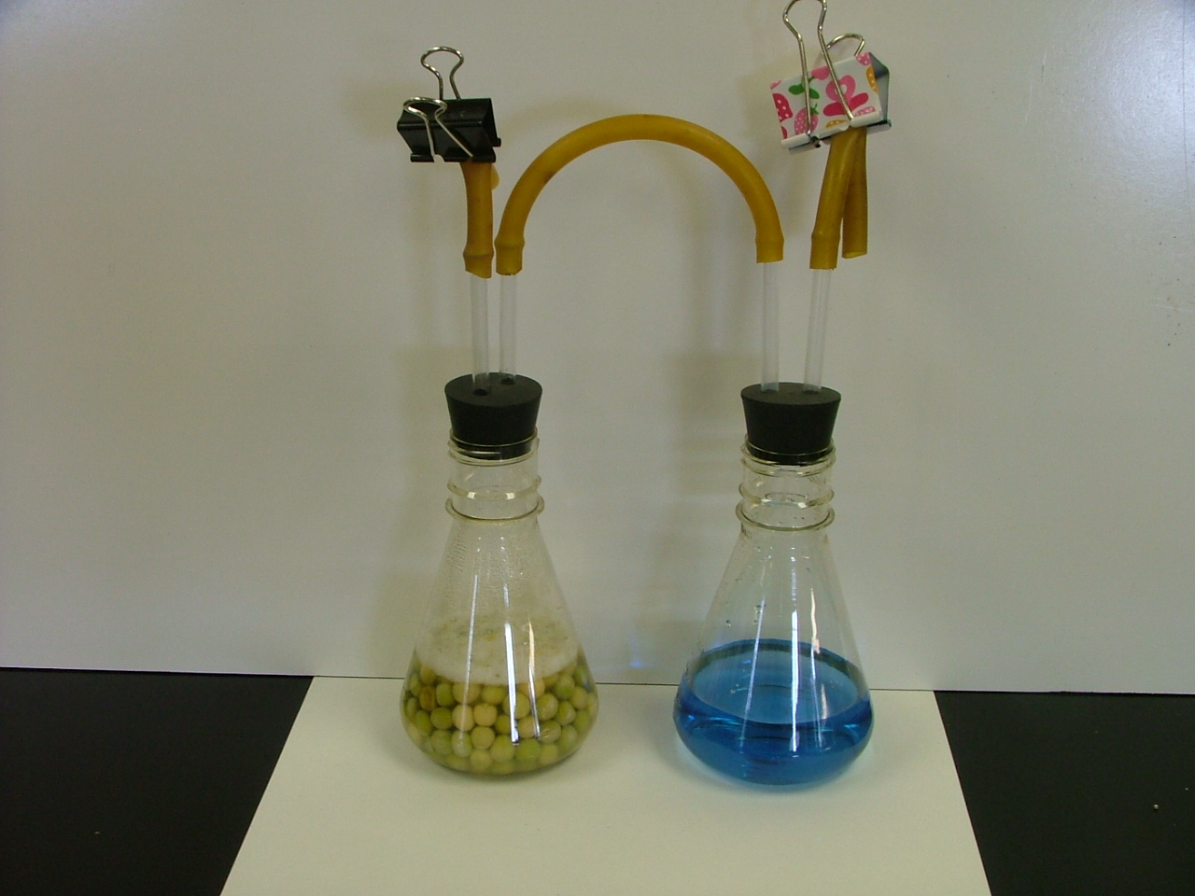
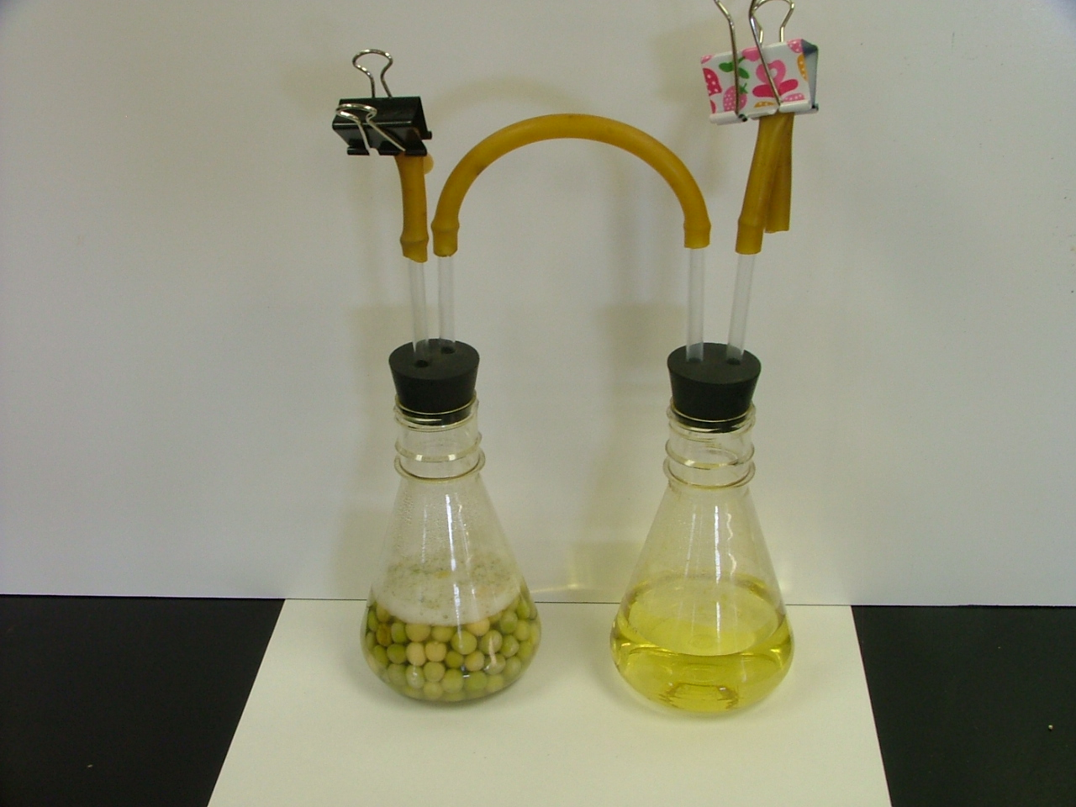
Demonstration Pictures:
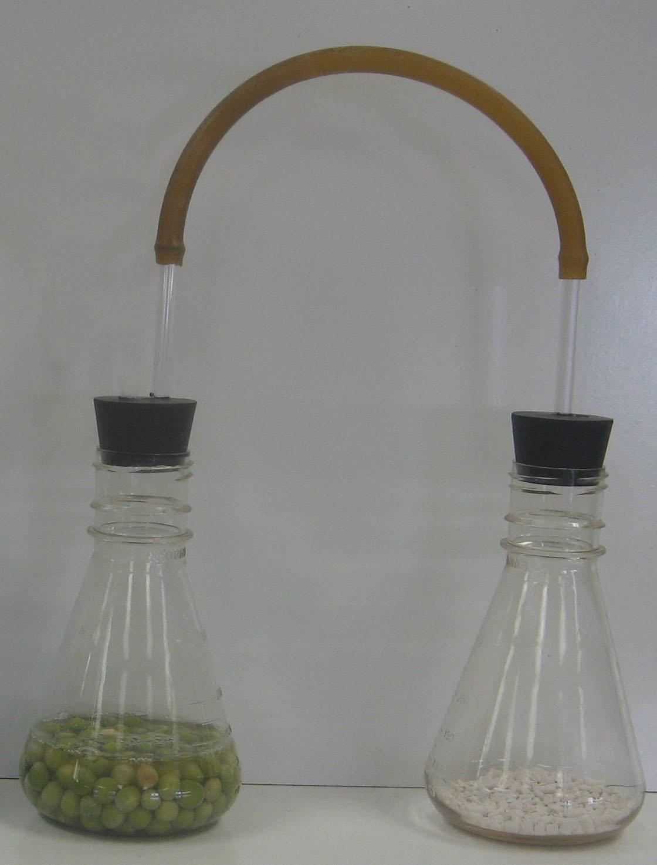
BTB Color Before BTB Color After
Soda Lime Set-up
Option 2: Vernier CO₂ Probe (or video of CO₂ probe demonstration)
Directions:
- Pass out the worksheet, The Air Around Seeds—CO₂ Probe.
- The equipment should be set-up before students arrive, but demonstrate the set-up for students to see. The germinating pea seeds could be added as part of the demonstration instead of in advance. Obtain 50 germinating peas and blot them dry between two pieces of paper towel and place in the respiration chamber.
- Attach the probe but wait several minutes before tightly sealing the chamber with parafilm. Point out to students that the chamber is in the light.
- Ask students, “Do you think CO₂ levels around seeds will go up, down, or stay the same?” Have students record their predictions on their worksheets and write down their reasoning.
- While students write, seal the connection between the tee and respiration chamber using parafilm. Start data collection but do not project to class. Share the starting CO₂ level with students to record on their handouts.
- Spend 10 minutes allowing several students to share their predictions and reasoning, while the probe collects data (which is still not projected to students).
- After 10 minutes, reveal the data to students and have them record their 10-minute CO₂ level on their worksheet. Allow the probe to collect for another 5 minutes. Then record the 15-minute CO₂ level. If there is time, allow the probe to collect for another 5 minutes, but this time cover the chamber to make it completely dark. The level should continue to go up despite being in the light or the dark.
- Have students discuss, in partners, the question on the bottom of their worksheet: Do you think seeds could lose their mass to the air? Why or why not? Spend the remaining 10 minutes discussing this question as a group. Notes that this discussion may vary depending on whether you have already taught cellular respiration. If so, help students make the connection to respiration in other organisms. If not, help students see the difference between photosynthesis and this new pattern for mass loss in the dark.

Video Alternative: If probes are not available, you may choose to show a video of the probe investigation to students and use the sample data for discussion. You can access the probe videos using the following link: http://www.youtube.com/watch?v=WCrV1MvXNcI

Sample Data:
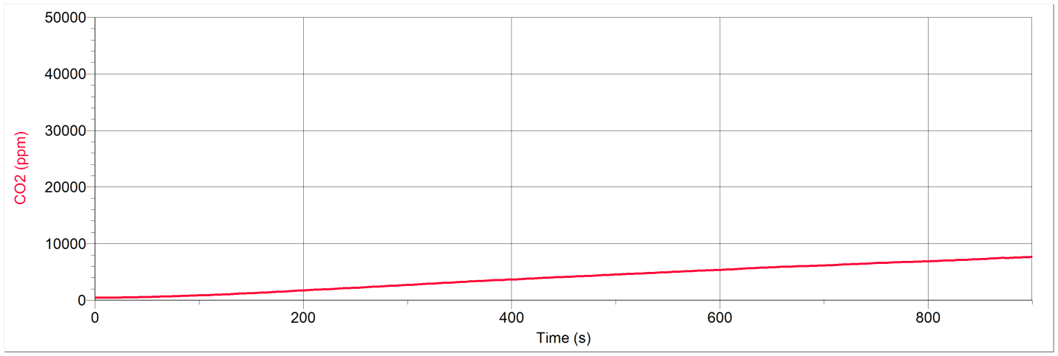

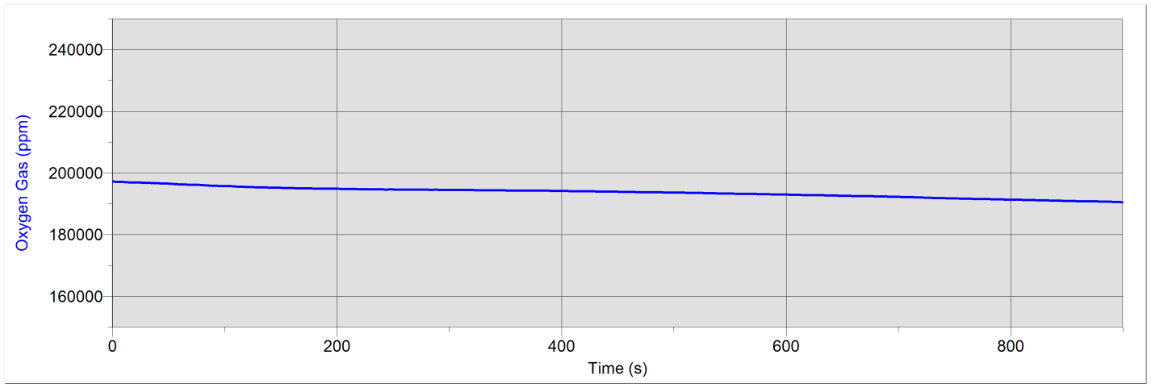
Time (sec) | CO2 Concentration (ppm) | O2 Concentration (ppm)
0 | 490.19 | 197274.25
40 | 543.59 | 196696.09
80 | 734.33 | 196092.79
120 | 1016.62 | 195534.73
160 | 1371.38 | 195162.70
200 | 1749.04 | 194911.32
240 | 2134.32 | 194745.42
280 | 2517.70 | 194594.59
320 | 2931.59 | 194499.07
360 | 3337.86 | 194343.21
400 | 3669.74 | 194242.66
440 | 4037.86 | 194006.37
480 | 4377.37 | 193765.05
520 | 4720.69 | 193574.01
560 | 5067.83 | 193322.63
600 | 5374.91 | 193076.28
640 | 5756.38 | 192754.52
680 | 6038.67 | 192478.01
720 | 6351.47 | 192070.78
760 | 6645.20 | 191733.94
800 | 6898.88 | 191397.10
840 | 7188.80 | 191065.28
880 | 7526.40 | 190773.68
900 | 7671.36 | 190577.61

Activity 3: What Is Cellular Respiration In Plants?

Time: 25 minutes

Rationale & Description:
In this activity, students use a reading and/or PowerPoint with process diagrams to construct a scientific account of cellular respiration in plants. Students will need to discuss whether cellular respiration makes sense given the data they have collected during the past lessons, such as mass lost by their plants in the dark, and the rising CO₂ levels around plants in the dark and seeds.

Directions:
- If the reading is chosen, handout the reading What Is Cellular Respiration In Plants? and the student worksheet How Do Plants Use Glucose? to each student. Alternatively you may want to simply use the Cellular Respiration part of the Plant VTTs PowerPoint with whole group discussion in lieu of the reading and worksheet. Either way is fine so long as students are focused on constructing a scientific account of respiration and comparing this account to their evidence.

Information About Reading
- The reading provides a lot of information for students, so it will be necessary to stop at several places to point out key ideas, as suggested below. As the various stopping points, help students connect back to what they observed in prior investigations:
  - After the second paragraph: Take a moment to ask students where most plant mass comes from during photosynthesis. This will be a check on their understanding from previous lessons. Students should identify carbon dioxide as contributing most mass.
  - After the third paragraph: Discuss the graphic. Point out the size of the plant and the plant cell and the cell wall. Use the extra overhead transparency to trace the materials through the plant at different scales.
  - End of first page: Discuss the question, “So how does energy change in a plant—beginning from sunlight taken in for photosynthesis?” Student should develop a basic storyline about energy that goes from light energy to chemical energy to kinetic energy + heat.
  - After reading the explanation of cellular respiration, explain to students that the molecules of water and CO₂ do not have much energy—they are inorganic matter. Ask students what evidence they have that plants give off CO2 and water? They should point back to the probe investigation as one source of evidence.

Information About Cellular Respiration part of the Plant VTTs PowerPoint
- The Cellular Respiration part of the Plant VTTs PowerPoint uses process diagrams at the macroscopic scale, cellular/microscopic scale, and the atomic-molecular scale to explain how matter and energy change in respiration. This PowerPoint could be used in combination with the reading above, or used exclusively without the reading.
  - Slides 43-48 construct a macroscopic account for cellular respiration
  - Slide 49 zooms into a plant cell.
  - Slides 49-54 construct a cellular account of matter and energy in respiration
  - Slides 55-60 construct an atomic-molecular account for matter and energy during cellular respiration that could be used in tandem with molecular models described below.

Optional Activity: Modeling Cellular Respiration In Plants

Time: 25 minutes

Rationale & Description:
Molecular model kits allow students to physically rearrange atoms from reactants to products to demonstrate conservation of matter (atoms). This rearrangement of atoms through cellular respiration also gives students a visual for where carbon atoms go once they leave the plant, as well as how energy changes from chemical energy to other forms of energy.

Directions:
- Pass out model kits to groups of 3-4 students along with Modeling Cellular Respiration Instructions. Students will first build glucose and oxygen molecules, answering questions about the types of atoms and bonds on the back of their How Do Plants Use Glucose? worksheet. They will then rearrange the molecules into carbon dioxide and water. They need to be aware that matter is conserved and that chemical energy in the glucose is transformed into usable energy, such as kinetic energy (and heat waste).
- Demonstrate for students how to use the molecular model kits. Then, as a class, build glucose and oxygen molecules. Use your display set if students need a visual.
- Have students respond to questions on their handout. Make sure to point out that glucose is energy-rich, organic matter reacted with inorganic oxygen.
- Then have groups break apart their molecules following the instructions and begin to build carbon dioxide and water.
- Give students time to complete their worksheet, pointing out that carbon dioxide and water are now inorganic materials and not a source of chemical energy, so the energy must have gone somewhere.
- Discuss the two questions on the student worksheet to conclude the activity.
  - Suppose you heard someone claim that plants lose mass at night, and this mass goes into the air. Explain how this might be correct or incorrect. Plants lose mass at night because they do cellular respiration and give off carbon dioxide and water. Note that plants do cellular respiration during the day as well, but during the day the process of photosynthesis (which leads to gaining mass) counterbalances the process of cellular respiration.
  - You modeled that cellular respiration is a process where plant cells oxidized glucose and rearrange the atoms from high-energy bonds to low-energy bonds. What happens to this chemical energy, and how does energy change? The chemical energy found in glucose is converted to kinetic energy or heat. Carbon dioxide and water do not have C-C or C-H bonds so they do not have chemical energy.

Name: _____________________ Period: ____ Date: ________

When Seeds and Plants Lose Mass

You have evidence to show that seeds and plants can lose mass. Below are three explanations about how this might happen, and where the mass goes. Read each explanation, and then pick the one you think is supported by your evidence.
Carmen: When plants and seeds lose mass, it mostly goes into the air as carbon dioxide.
Alex: Plants and seeds lose mass because the plant is not getting what it needs, so the mass just goes away.
Blake: Plants and seeds lose mass because they can’t do photosynthesis. The mass may go back into the soil around the plant.

Which explanation is supported by your evidence? Explain why it is the best explanation.

Write an explanation about how young seeds lose mass, and where you think the mass goes.

Name: _____________________ Period: ____ Date: ________

The Air Around Seeds- BTB and Soda Lime

In this investigation you will make observations of whether seeds change the air around them.

Part 1: Initial Explanation and Predictions

Prediction: Based on your ideas about where mass goes, what do you predict will happen to the amount of CO₂ around seeds? |  | Seeds
 | The amount of CO₂ will… | ◻ increase  ◻ be the same  ◻ decrease

Your explanation: How are reactants changing into products when observing seeds?

Use the Process Tool to show your explanation and prediction: Show your ideas about how matter and energy change when seeds in a chamber are observed.

Name:_____________________ Period:____ Date:_________
Part 2: Measurements During the Investigation

Make your observations:
 | Color of BTB |  |  | Mass of Seeds | Mass of Soda Lime
0 minutes |  |  | 0 minutes
24 hours |  |  | 24 hours
 |  |  |  | Mass change: | Mass change:

Initial Explanation:

Do you think seeds could lose their mass to the air? Why or why not?

What is the energy form a seed uses to start growing?

Part 3: Explaining Your Results
Claims—your revised explanation: How are reactants changing into products when seeds are observed?

Using the Process Tool: Show your new ideas about how reactants changed into products on the process tool diagram below.
Evidence—the measurements that support your explanation: What are the key observations and measurements that support your explanation?

Reasoning—connecting claims to evidence and scientific principles
Connecting explanations and evidence: How does the evidence support your explanation?

Connecting evidence and principles. Does your explanation follow the principles that apply to chemical changes?
Yes No Not sure Conservation of matter: Materials (solids, liquids, or gases change into other materials, but matter is not created or destroyed.
Yes No Not sure Conservation of mass: The masses of reactants and products are equal.
Yes No Not sure Conservation of energy: Energy is not created or destroyed.
Yes No Not sure Conservation of atoms: Atoms are not created or destroyed.

Name: _____________________ Period: ____ Date: ________

The Air Around Seeds- CO2 Probe

In this investigation you will make observations of whether seeds change the air around them.

Part 1: Initial Explanation and Predictions

Prediction: Based on your ideas about where mass goes, what do you predict will happen to the amount of CO₂ around seeds? |  | Seeds
 | The amount of CO₂ will… | ◻ increase  ◻ be the same  ◻ decrease

Your explanation: How are reactants changing into products when observing seeds?

Use the Process Tool to show your explanation and prediction: Show your ideas about how matter and energy change when seeds in a chamber are observed.

Name:_____________________ Period:____ Date:_________
Part 2: Measurements During the Investigation

Make your observations:
CO₂ Level Around Seeds
0 minutes
10 minutes
15 minutes

Initial Explanation:

Do you think seeds could lose their mass to the air? Why or why not?

What is the energy form a seed uses to start growing?

Part 3: Explaining Your Results
Claims—your revised explanation: How are reactants changing into products when seeds are observed?

Using the Process Tool: Show your new ideas about how reactants changed into products on the process tool diagram below.
Evidence—the measurements that support your explanation: What are the key observations and measurements that support your explanation?

Reasoning—connecting claims to evidence and scientific principles
Connecting explanations and evidence: How does the evidence support your explanation?

Connecting evidence and principles. Does your explanation follow the principles that apply to chemical changes?
Yes No Not sure Conservation of matter: Materials (solids, liquids, or gases change into other materials, but matter is not created or destroyed.
Yes No Not sure Conservation of mass: The masses of reactants and products are equal.
Yes No Not sure Conservation of energy: Energy is not created or destroyed.
- Yes No Not sure Conservation of atoms: Atoms are not created or destroyed.

Name:_____________________ Period:____ Date:_________
How Do Plants Use Glucose?
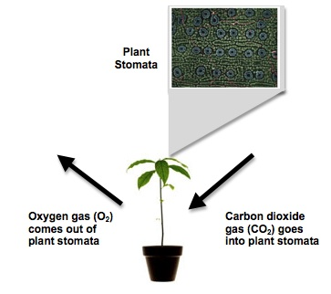

Look at the diagram to the right. Now that you know more about photosynthesis and cellular respiration, explain what is true about the diagram, and what is missing?

Plants take in carbon dioxide and give off oxygen. Explain why this is true for plants growing in the light. What is missing? | Plants change the air in a different way when it is dark. Explain what you now know about plants in the dark.
Part 2: Molecular Models
 | Matter |  |  | Energy
 | How many  carbon atoms | How many  oxygen atoms | How many  hydrogen atoms | Chemical energy: Yes or No?  (C-C; C-H Bonds)
Began with…
Glucose
Oxygen
End with…
Carbon Dioxide
Water

Part 3: My Explanations

1. Suppose you heard someone claim that plants lose mass at night, and this mass goes into the air. Explain how this might be correct or incorrect. _________________________________
____________________________________________________________________________________________________________________________________________________________________________________________________________________________________

2. You modeled that cellular respiration is a process where plant cells oxidize glucose and rearrange the atoms from high-energy bonds to low-energy bonds. What happens to this chemical energy, and how does energy change? _____________________________________
____________________________________________________________________________
________________________________________________________________________________________________________________________________________________________

Core 7: Plant Application Activities

Time/Duration: About two and a half hours
Activity 1: Examples of Photosynthesis, Biosynthesis, & Cell Respiration ~45 minutes
Optional Activity: What’s the Carbon Trend? ~45 minutes
Optional Activity: How Many Trees Do I Need? ~45 minutes

Lesson Description:
In these activities, students will have an opportunity to apply the understandings and practices they have developed during the Plant Unit in new contexts. In the first activity, students use the process tool to help explain what is happening in different examples of plant photosynthesis, biosynthesis, and cellular respiration. In the Keeling Curve optional activity, students combine their understanding of plants and carbon dioxide with new information to develop scientific arguments that help explain why the Keeling Curve looks the way it does. In the final optional activity, students calculate how much carbon is emitted by various activities. They then compare those amounts to the number of trees that would be need to be planted to offset emissions from the activities.

Lesson Materials:
Per Student
- Worksheet: Examples of Photosynthesis, Biosynthesis, and Cellular Respiration
- Optional Worksheet: What’s the Carbon Trend? Explaining the Keeling Curve
- Optional Worksheet: How Many Trees Do I Need?
- Calculators

Activity 1: Examples of Photosynthesis, Biosynthesis, and Cellular Respiration

Time: 45 minutes

Rationale & Description:
Students use the process tool to help explain what is happening in different examples of plant photosynthesis, biosynthesis, and cellular respiration.

Directions:
- Pass out student worksheet Examples of Photosynthesis, Biosynthesis, and Cellular Respiration. Students can work in pairs or small groups on the questions.
- After students work on the questions, convene a whole class discussion to share their ideas. It will be helpful to project the worksheets while students talk. Ask groups if they agree with other groups’ responses and what they would change or add. By the end of the discussion, reasonable scientific explanations for the questions should be agreed upon by the class.

Optional Activity 2: What’s the Carbon Trend? Explaining the Keeling Curve

Time: 45 minutes

Rationale & Description:
This activity introduces students to the Keeling Curve and helps them to make sense of what the data underlying the Keeling Curve tell us about carbon in Earth’s atmosphere over the past five decades. The activity also helps students to develop understanding and explanations of the role of plants in regulating Earth’s climate over yearly cycles, and over longer periods of time.

Materials:
Per Student
- Worksheet What’s the Carbon Trend? Explaining the Keeling Curve

Directions:
- Begin by passing out the first three pages of the worksheet. Review the first page as a group. Have students work in small groups. Begin by having students complete questions 1 and 2 in their small groups. Follow with a whole group discussion, checking that all students are interpreting the basic information about carbon trends correctly.
- Next, have students complete question 3 in their small groups, and again discuss as a whole class. Engage students in presenting and evaluating their own and other groups’ arguments.
- After students have developed understanding of the decadal trends in carbon concentrations, ask the small groups to answer questions four and five. Engage in whole group discussion to elicit and share students’ ideas.
- Next, handout the final two pages of the workshop. Have students complete the handout in their small groups, then conduct a whole class discussion. Again, engage the students in presenting and evaluating their own and other groups’ arguments about what is being shown in the Keeling Curve.

Optional Activity 3: How Many Trees Do I Need?

Time: 45 minutes

Rationale & Description:
This activity can be used as a fading activity for students to make connections between what they’ve learned about plants and photosynthesis with the rationale behind planting trees (especially when these are claimed to offset carbon emissions). In this activity students sort through a list of 22 common daily activities, choosing those they do regularly and then calculating a rough estimate of the carbon emitted from those activities alone. Students then calculate how many trees they would need to offset this carbon compared to the carbon given off by the average American and average world citizen.

Materials:
General
- Public space to record students’ tree counts
Per Student
- Daily Activity Slips
- Worksheet How Many Trees Do I Need?
- Calculators

Advance Prep:
- Assemble Daily Activity slip packets. Each pack should contain 22 daily activities.

Directions:
- Introduce carbon offsets. Students may have heard of carbon offsets on television or the Internet, where people can pay to have their carbon offset (either by planting a tree or purchasing renewable energy). Ask students why we can “plant trees” to offset our carbon?
- Pass out packets of daily activities to each student, along with the worksheet How Many Trees Do I Need? The packets contain slips of paper with common activities students might do each and every day. On one side of each slip, the activity and CO₂ output is indicated. On the other side is information about how the CO₂ output was calculated. Have students sort through these slips of paper to construct a list of their daily activities. They will then need to calculate the total for their carbon emissions for each day.
- Have students calculate how many trees they would need to take up this carbon, dividing their daily emission by 0.06.
- Have students calculate—on average—how many trees an American that emits 32,000 pounds of CO₂ needs compared to global average output of 8,500 pounds.
- Have students share their tree counts with the class, and make a decision about 1 or 2 things they could change in their actions to lower the amount of trees they would need.

Application: Examples of Photosynthesis, Biosynthesis, and Cellular Respiration

Questions about Plant Biosynthesis and Cellular Respiration

1. Choose two examples of changes that happen when plants grow and move
- A carrot grows under the ground
- An oak tree lives through the winter without leaves
- A test for starch shows that there is more starch in the leaves of a houseplant in the afternoon than in the morning
- A grower keeps alfalfa seeds moist to make alfalfa sprouts for salads
- A flower makes nectar (mostly sugar dissolved in water) to attract bees and hummingbirds

2. Use the Process Tool and questions on the next two pages to predict what will happen in your examples.

3. (Optional): Use molecular models to show what happens inside the cells of the plant.

Questions about Other Chemical Changes

Connect to combustion: Of the three kinds of chemical changes that you studied in plants:
- Photosynthesis
- Biosynthesis
- Cellular respiration
Circle which change is most like combustion, the chemical change that you studied in Systems and Scale? Explain your reasoning.

Stump the class: The Law of Conservation of Mass says that mass is conserved in EVERY chemical and physical change, including all changes that occur in plants. Can you think of an example of something that a plant does where mass is not conserved?

1. Try to think of an example where mass seems to disappear—the products at the end are lighter than the reactants at the beginning. Can anyone in the class suggest a possible explanation?

2. Try to think of an example where mass seems to be created—the products at the end are heavier than the reactants at the beginning. Can anyone in the class suggest a possible explanation?

Name: _____________________ Period: ____ Date: ________
Predicting and Explaining an Example of Chemical Change in a Plant
1. Write your own explanation for what chemical changes are involved in this process.
2. Predict what happens to the masses of materials involved in this process.

3. Explain what happens to the chemical energy stored in the C-C and C-H bonds of organic materials.

4. Use the process tool to identify the reactants, products, and energy changes.

5. Does your explanation follow the principles that apply to chemical changes?
Yes No Not sure Conservation of matter: Materials (solids, liquids, or gases) change into other materials, but matter is not created or destroyed.
Yes No Not sure Conservation of mass: The masses of reactants and products are equal.
Yes No Not sure Conservation of energy: Energy is not created or destroyed.
Yes No Not sure Conservation of atoms: Atoms are not created or destroyed.

Name: _____________________ Period: ____ Date: ________
Predicting and Explaining an Example of Chemical Change in a Plant
1. Write your own explanation for what chemical changes are involved in this process.
2. Predict what happens to the masses of materials involved in this process.

3. Explain what happens to the chemical energy stored in the C-C and C-H bonds of organic materials.

4. Use the process tool to identify the reactants, products, and energy changes.

5. Does your explanation follow the principles that apply to chemical changes?
Yes No Not sure Conservation of matter: Materials (solids, liquids, or gases) change into other materials, but matter is not created or destroyed.
Yes No Not sure Conservation of mass: The masses of reactants and products are equal.
Yes No Not sure Conservation of energy: Energy is not created or destroyed.
Yes No Not sure Conservation of atoms: Atoms are not created or destroyed.
Application Activity
What’s the Carbon Trend? Explaining the Keeling Curve

In this activity, you will use what you have learned in the Plants Unit to interpret the Keeling Curve and consider why it looks the way it does.

Below is a famous graph called the Keeling Curve. This graph was originally created by a scientist named Charles Keeling. Starting in the 1950s, Keeling studied levels of carbon dioxide in the atmosphere at Mauna Loa scientific observatory in Hawaii. The first version of the graph was created with only about three years of data, beginning in 1958. Even with just three years of data, Keeling was able to see evidence of a trend in the concentration of carbon dioxide in the atmosphere. The graph below shows the data trend over the last 50 years, up to 2008.

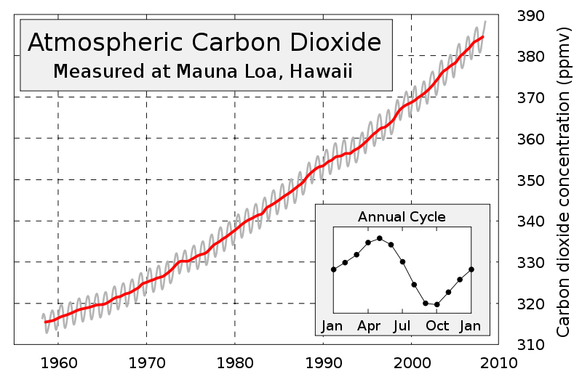
The Keeling Curve: Atmospheric CO₂ concentrations measured at Mauna Loa Observatory

With your group, discuss and respond to the following questions to explain why the Keeling Curve looks the way it does.

- Describe the general trend in the level of carbon dioxide in the atmosphere between 1958 and 2008? In other words, is the level of carbon dioxide in the atmosphere going up, going down, or staying the same? (Hint: Use the red trend line to consider this question).

- Is the rate at which the carbon dioxide level in the atmosphere is changing staying the same or changing over time? (Hint: To help answer this question, compare how much the concentration of carbon dioxide changed in each of the five decades shown on the graph).

- Use what you have learned in the Plants Unit and the text below to develop an explanation answering the following question. WHY IS THE CONCENTRATION OF CARBON DIOXIDE IN THE ATMOSPHERE CHANGING THE WAY THAT IS SHOWN IN THE KEELING CURVE? Your explanation should include a claim about the direction of the trend, evidence supporting the claim, and reasoning describing WHY the trend is going the way it is.

Background information: Fossil fuels contain carbon that was stored by organisms (mostly plants) hundreds of millions of years ago. Plants that turned into fossil fuels were plants that lived in oceans, lakes and swamps. When these plants died, they sank to the bottoms of these areas and accumulated to great depths where they were eventually covered by layers of heavy sediments. The heavy layers above created conditions in which the dead, buried plants were subjected to high levels of heat and pressure. Under these conditions, the buried plants were slowly transformed into coal and petroleum, which can be used as fuels. Most of these carbon-containing fossil fuels remained buried for hundreds of millions of years, until modern times.

Through the process described above, Earth’s store of fossil fuels was created over hundreds of millions of years. While biogeochemical processes can create more fossil fuels over time, humans today are using our planet’s store of fossil fuels at a rate that is much greater than what can be replaced by natural processes even if widespread conditions favorable to the accumulation of carbon-rich materials still existed.

Provide your argument here:
Claim
The concentration of CO₂ in Earth’s atmosphere is (circle one: going up, going down, staying the same).

Evidence
The evidence that supports this claim is:

Reasoning
The reason why the concentration of carbon dioxide in Earth’s atmosphere is changing this way is because:
Plants take in carbon dioxide from the atmosphere. Fossil fuels used to be plants. When these plants died, they got buried, so they couldn’t return their carbon to the atmosphere when they died. So over millions of years, carbon in these plants got stored and converted into fossil fuels containing carbon. Now humans are releasing the carbon that was stored in the fossil fuels back into the atmosphere by burning the fuels. The amount of carbon that is continuing to be taken from the atmosphere and stored as fossil fuels in the Earth is much smaller than the amount that is being released into the atmosphere when we burn fossil fuels. That’s why the level of carbon dioxide in the atmosphere is rising every year.

Students may also explain that the rate at which carbon dioxide levels is changing is also increasing, and that the reason why carbon dioxide levels are increasing more rapidly more recently is because humans have been increasing their fossil fuel use over the past fifty years.

- Now let’s consider the gray colored line on the Keeling Curve. In your own words, describe the trend shown by the gray line. (Hint: The Annual Cycle inset in the graph should help you explain the gray trend line more precisely.)

- So, what is the reason why the concentration of carbon dioxide in Earth’s atmosphere is changing the way that is shown by the gray line? Discuss with your group and write your initial ideas about what might explain this pattern.

- Question 5 is a hard question! We can give you a hint that plants play a big role in explaining the short term fluctuations shown by the gray line. Consider what you know about how plants change the air around them to help you think about this question. The information provided below may also help you think about the reason for the gray line trend.

Consider that seasons on Earth are determined by the tilt of our planet on its axis. Due to this tilt, when it is summer in the northern hemisphere it is winter in the southern hemisphere, and vice versa. This relationship is shown in the diagram below.

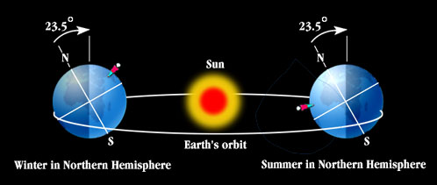
Graphic from http://lasp.colorado.edu/~bagenal/1010/SESSIONS/3.CelestialCycles.html

And, here are a few more facts. Considering the planet as a whole, water covers about 71% of Earth’s surface and land covers about 29%. However, the land masses on Earth are not equally distributed all over the planet. In fact, the distribution is pretty different in the northern and southern hemispheres. The northern hemisphere is about 39% land and 61% water. The southern hemisphere is only about 19% land. The southern hemisphere is covered by more water; about 81% of the southern hemisphere is water.

How can this evidence help you explain the reason for the gray line trend in the Keeling Curve? Discuss with your group and provide a revised argument here.
Claim
While overall, there has been a trend of carbon dioxide in the atmosphere rising for the past 50 years, every year the concentration of carbon dioxide in the atmosphere fluctuates such that it is (choose one):
- Going down in southern hemisphere summer and going up in southern hemisphere winter
- Going down in northern hemisphere summer and going up northern hemisphere winter

Reasoning
The reason why the concentration of CO₂ in Earth’s atmosphere is changing this way is because:
Through photosynthesis, plants incorporate carbon into their bodies. The sun’s energy drives photosynthesis, so plants can incorporate more photosynthesis into their bodies when there is more light energy hitting them. Even though there are plants in the ocean, a lot of plants are on land. Because there is more land in the northern hemisphere, there is more photosynthesis going on in northern hemisphere summer (when there’s more light energy reaching the northern hemisphere) than there is in southern hemisphere summer. During northern hemisphere summer, levels of carbon dioxide in Earth’s atmosphere dip a little because more carbon dioxide is being incorporated into plant bodies through photosynthesis than during the northern hemisphere winter. Because there’s less land mass in the southern hemisphere, there’s less photosynthesis going on around the Earth in southern hemisphere summer, so carbon dioxide levels go up in southern hemisphere summer.

- Some people who want to limit their carbon footprint (that is, the amount of carbon dioxide that they send into the atmosphere as a result of their activities) do so by paying for trees to be planted in forests around the world. Explain how planting trees helps to reduce the amount of carbon dioxide in the atmosphere.

Name:_____________________ Period:____ Date:_________

How Many Trees Do I Need?
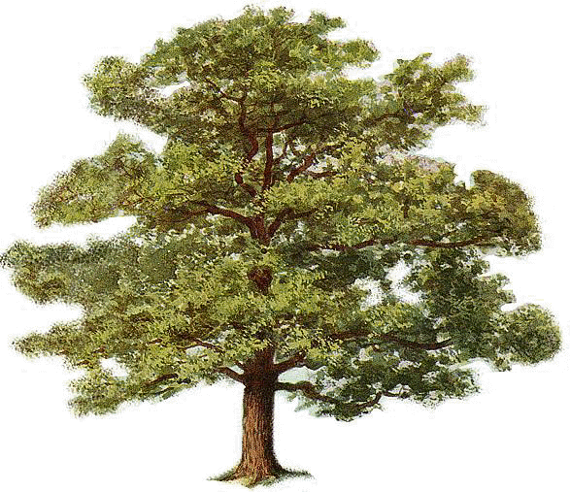
Nowadays, companies offer to plant trees to offset the carbon we put in the air. For example, an airline company might offer to plant a tree to offset the fuel they use to get passengers from one city to another. Why would planting trees matter? Well, it all has to do with carbon dioxide. We put carbon dioxide into the air when we drive, fly, use electricity at home, and even when we eat things!

Today you figure out how much carbon dioxide you put into the air when you go about a regular school day. Then you will figure out how many trees you would need to take up all this carbon dioxide.

Step 1: Look at the slips of paper with all the things you could do in a regular school day. Choose as many of these things that you do each and every day. Set aside the things you do not usually do.
 | Pounds of CO2 given off each day | Number of Trees to take up this CO2 (divide by 0.06)
My Trees

An American’s Trees | 85 lbs of CO₂ per day
World Average Trees | 22 lbs of CO₂ per day

Step 2: Add up the total POUNDS of carbon dioxide you put into the air to do these things, and put the total in the table to the right.

Step 3: A mature tree takes in an average of about 0.06 pounds of CO₂ a day. This is about 22 pounds of CO₂ in a year and about 1 metric ton (2204 pounds) of CO₂ in the course of its life. Divide your daily carbon dioxide output by 0.06 to find out how many trees you need working for you each and every day.

Step 4: The average American emits about 85 pounds of CO₂ each day. This is once you add all the things Americans do that require electricity and fuel (including what we eat!). The global average for people is only about 22 pounds of CO₂ a day. Calculate how many trees an American needs compared to the average amount around the world.

Step 5: Look back at your list of things you do each and every day. What is one thing you could change that would reduce the amount of trees you would need?

Eat Cereal & Milk For Breakfast | 2.70 Pounds CO₂ released
Eat Eggs and Bacon For Breakfast | 2.90 Pounds CO₂ released
Take A 15-Min Shower | 4.00 Pounds CO₂ released
Listen to iPod | 0.50 Pounds CO₂ released
Drive to/from School | 8.00 Pounds CO₂ released
Bike or Walk to School | 0.00 Pounds CO₂ released
Hangout With Friends Before/After School | 0.00 Pounds CO₂ released
Talk on Cell Phone (average daily use) | 0.70 Pounds CO₂ released
Practice a Sport For an Hour | 0.00 Pounds CO₂ released
Do Homework Right After School (in light) | 0.00 Pounds CO₂ released
Do Homework Right Before Bed (by lamp) | 0.30 Pounds CO₂ released
Drive To/From Friend’s House | 10.00 Pounds CO₂ released
Eat Garden Salad For Lunch | 0.90 Pounds CO₂ released
Eat Cheeseburger/Beef Burrito For Lunch | 6.00 Pounds CO₂ released
Eat 2 Slices Cheese Pizza For Dinner | 0.50 Pounds CO₂ released
Eat 2 Slices Pepperoni Pizza For Dinner | 0.75 Pounds CO₂ released
Surf Internet For An Hour | 0.30 Pounds CO₂ released
Chat on Facebook For An Hour | 0.30 Pounds CO₂ released
Play Video Game For An Hour | 1.50 Pounds CO₂ released
Read A Book (by lamp) | 0.30 Pounds CO₂ released
Walk Dog In The Park | 0.00 Pounds CO₂ released
Watch TV/Movie For 2 Hours | 1.25 Pounds CO₂ released

Eat Cereal & Milk: Cereal requires a lot of energy to process, plus all the energy that goes into making grain/feed for cows to produce milk, which is shipped to our stores (in refrigeration).

Eat Eggs and Bacon: Food that we get from animals requires a lot of energy. We must grow grain to feed the animals, then process the food, which much be refrigerated all the way to our grocery store and then taken to our homes where it is also refrigerated.

Take A Shower: Taking a 15-minute hot shower requires both energy to pump the water to your shower, and energy to run your hot water heater. It is estimated that every minute in a hot shower pumps out 0.25 pounds of CO₂ into the air.

Listen to iPod: For every charge of your iPod, it takes 0.14 pounds of coal to burn at your power plant. That means that every charge of your iPod gives off 0.50 pounds of CO₂!

Drive to School: For 1 gallon of gas used, it gives off about 20 pounds of CO₂ into the air. The estimate is based on a 5-mile drive to school (10 miles roundtrip) in a car that gets 25 mpg. Each roundtrip uses about 2/5 of a gallon of gas.

Bike or Walk to School: Walking or biking to school does not burn fossil fuels (like gasoline) so there are not CO₂ emissions given off, although some CO₂ is given off if you breathe!

Hangout With Friends: Visiting and socializing with your friends at school (in natural sunlight) does not give off CO₂.

Talk on Cell Phone to Friends: The average American emits about 250 pounds of CO₂ into the air every year just talking on the cell phone—it requires energy to keep the phone charged. Since there are 365 days in the year, that is about 0.70 pounds each day your phone is used.

Practice a Sport For an Hour: Playing a sport—like volleyball, soccer, basketball, etc—does not give off CO₂, at least not enough to count. You breathe out CO₂ but it is very little compared to what is given off by cars and homes!

Do Homework Right After School (in light): Doing homework right after school in natural light (not using a lamp or light in your home) does not given off CO₂

Do Homework Right Before Bed (by lamp): This calculation is based on doing homework for up to 2 hours by lamplight or overhead light, which draws 100watts.

Drive Over To Friend’s House: For 1 gallon of gas used, it gives off about 20 pounds of CO₂ into the air. The estimate is based on a 6-mile drive to friend’s (10 miles roundtrip) in a car that gets 25 mpg. Each roundtrip uses about 1/2 of a gallon of gas.

Eat A Garden Salad For Lunch: A garden salad is all vegetables, but it still takes some energy to grow vegetables. We use energy to get water to the crops, and energy to ship the vegetables to our stores.

Eat A Cheeseburger For Lunch: Cheeseburgers, beef burritos, or beef tacos all require lots of energy to raise the beef, to get cheese from the cows, to ship everything to our stores and cafeterias, and then to cook the meat.

Eat 2 Slices Veggie Pizza For Dinner: Veggie or cheese pizza requires cheese and vegetables to be grown and shipped to our stores, then cooked at the restaurant or in our homes.

Eat 2 slices Pepperoni Pizza For Dinner: In addition to cheese and vegetables, pepperoni requires energy to raise the meat.

Surf Internet For An Hour: A typical computer draws between 100-250 watts/hour. This calculation is based on an active computer drawing about 200 watts over the hour.

Chat on Facebook For An Hour: A typical computer draws between 100-250 watts/hour. This calculation is based on an active computer drawing about 200 watts over the hour.

Play Video Game For An Hour: To play a video game you use either a television and game machine or a computer. Assuming a computer that draws 250 watts/hr for gaming, this could be less than a pound of CO₂ an hour. A television/game machine might emit as much as 1.5 lbs/hr.

Read A Book (by lamp): This assumes you use a regular 100-watt light bulb and have the bulb on for at least 2 hours. For every hour, 0.15 pounds of CO₂ are emitted (if your home gets your power from coal).

Walk Dog In The Park: Taking a walk in the park with your dog does not emit CO₂ into the air.

Watch TV/Movie For 2 Hours: calculation assumes a color television running off electricity made from coal power. (from "Your Contribution to Global Warming," by George Barnwell, p. 53 of the February-March 1990 issue of National Wildlife).

APPENDICES

Optional: Air Adds Mass Demonstrations

Investigation #1: Move Air Under Water


This investigation is a simple demonstration to transfer air between two submerged cups. Fill an aquarium or large, transparent container with water. Use 2 small plastic cups for the demonstration. As you submerge the cups, make sure one fills with water, while the other captures mostly air. Place the cup with the air tilted underneath the cup with water and slowly move the air back-air-forth between the cups. Ask students if the air or air bubbles take up space, and how they know that.

Investigation #2: Keep a Napkin Dry Under Water


This investigation is a simple investigation to show that a napkin can stay dry under water. Tape a tissue/napkin into the bottom of a clear cup. Fill an aquarium or large container with water. Flip the cup so that it is facing down. Carefully submerge the cup trapping air inside the cup as it enters the water. Be careful not to tilt the cup because this may release water. Slowly bring the cup out of the water. Let students feel the napkin to verify that it is still dry. Ask students if this shows that air takes up space.

Investigation #3: Blow-Up a Balloon

Tell students to blow up a balloon or, as a demonstration, blow one up yourself. Ask students what is inside the balloon. Ask students if the balloon shows that air takes up space.

Ask students to take a deep breath. What fills up their lungs? Does their chest expand? Is the air inside their lungs taking up space?


Investigation #4: Ball and Pump

Procure a set of recess balls, borrowed from the physical education department or brought from home (Carbon TIME may supply if needed). Use a digital scale sensitive to 0.01g or 0.1g. Weigh an athletic ball on the scale and record the weight. Then use a pump to force air into the ball. Make sure to get as much compressed air inside as possible. Then re-weigh the ball. Ask students, “Does this show that air has mass/weight?” Make sure to weigh the ball carefully and to use the same ball for before and after since different amounts of plastic/rubber can change weight dramatically.

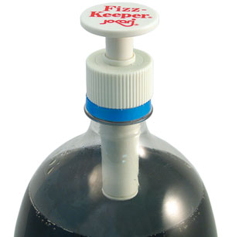

Investigation #5: Pump Air into a soda bottle

Use a two-liter soda bottle emptied and clean. Screw on the fizz pump. This pump allows you to pump air into the soda bottle. Tell students to watch as the soda bottle pumps up. You may also be able to weigh before and after if you have a sensitive scale, but the air will not be as dense as the gym ball demo so the difference may not be detectable. Students will observe the soda bottle becoming more rigid and when the pump is removed they will hear a “whoosh” of air.

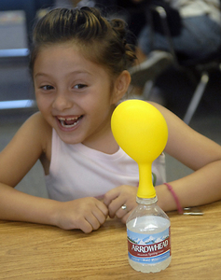
Investigation #6: Alka-Seltzers and Balloon

This investigation uses Alka-Seltzers and water, which when mixed, give off carbon dioxide gas. Use a soda or water bottle filled with an inch of water. Drop two Alka-Seltzers into the water and quickly cover the top with a balloon. If the balloon is too small it may pop, so consider using larger balloons made of thicker material. The CO₂ gas will collect in the balloon. Ask students, “What is filling the balloon?” “Does air take up space?”

Investigation #7: Alka-Seltzers and Scale

You will need an empty wide-mouth soda, water, or juice plastic container. Fill the container with an inch of water. Place the lid on top of the container. Then place 2 Alka-Seltzer tablets on top of the lid. Weigh with a scale sensitive to at least 0.1g (0.01g is even better). Make sure all students see the weight.

Leave the bottle on the scale. Unscrew the lid and place the 2 Alka-Seltzer tablets inside the lid. Quickly turn the lid over (dropping the tablets in the water and screw lid back on bottle, allowing the tablets to drop in the water without letting too much air escape. As the tablets decrease, have students note the mass is still the same even though the bottle is expanding with air. Point out that the size of the tablet is decreasing, but air is increasing. The mass stays the same, so there is the same amount of “stuff” in the bottle, it’s just changing from solid to gas. Then unscrew the lid slowly to release the air. Watch the mass go down as air escapes. Ask students, “Does the air (that came from the solid) have mass?” “Did it take up space?”

Alternative: Suspension system

You will need an empty wide-mouth soda, water, or juice plastic container. Fill the container with an inch of water. Place two Alka-Seltzer tablets in a mesh square cloth. Tie the cloth with thin string (such as fishing line) or tape the tablets to the inside of the lid, dangling the mesh inside the plastic container just below the opening. Leave part of the string outside the container and screw on the plastic lid. Weigh the container on a scale sensitive to 0.01g (0.01g is even better).

Then, turn the container upside down on the scale and allow the water to react with the Alka-Seltzer. The bottle needs to be able to balance upside down so a wide mouth container may work best. Have students note that the mass is still the same. Point out that the size of the tablet is decreasing, but the air is increasing. The mass stays the same, so there is the same amount of “stuff” in the bottle, it’s just changing from solid to gas. Then flip the bottle over and unscrew the lid slowly to release the air. Watch the mass go down as air escapes. Ask students, “Does the air (that came from the solid) have mass?” “Did it take up space?”

Regular potting soil contains organic carbon that provides food for decomposing bacteria. These bacteria will produce carbon dioxide and the decomposition of the organic material may affect the mass of the soil. For this experience, it is preferable to work with inert amendments such as perlite or vermiculite (or a mixture of both).
Not addressed in this unit: when organisms bond two sugar monomers to build a polymer, a molecule of water is produced.

